

DEPARTMENT OF COMPUTER SCIENCE AND ENGINEERING

LAB MANUAL

U23CSP51
DATA MINING AND DATA WAREHOUSING
LABORATORY

REGULATIONS 2023

YEAR / SEM: III / V

PREPARED BY VERIFIED BY

U23CSP51 DATA MINING AND DATA WAREHOUSING LABORATORY

COURSE OBJECTIVE:
- Learn how to build a data warehouse and query it (using open source tools like Pentaho Data Integration Tool, Pentaho Business Analytics).
- Learn to perform data mining tasks using a data mining toolkit (such as open source WEKA).
- Understand the data sets and data preprocessing
- Demonstrate the working of algorithms for data mining tasks such association rule mining, classification, clustering and regression.
- Exercise the data mining techniques with varied input values for different parameters.
- To obtain Practical Experience Working with all real data sets.

LIST OF EXPERIMENTS
- Build Data Warehouse and Explore WEKA
- Create an Employee Table with the help of Data Mining Tool WEKA.
- Create a Weather Table with the help of Data Mining Tool WEKA.
- Apply Pre-Processing techniques to the training data set of Weather Table
- Apply Pre-Processing techniques to the training data set of Employee Table
- Normalize Weather Table data using Knowledge Flow.
- Normalize Employee Table data using Knowledge Flow.
- Finding Association Rules for Buying data. Finding Association Rules for Banking data.
- Perform data preprocessing tasks and Demonstrate performing association rule mining on data set
- Demonstrate performing classification on data sets
- Demonstrate performing clustering on data sets
- Demonstrate performing Regression on data sets
- Credit Risk Assessment. Sample Programs using German Credit Data
- Sample Programs using Hospital Management System
- Beyond the Syllabus -Simple Project on Data Preprocessing

COURSE OUTCOME
At the end of the course, the student should be able to:
CO 1: Ability to understand the various kinds of tools
CO 2: Demonstrate the classification, clustering and etc. in large data sets
CO 3: Describe various preprocessing techniques and statistical techniques and apply those techniques on the given data set
CO 4: Ability to add mining algorithms as a component to the exiting tools.
CO 5: Ability to apply mining techniques for realistic data
CO 6: Create an application using outlier analysis

LIST OF EXERCISES

S.NO | NAME OF THE EXERCISE | PAGE NO.
1 | Build Data Warehouse and Explore WEKA
2 | Create an Employee Table with the help of Data Mining Tool WEKA.
3 | Create a Weather Table with the help of Data Mining Tool WEKA.
4 | Apply Pre-Processing techniques to the training data set of Weather Table
5 | Apply Pre-Processing techniques to the training data set of Employee Table
6 | Normalize Weather Table data using Knowledge Flow.
7 | Normalize Employee Table data using Knowledge Flow.
8 | Finding Association Rules for Buying data. Finding Association Rules for Banking data
9 | Perform data preprocessing tasks and Demonstrate performing association rule mining on data set
10 | Demonstrate performing classification on data sets
11 | Demonstrate performing clustering on data sets
12 | Demonstrate performing Regression on data sets
13 | Credit Risk Assessment. Sample Programs using German Credit Data
14 | Sample Programs using Hospital Management System
15 | Beyond the Syllabus -Simple Project on Data Preprocessing

DHANALAKSHMI SRINIVASAN ENGINEERING COLLEGE (AUTONOMOUS)
Vision of the Institute
An active and committed centre of advanced learning focused on research and training in the fields of Engineering, Technology and Management to serve the nation better.
Mission of the Institute
M1: To develop eminent scholar with a lifelong follow up of global standards by offering UG, PG and Doctoral Programmes.
M2: To pursue Professional and Career growth by collaborating mutually beneficial partnership with industries and higher institutes of research.
M3: To promote sustained research and training with emphasis on human values and leadership qualities.
M4: To contribute solutions for the need-based issues of our society by proper ways and means as dutiful citizen.
Vision of the Department
To produce globally competent, socially responsible professionals in the field of Computer Science and Engineering.
Mission of the Department
M1: Impart high quality experiential learning to get expertise in modern software tools
M2: Inculcate industry exposure and build inter disciplinary research skills.
M3: Mould the students to become Software Professionals, Researchers and Entrepreneurs by providing advanced laboratories.
M4: Acquire Innovative skills and promote lifelong learning with a sense of societal and ethical responsibilities
Program Educational Objectives (PEO's)
PEO1: Graduates of the program will develop proficiency in identifying, formulating, and resolving complex computing problems.
PEO2: Graduates of the program will achieve successful careers in the field of computer science and engineering, pursue advanced degrees, or demonstrate entrepreneurial success. PEO3: Graduates of the program will cultivate effective communication skills, teamwork abilities, ethical values, and leadership qualities for professional engagement in industry and research organizations.
Program Outcomes (PO'S)
PO1: Engineering knowledge: Apply the basic knowledge of science, mathematics and engineering fundamentals in the field of Computer Science and Engineering to solve complex engineering problems.
PO2: Problem analysis: Ability to use basic principles of mathematics, natural sciences, and engineering sciences to Identify, formulate, review research literature and analyze Computer Science and engineering problems.

PO3: Design/development of solutions: Ability to design solutions for complex Computer Science and engineering problems and basic design system to meet the desired needs within realistic constraints such as manufacturability, durability, reliability, sustainability and economy with appropriate consideration for the public health, safety, cultural, societal, and environmental considerations
PO4: Conduct investigations of complex problems: Ability to execute the experimental activities using research-based knowledge and methods including analyze, interpret the data and results with valid conclusion.
PO5: Modern tool usage: Ability to use state of the art of techniques, skills and modern engineering tools necessary for engineering practice to satisfy the needs of the society with an understanding of the limitations.
PO6: The Engineer and Society: Ability to apply reasoning informed by the contextual knowledge to assess the impact of Computer Science and engineering solutions in legal, health, cultural, safety and societal context and the consequent responsibilities relevant to the professional engineering practice.
PO7: Environment and sustainability: Ability to understand the professional responsibility and accountability to demonstrate the need for sustainable development globally in Computer Science domain with consideration of environmental effect.
PO8: Ethics: Ability to understand and apply ethical principles and commitment to address the professional ethical responsibilities of an engineer.
PO9: Individual and team work: Ability to function efficiently as an individual or as a group member or leader in a team in multidisciplinary environment.
PO10: Communication: Ability to communicate, comprehend and present effectively with engineering community and the society at large on complex engineering activities by receiving clear instructions for preparing effective reports, design documentation and presentations.
PO11: Project management and finance: Ability to acquire and demonstrate the knowledge of contemporary issues related to finance and managerial skills in one’s own work, as a member and leader in a team, to manage projects and in multidisciplinary environments.
PO12: Life-long learning: Ability to recognize and adapt to the emerging field of application in engineering and technology by developing self-confidence for lifelong learning process.
Program Specific Outcome (PSO's)
The graduates of Bachelor of Engineering in Computer Science and Engineering Programme will be able to
PSO1: Analyze, develop and provide solutions to industrial problems in computer domain using programming, data processing and analytical skills.
PSO2: Apply software application-oriented skills to innovate solution to meet the ever-changing demands of IT industry.

EX.NO: 01 Build Data Warehouse and Explore WEKA

Build a Data Warehouse/Data Mart (using open source tools like Pentaho Data Integration tool, Pentaho Business Analytics; or other data warehouse tools like MicrosoftSSIS, Informatica, Business Objects, etc.).

  - Identify source tables and populate sample data

In this task, we are going to use MySQL administrator, SQLyog Enterprise tools for building & identifying tables in database & also for populating (filling) the sample data in those tables of a database.A data warehouse is constructed by integrating data from multiple heterogeneous sources. It supports analytical reporting, structured and/or ad hoc queries and decision making. We are building a data warehouse by integrating all the tables in database & analyzing those data. In the below figure we represented MySQL Administrator connection establishment.
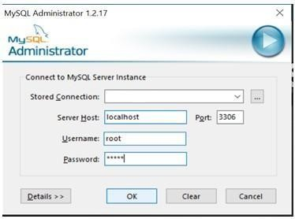

After successful login, it will open new window as shown below.
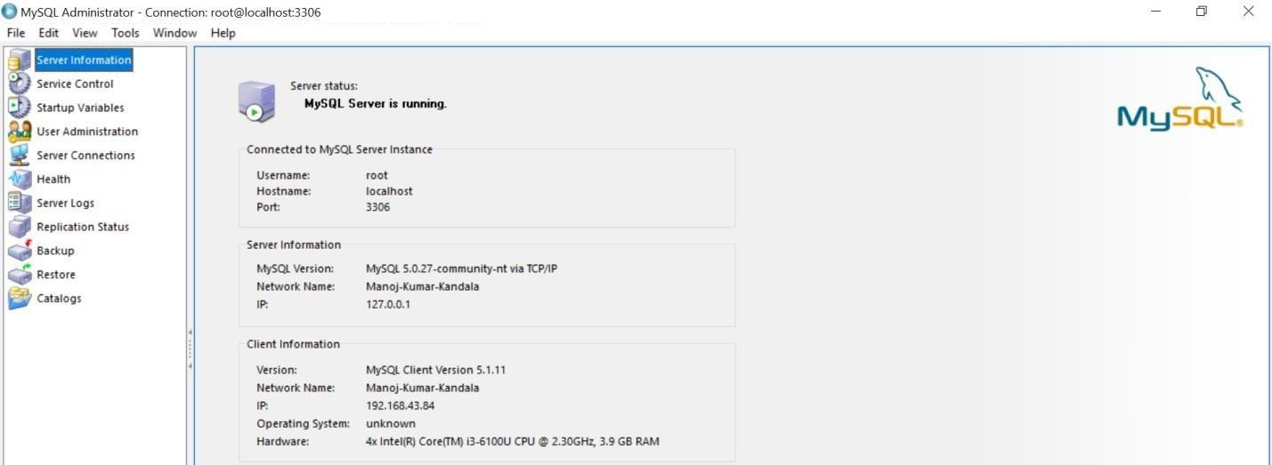

There are different options available in MySQL administrator. Another tool SQLyog Enterprise, we are using for building & identifying tables in a database after successful connection establishment through MySQL Administrator. Below we can see the window of SQLyog Enterprise.

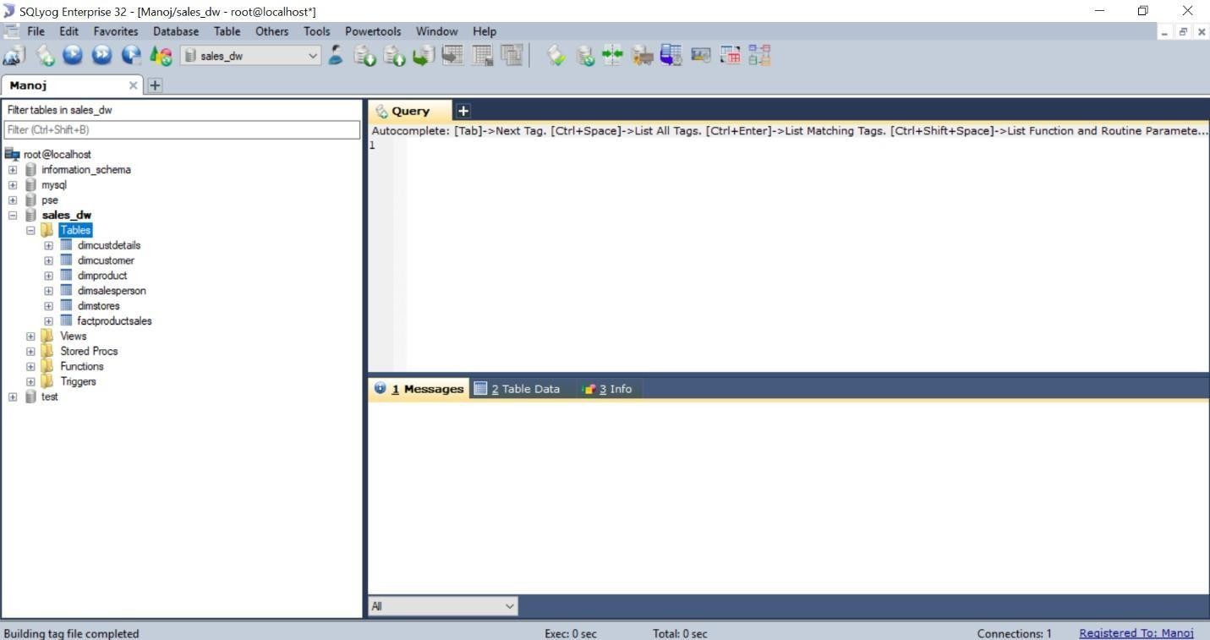

On left-side navigation, we can see different databases & it‘s related tables. Now we are going to build tables & populate table‘s data in database through SQL queries. These tables in database can be used further for building data warehouse.

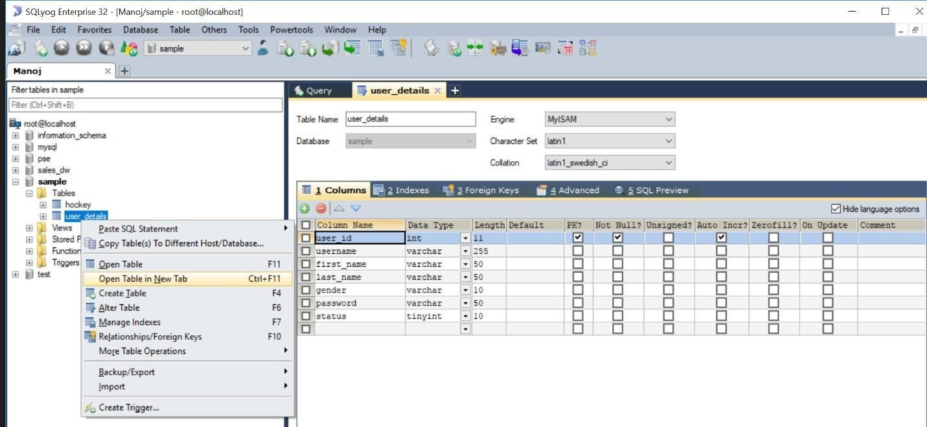

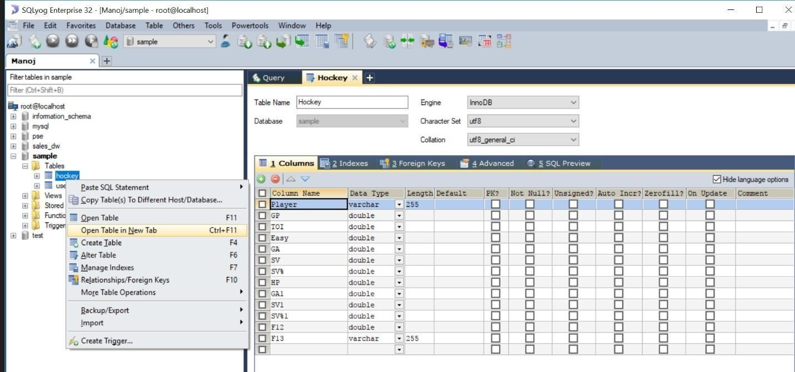

In the above two windows, we created a database named “sample”& in that database we created two tables named as “user_details”& “hockey”through SQL queries.
Now, we are going to populate (filling) sample data through SQL queries in those two created tables as represented in below windows.

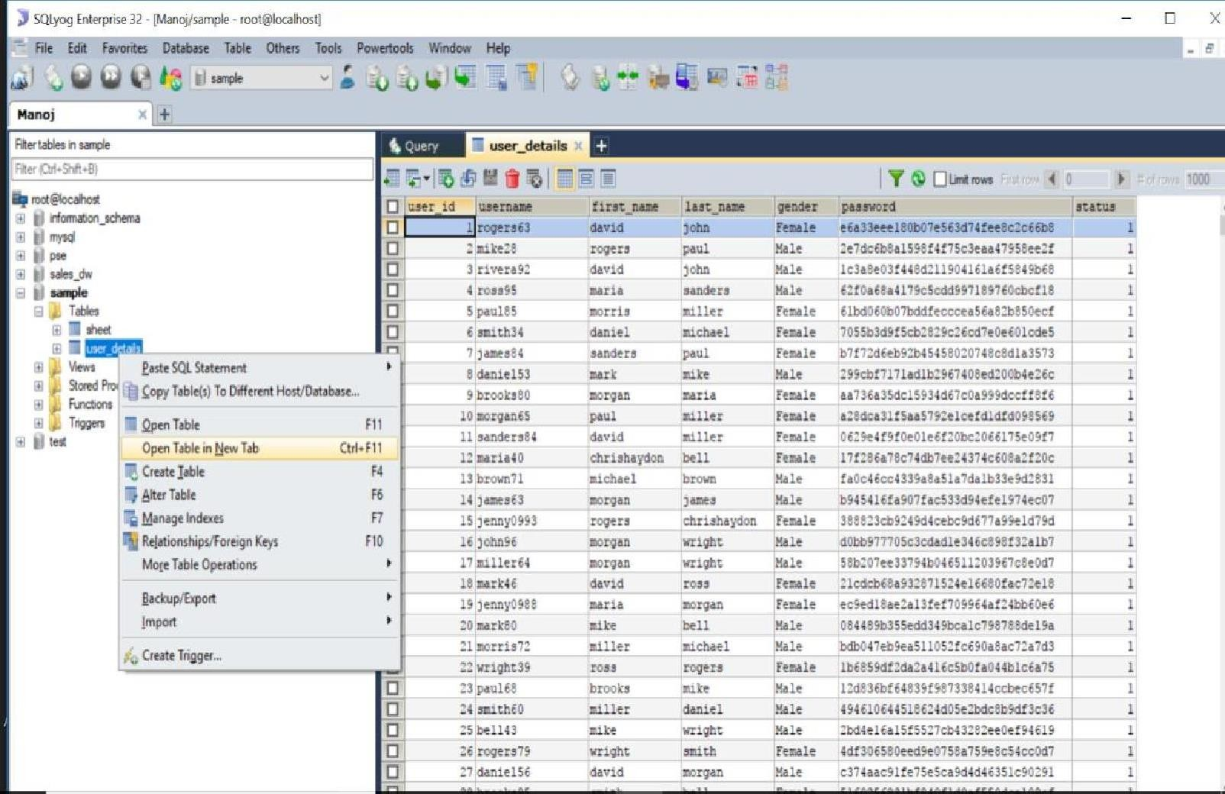

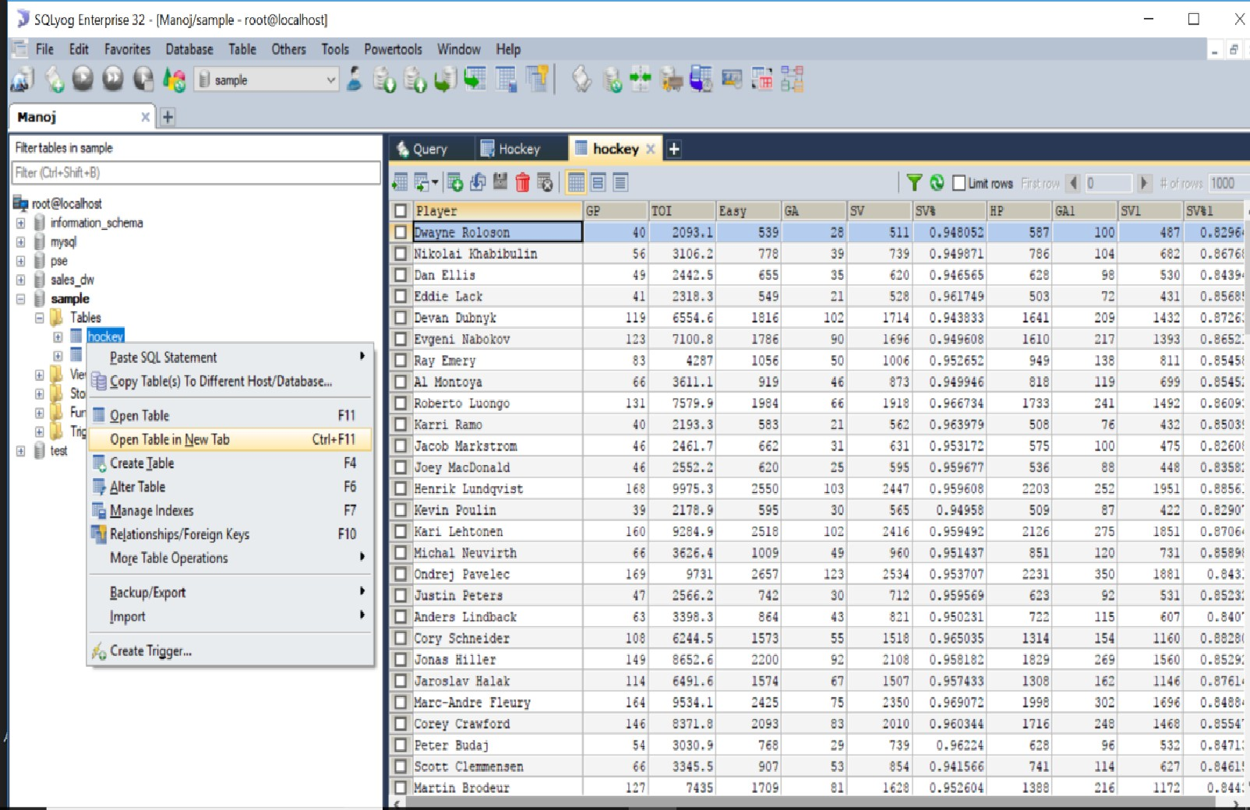

Through MySQL administrator & SQLyog, we can import databases from other sources (.XLS, .CSV, .sql) & also we can export our databases as backup for further processing. We can connect MySQL to other applications for data analysis & reporting.

Design multi-dimensional data models namely Star, snowflake and Fact constellation schemas for any one enterprise (ex. Banking, Insurance, Finance, Healthcare, Manufacturing, Automobile, etc.).

Multi-Dimensional model was developed for implementing data warehouses & it provides both a mechanism to store data and a way for business analysis. The primary components of dimensional model are dimensions & facts. There are different of types of multi-dimensional data models. They are:
1. Star Schema Model 2. Snow Flake Schema Model 3. Fact Constellation Model.

Now, we are going to design these multi-dimensional models for the Marketing enterprise.
First, we need to built the tables in a database through SQLyog as shown below.

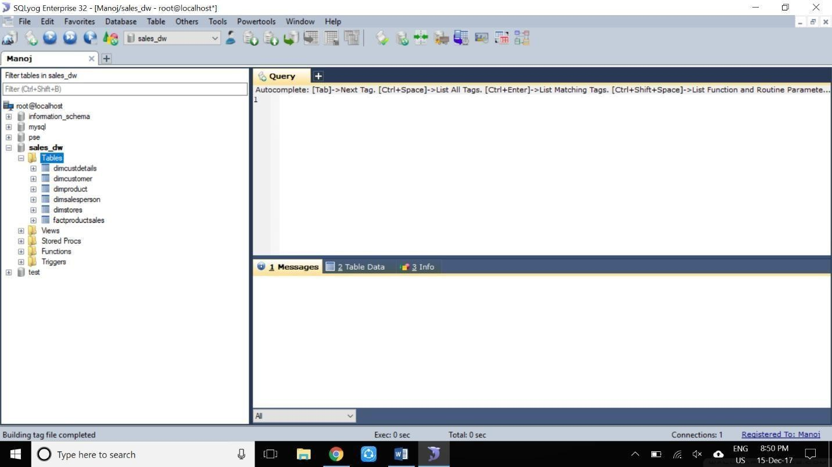

In the above window, left side navigation bar consists of a database named as
―sales_dw‖ in which there are six different tables (dimcustdetails, dimcustomer, dimproduct, dimsalesperson, dimstores, factproductsales) has been created.

After creating tables in database, here we are going to use a tool called as “Microsoft Visual Studio 2012 for Business Intelligence” for building multi-dimensional models.

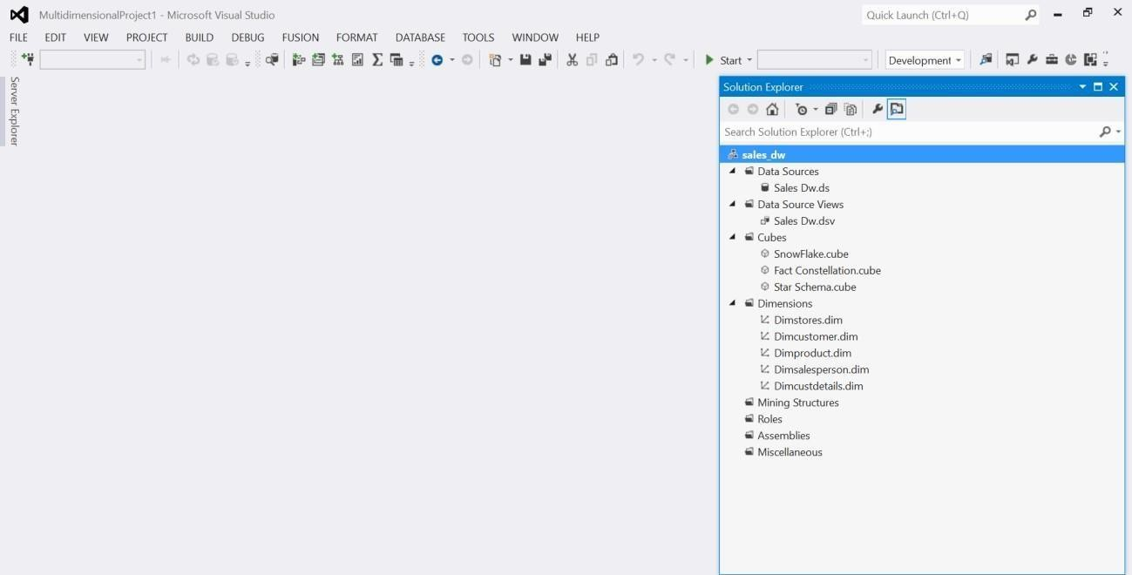

In the above window, we are seeing Microsoft Visual Studio before creating a project In which right side navigation bar contains different options like Data Sources, Data Source Views, Cubes, Dimensions etc.

Through Data Sources, we can connect to our MySQL database named as “sales_dw”. Then, automatically all the tables in that database will be retrieved to this tool for creating multidimensional models.

By data source views & cubes, we can see our retrieved tables in multi- dimensional models. We need to add dimensions also through dimensions option. In general, Multidimensional models consists of dimension tables & fact tables.

Star Schema Model:

A Star schema model is a join between a fact table and a no. of dimension tables. Each dimensional table are joined to the fact table using primary key to foreign key join but dimensional tables are not joined to each other. It is the simplest style of dataware house schema.

Star schema is a entity relationship diagram of this schema resembles a star with point radiating from central table as we seen in the below implemented window in visual studio.

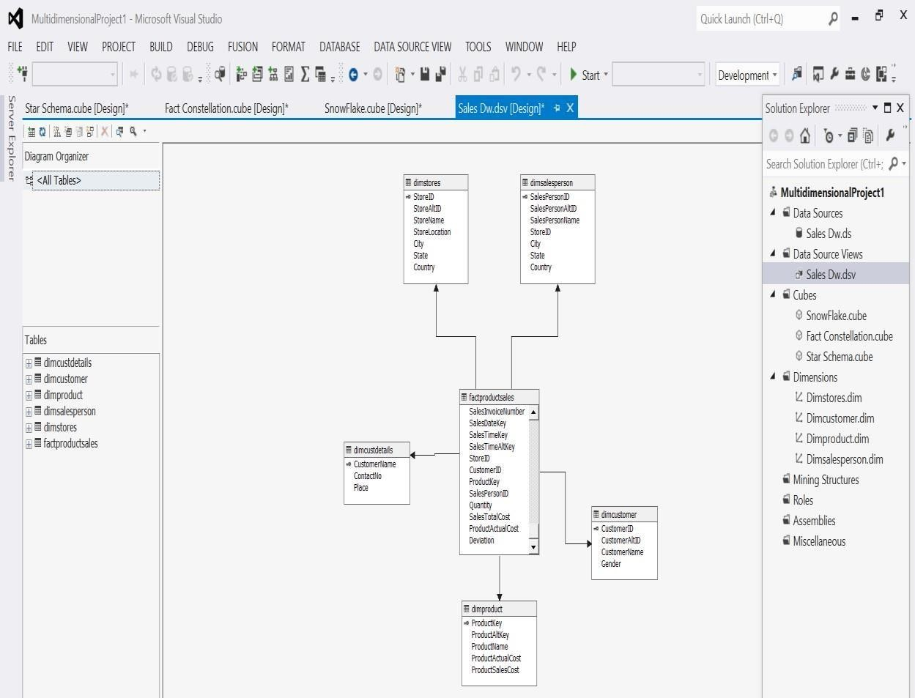

Snow Flake Schema:
It is slightly different from star schema in which dimensional tables from a star schema are organized into a hierarchy by normalizing them.

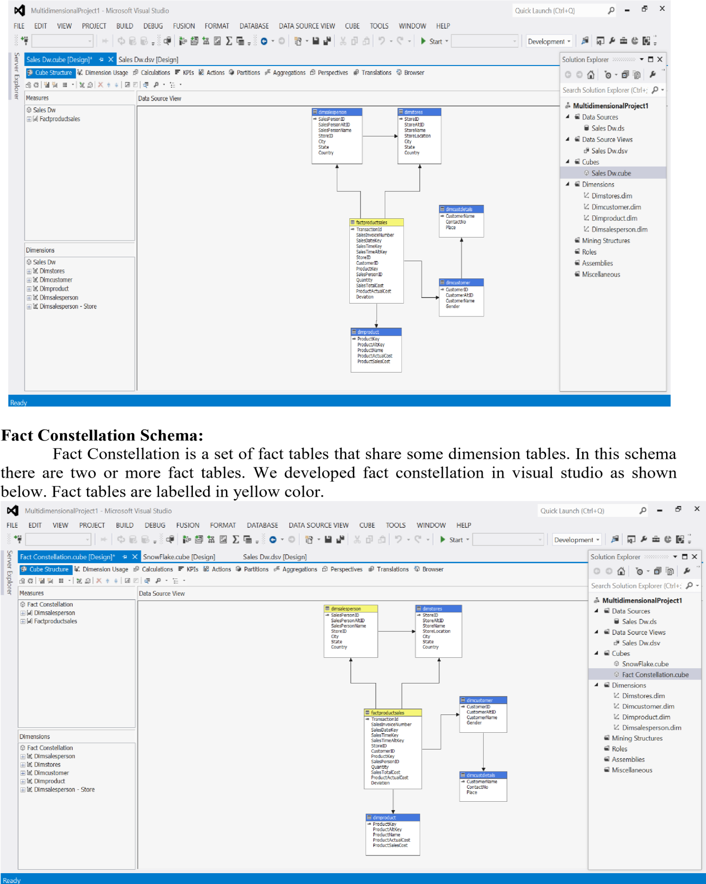
Snow flake schema is represented by centralized fact table which are connected to
multiple dimension tables. Snow flake effects only dimension tables not fact tables. we developed a snowflake schema for sales_dw database by visual studio tool as shown below.

Write ETL scripts and implement using data warehouse tools

ETL (Extract-Transform-Load):
ETL comes from Data Warehousing and stands for Extract-Transform-Load. ETL covers a process of how the data are loaded from the source system to the data warehouse.
Currently, the ETL encompasses a cleaning step as a separate step. The sequence is then Extract-CleanTransform-Load. Let us briefly describe each step of the ETL process.

Process Extract:
The Extract step covers the data extraction from the source system and makes it accessible for further processing. The main objective of the extract step is to retrieve all the required data from the source system with as little resources as possible. The extract step should be designed in a way that it does not negatively affect the source system in terms or performance, response time or any kind of locking.
There are several ways to perform the extract:
- Update notification - if the source system is able to provide a notification that a record has been changed and describe the change, this is the easiest way to get the data.
- Incremental extract - some systems may not be able to provide notification that an update has occurred, but they are able to identify which records have been modified and provide an extract of such records. During further ETL steps, the system needs to identify changes and propagate it down. Note, that by using daily extract, we may not be able to handle deleted records properly.
- Full extract - some systems are not able to identify which data has been changed at all, so a full extract is the only way one can get the data out of the system. The full extract requires keeping a copy of the last extract in the same format in order to be able to identify changes. Full extract handles deletions as well.
When using Incremental or Full extracts, the extract frequency is extremely important. Particularly for full extracts; the data volumes can be in tens of gigabytes.

Clean:
The cleaning step is one of the most important as it ensures the quality of the data in the data warehouse. Cleaning should perform basic data unification rules, such as:
- Making identifiers unique (sex categories Male/Female/Unknown, M/F/null, Man/Woman/Not Available are translated to standard Male/Female/Unknown)
- Convert null values into standardized Not Available/Not Provided value
- Convert phone numbers, ZIP codes to a standardized form
- Validate address fields, convert them into proper naming, e.g. Street/St/St./Str./Str
- Validate address fields against each other (State/Country, City/State, City/ZIP code, City/Street).

Transform:
The transform step applies a set of rules to transform the data from the source to the target. This includes converting any measured data to the same dimension (i.e. conformed dimension) using the same units so that they can later be joined. The transformation step also requires joining data from several sources, generating aggregates, generating surrogate keys, sorting, deriving new calculated values, and applying advanced validation rules.

Load:
During the load step, it is necessary to ensure that the load is performed correctly and with as little resources as possible. The target of the Load process is often a database. In order to make the load process efficient, it is helpful to disable any constraints and indexes before the load and enable them back only after the load completes. The referential integrity needs to be maintained by ETL tool to ensure consistency.
Managing ETL Process:
The ETL process seems quite straight forward. As with every application, there is a possibility that the ETL process fails. This can be caused by missing extracts from one of the systems, missing values in one of the reference tables, or simply a connection or power outage. Therefore, it is necessary to design the ETL process keeping fail-recovery in mind.

Staging:
It should be possible to restart, at least, some of the phases independently from the others. For example, if the transformation step fails, it should not be necessary to restart the Extract step. We can ensure this by implementing proper staging. Staging means that the data is simply dumped to the location (called the Staging Area) so that it can then be read by the next processing phase. The staging area is also used during ETL process to store intermediate results of processing. This is ok for the ETL process which uses for this purpose. However, tThe staging area should is be accessed by the load ETL process only. It should never be available to anyone else; particularly not to end users as it is not intended for data presentation to the end-user.may contain incomplete or in-the-middle- of-the-processing data.

ETL Tool Implementation:
When you are about to use an ETL tool, there is a fundamental decision to be made: will the company build its own data transformation tool or will it use an existing tool?
Building your own data transformation tool (usually a set of shell scripts) is the preferred approach for a small number of data sources which reside in storage of the same type.
The reason for that is the effort to implement the necessary transformation is little due to similar data structure and common system architecture. Also, this approach saves licensing cost and there is no need to train the staff in a new tool. This approach,

however, is dangerous from the TOC point of view. If the transformations become more sophisticated during the time or there is a need to integrate other systems, the complexity of such an ETL system grows but the manageability drops significantly. Similarly, the implementation of your own tool often resembles re-inventing the wheel.
There are many ready-to-use ETL tools on the market. The main benefit of using off-the- shelf ETL tools is the fact that they are optimized for the ETL process by providing connectors to common data sources like databases, flat files, mainframe systems, xml, etc. They provide a means to implement data transformations easily and consistently across various data sources. This includes filtering, reformatting, sorting, joining, merging, aggregation and other operations ready to use. The tools also support transformation scheduling, version control, monitoring and unified metadata management. Some of the ETL tools are even integrated with BI tools.

Some of the Well Known ETL Tools:
The most well-known commercial tools are Ab Initio, IBM InfoSphere DataStage, Informatica, Oracle Data Integrator, and SAP Data
Integrator. There are several open source ETL tools are
OpenRefine, Apatar, CloverETL, Pentaho and Talend.

In these above tools, we are going to use OpenRefine 2.8 ETL toolto different sample datasets forextracting, data cleaning, transforming & loading.

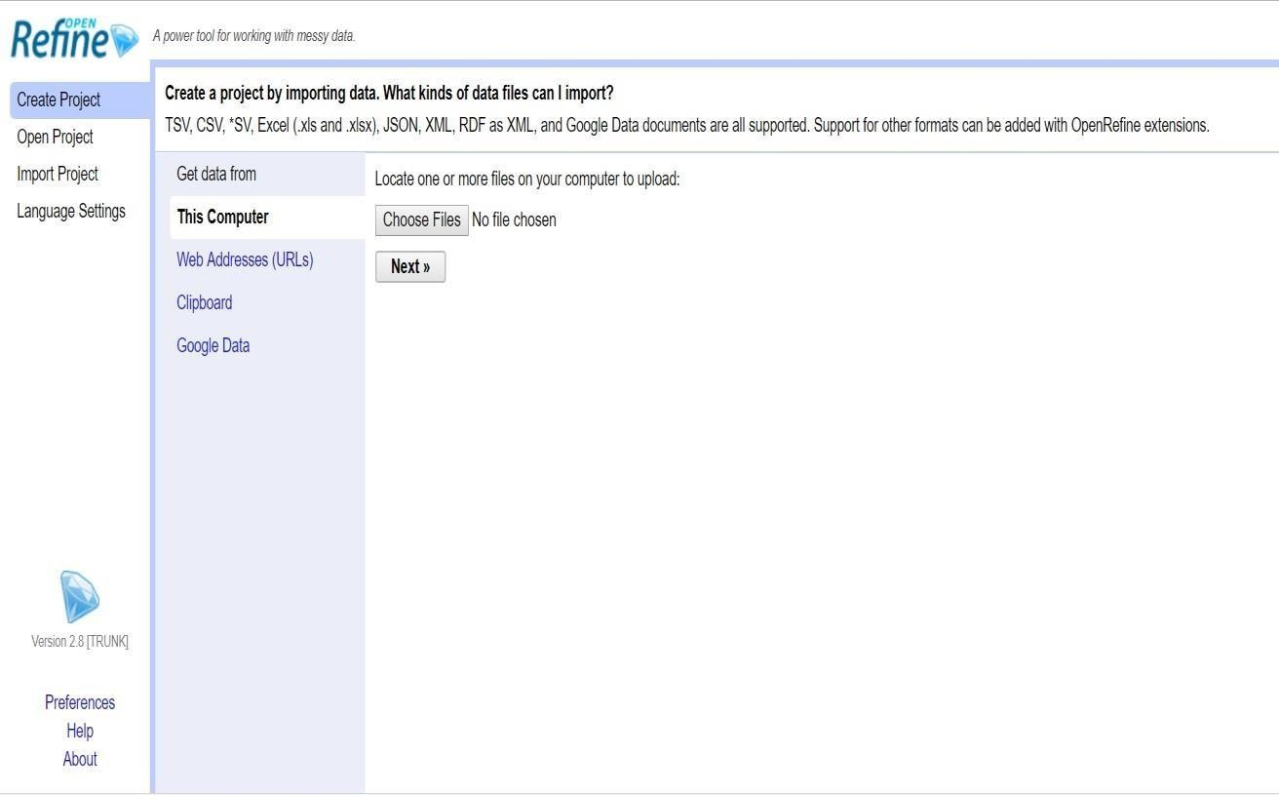

Perform various OLAP operations such slice, dice, roll up, drill down and pivot.
OLAP Operations:
Since OLAP servers are based on multidimensional view of data, we will discuss OLAP operations in multidimensional data.
Here is the list of OLAP operations
  - Roll-up (Drill-up)
  - Drill-down
  - Slice and dice
  - Pivot (rotate)
Roll-up (Drill-up):
Roll-up performs aggregation on a data cube in any of the following ways
  - By climbing up a concept hierarchy for a dimension
  - By dimension reduction
  - Roll-up is performed by climbing up a concept hierarchy for the dimension location.
  - Initially the concept hierarchy was "street < city < province < country".
  - On rolling up, the data is aggregated by ascending the location hierarchy from the level of city to the level of country.
  - The data is grouped into cities rather than countries.
  - When roll-up is performed, one or more dimensions from the data cube are removed.
Drill-down:
Drill-down is the reverse operation of roll-up. It is performed by either of the following ways By stepping down a concept hierarchy for a dimension
By introducing a new dimension.
  - Drill-down is performed by stepping down a concept hierarchy for the dimension time.
  - Initially the concept hierarchy was "day < month < quarter < year."
  - On drilling down, the time dimension is descended from the level of quarter to the level of month.
  - When drill-down is performed, one or more dimensions from the data cube are added. It navigates the data from less detailed data to highly detailed data.
Slice:
The slice operation selects one particular dimension from a given cube and
provides a new sub-cube.
Dice:
Dice selects two or more dimensions from a given cube and provides a new sub- cube.
Pivot (rotate):
The pivot operation is also known as rotation. It rotates the data axes in view in order to provide an alternative presentation of data.
Now, we are practically implementing all these OLAP Operations using Microsoft

Excel.

Procedure for OLAP Operations:

- Open Microsoft Excel, go toData tab in top & click on ―Existing Connections”.
- Existing Connections window will be opened, there “Browse for more”option should be clicked for importing .cub extension file for performing OLAP Operations. For sample, I took music.cub file.
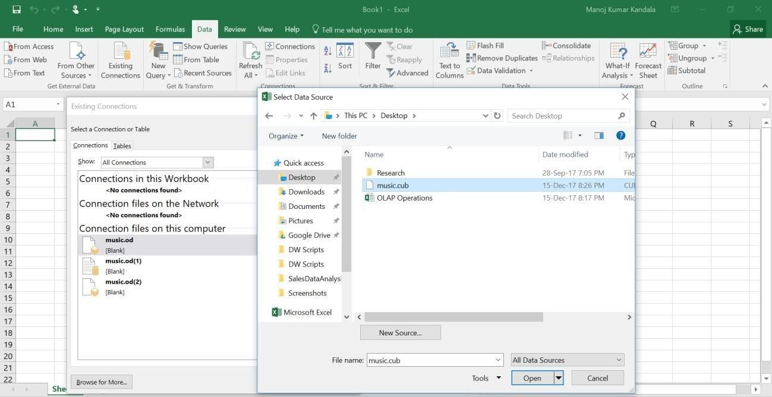
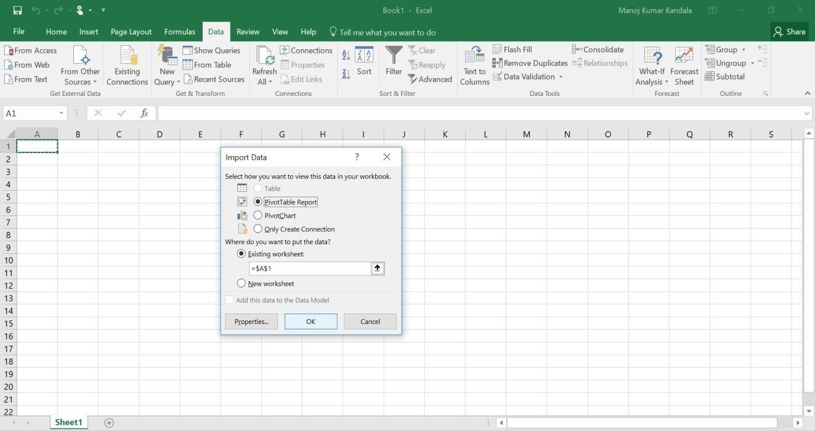

- As shown in above window, select ―PivotTable Report” and click “OK”.
- We got all the music.cub data for analyzing different OLAP Operations.Firstly, we performed drill-down operation as shown below.

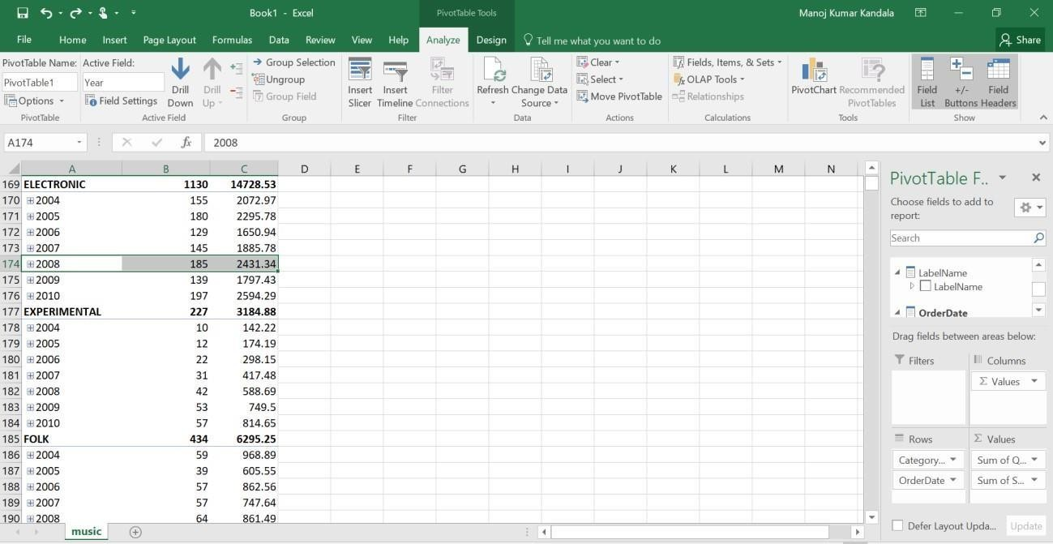

In the above window, we selected year „2008‟ in „Electronic‟ Category, then automatically the Drill-Down option is enabled on top navigation options. We will click on
„Drill-Down‟ option, then the below window will be displayed.

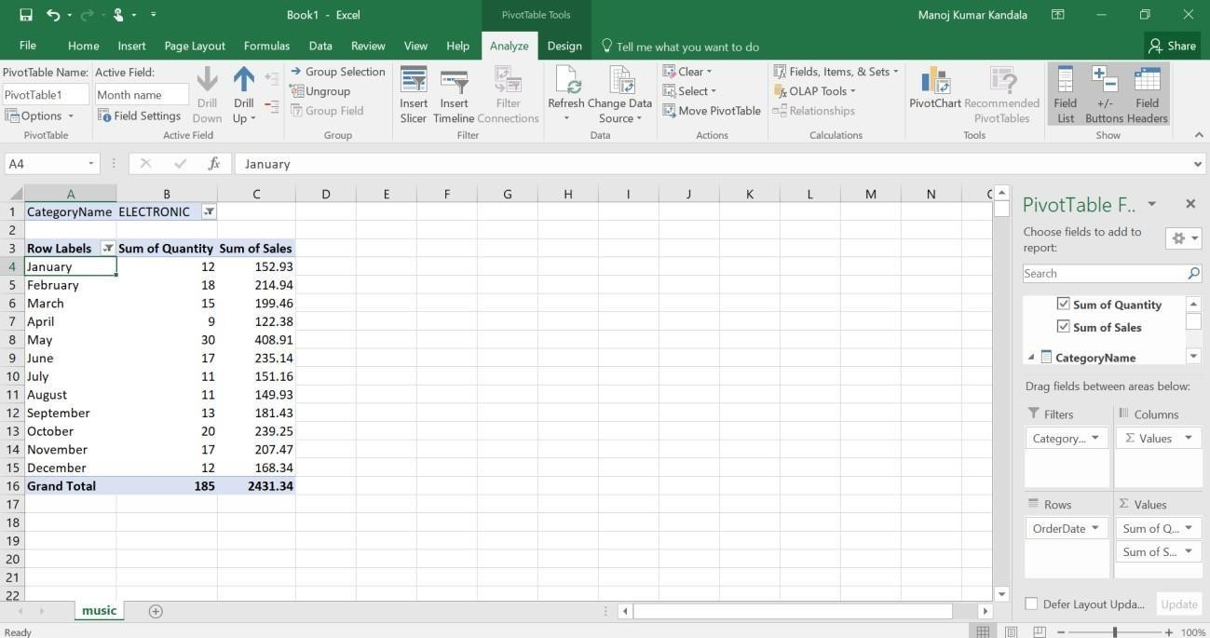

- Now we are going to perform roll-up (drill-up) operation, in the above window I selected January month then automatically Drill-up option is enabled on top. We will click on Drill-up option, then the below window will be displayed.

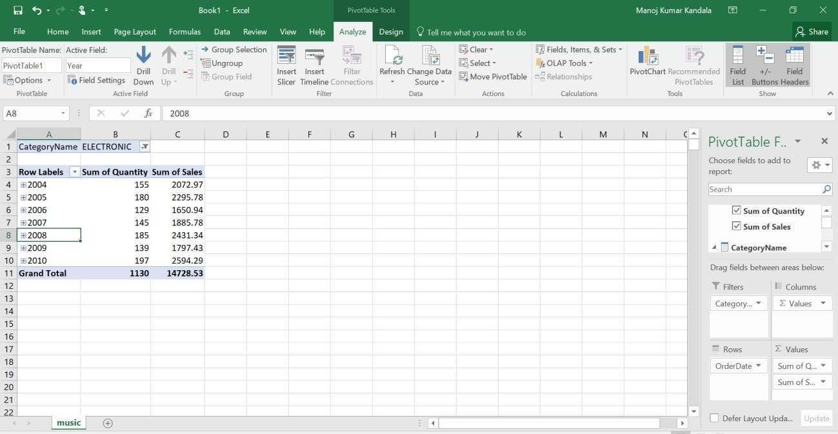
- Next OLAP operation Slicing is performed by inserting slicer as shown in top navigation options.
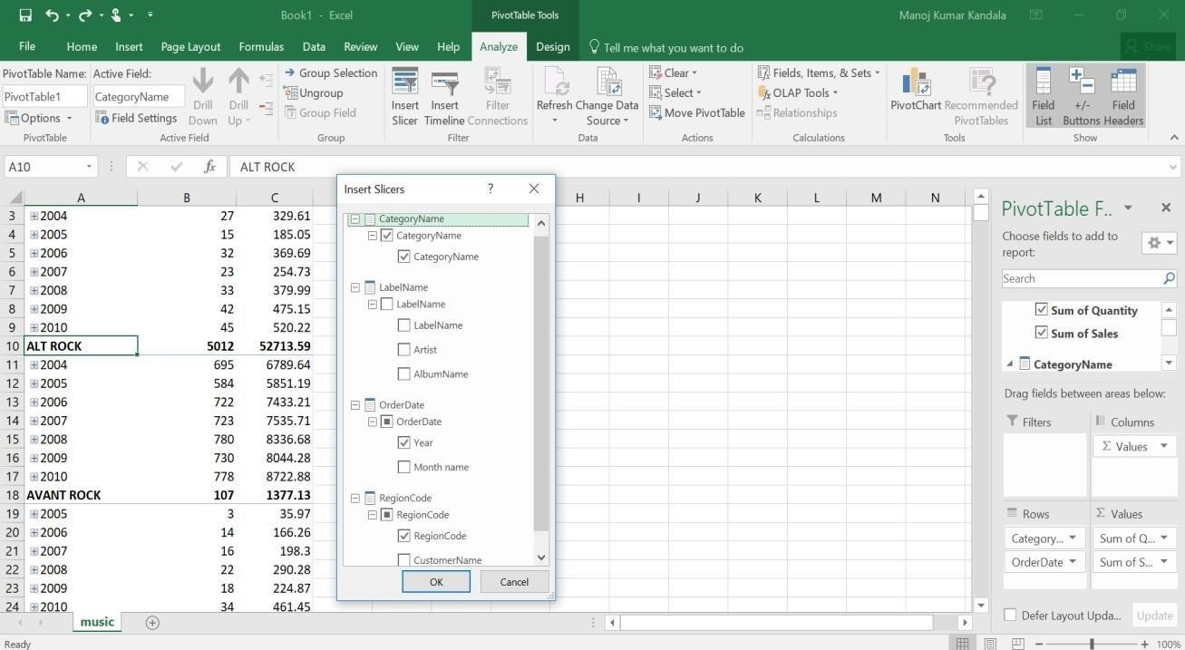

While inserting slicers for slicing operation, we select 2 Dimensions (for e.g. CategoryName & Year) only with one Measure (for e.g. Sum of sales).After inserting a slice& adding a filter (CategoryName: AVANT ROCK & BIG BAND; Year: 2009 & 2010), we will get table as shown below.

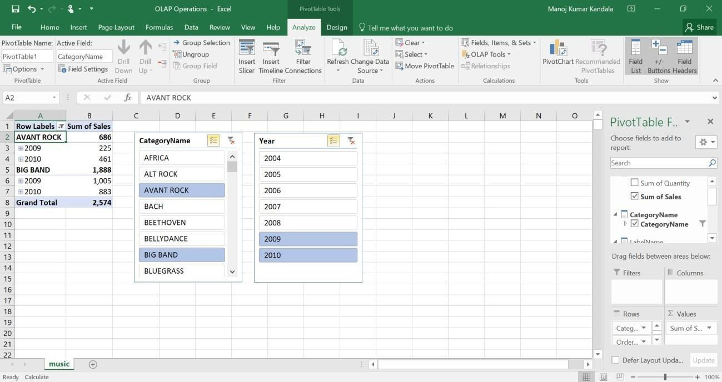

- Dicing operation is similar to Slicing operation. Here we are selecting 3 dimensions (CategoryName, Year, RegionCode)& 2 Measures (Sum of Quantity, Sum of Sales) through
„insert slicer‟ option. After that adding a filter for CategoryName, Year & RegionCode as shown below.

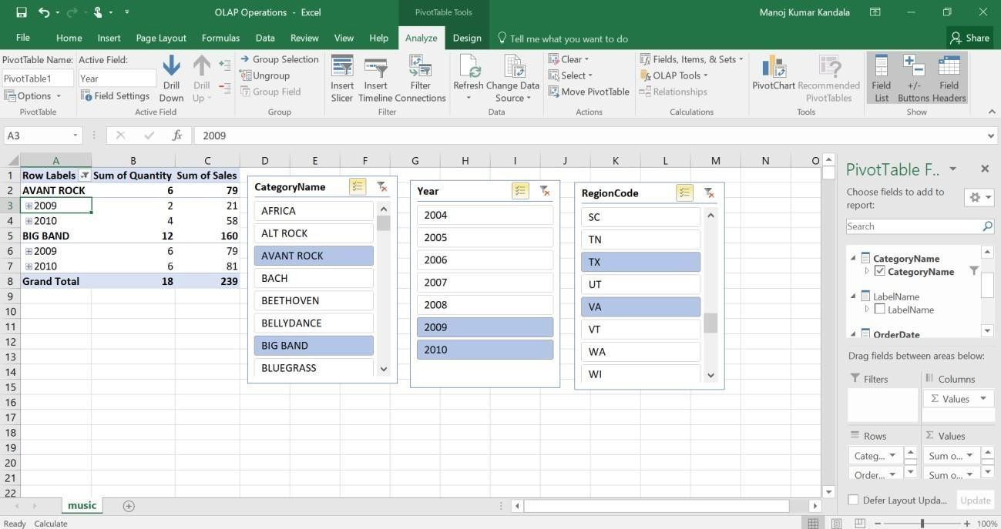

- Finally, the Pivot (rotate) OLAP operation is performed by swapping rows (Order Date-Year) & columns (Values-Sum of Quantity & Sum of Sales) through right side bottom navigation bar as shown below.
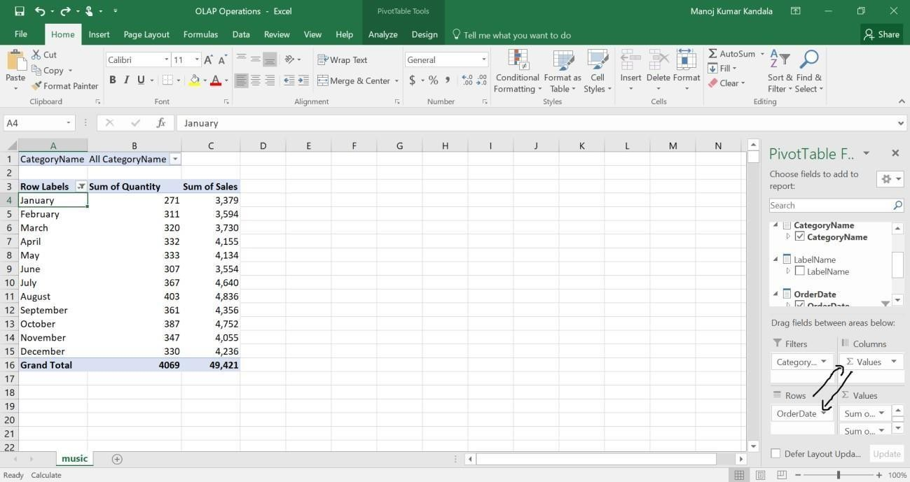
After Swapping (rotating), we will get resultant as represented below with a pie-chart for Category-Classical& Year Wise data.
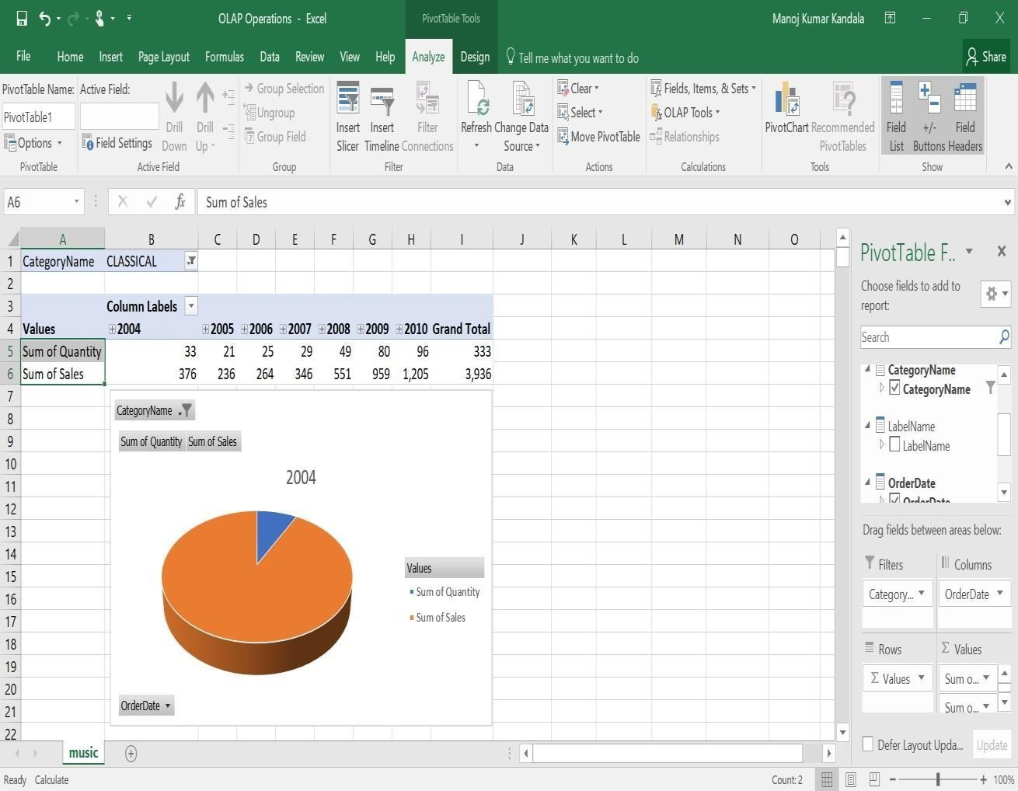

- Explore visualization features of the tool for analysis like identifying trends etc. There are different visualization features for analyzing the data for trend analysisin data warehouses. Some of the popular visualizations are:
- Column Charts
- Line Charts
- Pie Chart
- Bar Graphs
- Area Graphs
- X & Y Scatter Graphs
- Stock Graphs
- Surface Charts
- Radar Graphs
- Treemap
- Sunburst
- Histogram
- Box & Whisker
- Waterfall
- Combo Graphs
- Geo Map
- Heat Grid
- Interactive Report
- Stacked Column
- Stacked Bar
- Scatter Area

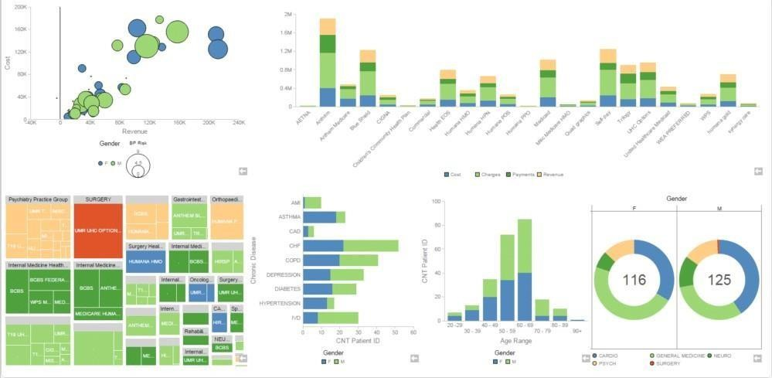

These type of visualizations can be used for analyzing data for trend analysis. Some of the tools for data visualization are Microsoft Excel, Tableau, Pentaho Business Analytics Online etc. Practically different visualization features are tested with different sample datasets.

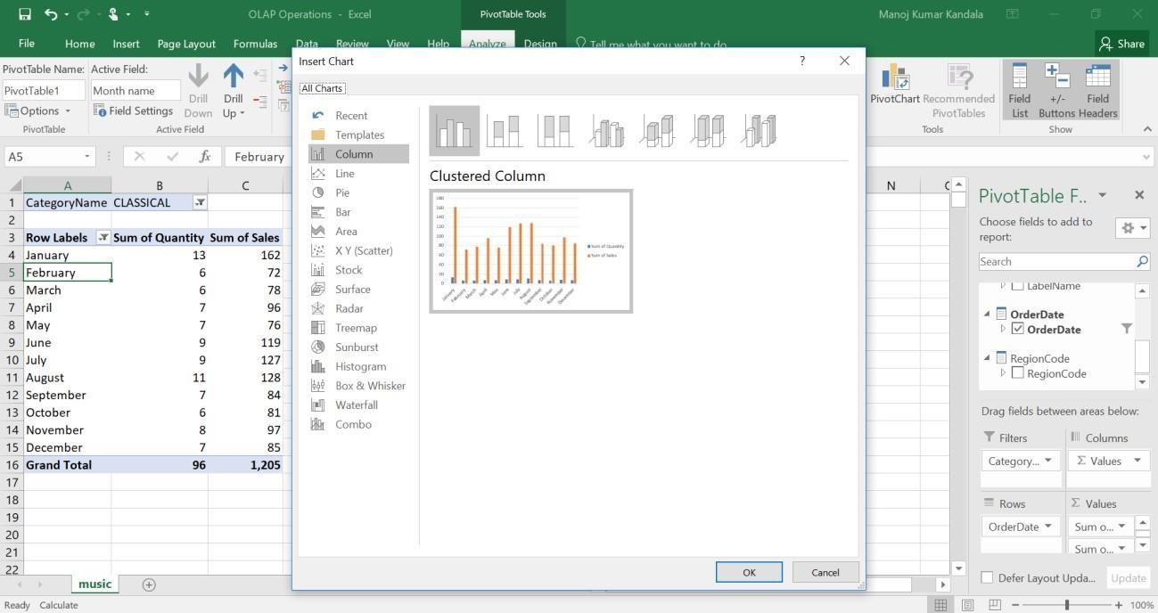

In the below window, we used 3D-Column Charts of Microsoft Excel for analyzing data in data warehouse.

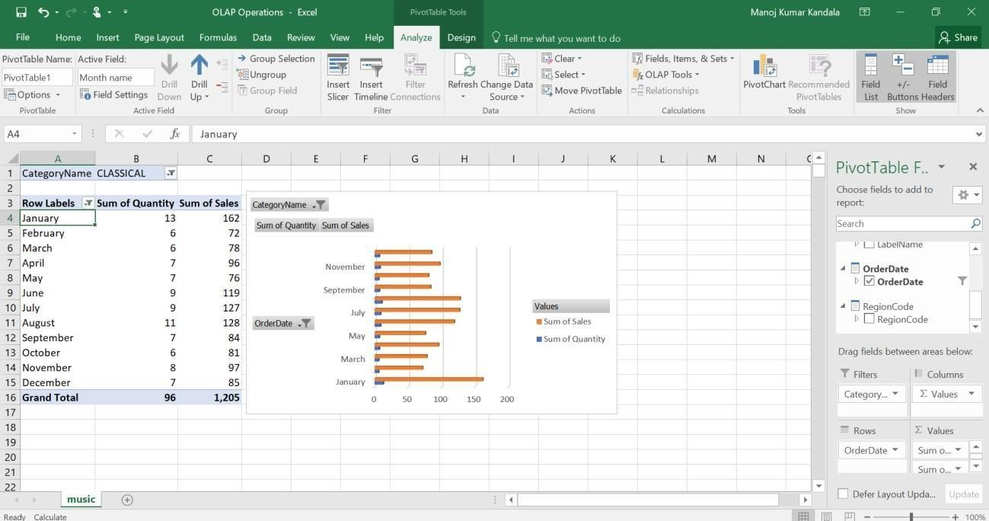

Below window, represents the data visualization through Pentaho Business Analytics tool online (http://www.pentaho.com/hosted-demo) for some sample dataset.

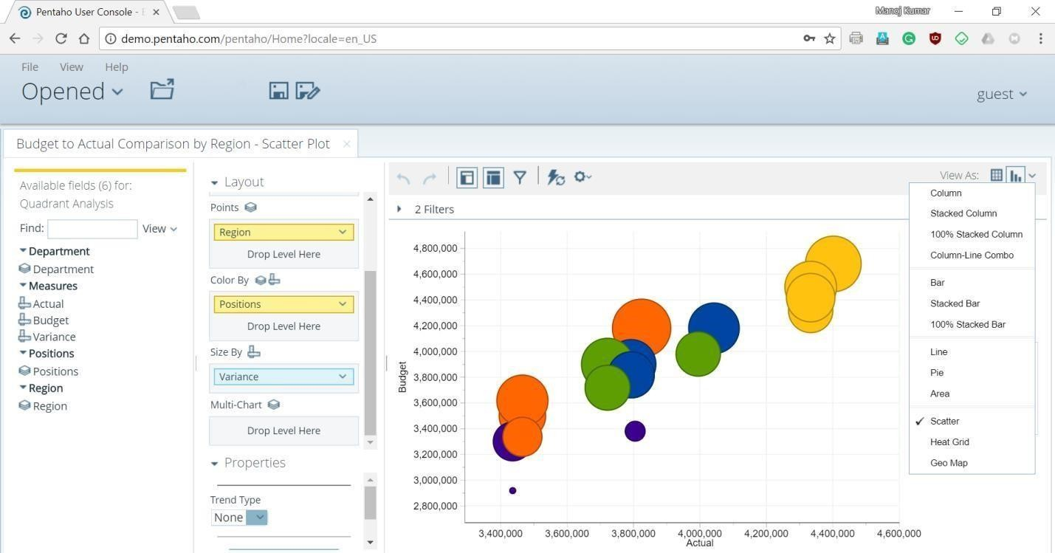

Explore WEKA Data Mining/Machine Learning Toolkit
  - Downloading and/or installation of WEKA data mining toolkit Procedure:
- Go to the Weka website, http://www.cs.waikato.ac.nz/ml/weka/, and download the software. On the left-hand side, click on the link that says download.
- Select the appropriate link corresponding to the version of the software based on your operating system and whether or not you already have Java VM running on your machine (if you don‘t know what Java VM is, then you probably don‘t).
- The link will forward you to a site where you can download the software from a mirror site. Save the self-extracting executable to disk and then double click on it to install Weka. Answer yes or next to the questions during the installation.
- Click yes to accept the Java agreement if necessary. After you install the program Weka should appear on your start menu under Programs (if you are using Windows).
- Running Weka from the start menu select Programs, then Weka.You will see the Weka GUI Chooser. Select Explorer. The Weka Explorer will then launch.

Understand the features of WEKA toolkit such as Explorer, Knowledge Flow interface, Experimenter, command-line interface.

The Weka GUI Chooser (class weka.gui.GUIChooser) provides a starting pointfor launching Weka‘s main GUI applications and supporting tools. If one prefersa MDI (―multiple document interface‖) appearance, then this is provided by analternative launcher called ―Main‖ (class weka.gui.Main).
The GUI Chooser consists of four buttons—one for each of the four majorWeka applications— and four menus.


The buttons can be used to start the following applications:
Explorer- An environment for exploring data with WEKA
- Click on ―explorer‖ button to bring up the explorer window.
- Make sure the ―preprocess‖ tab is highlighted.
- Open a new file by clicking on ―Open New file‖ and choosing a file with ―.arff‖ extension from the ―Data‖ directory.
- Attributes appear in the window below.
- Click on the attributes to see the visualization on the right.
- Click ―visualize all‖ to see them all
Experimenter- An environment for performing experiments and conducting statistical tests between learning schemes.
- Experimenter is for comparing results.
- Under the ―set up‖ tab click ―New‖.
- Click on ―Add New‖ under ―Data‖ frame. Choose a couple of arff format files from ―Data‖ directory one at a time.
- Click on ―Add New‖ under ―Algorithm‖ frame. Choose several algorithms, one at a time by clicking ―OK‖ in the window and ―Add New‖.
- Under the ―Run‖ tab click ―Start‖.
- Wait for WEKA to finish.
- Under ―Analyses‖ tab click on ―Experiment‖ to see results.

Knowledge Flow- This environment supports essentially the same functions as the Explorer but with a drag-and-drop interface. One advantageis that it supports incremental learning.
SimpleCLI - Provides a simple command-line interface that allows directexecution of WEKA commands for operating systems that do not provide their own command line interface.

Navigate the options available in the WEKA (ex. Select attributes panel, Preprocess panel, classify panel, Cluster panel, Associate panel and Visualize panel)

When the Explorer is first started only the first tab is active; the others are greyed out. This is because it is necessary to open (and potentially pre-process) a data set before starting to explore the data.
The tabs are as follows:
- Preprocess. Choose and modify the data being acted on.
- Classify. Train and test learning schemes that classify or perform regression.
- Cluster. Learn clusters for the data.
- Associate. Learn association rules for the data.
- Select attributes. Select the most relevant attributes in the data.
- Visualize. View an interactive 2D plot of the data.
Once the tabs are active, clicking on them flicks between different screens, on which the respective actions can be performed. The bottom area of the window (including the status box, the log button, and the Weka bird) stays visible regardless of which section you are in.

Preprocessing

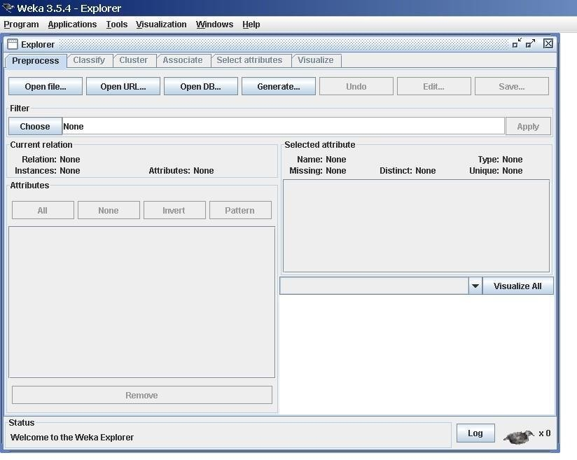

Loading Data:
The first four buttons at the top of the preprocess section enable you to loaddata into WEKA:
  - Open file Brings up a dialog box allowing you to browse for the datafile on the local
file system.
  - Open URL Asks for a Uniform Resource Locator address for wherethe data is stored.
  - Open DB Reads data from a database. (Note that to make this workyou might have to
edit the file in weka/experiment/DatabaseUtils.props.)
  - Generate Enables you to generate artificial data from a variety ofDataGenerators.
Using the Open file button you can read files in a variety of formats:
WEKA‘s ARFF format, CSV format, C4.5 format, or serialized Instances format. ARFF files typically have a .arff extension, CSV files a .csv extension,C4.5 files a .data and
.names extension, and serialized Instances objects a .bsiextension.

Classification:
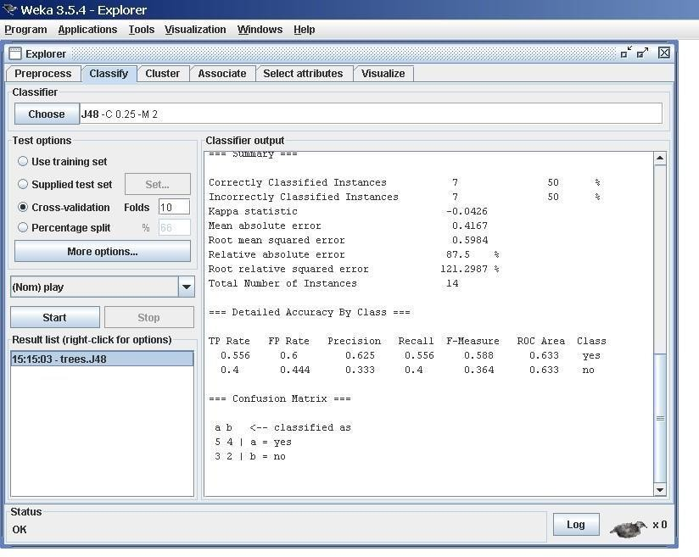

Selecting a Classifier
At the top of the classify section is the Classifier box. This box has a text fieldthat gives the name of the currently selected classifier, and its options. Clickingon the text box with the left mouse button brings up a GenericObjectEditordialog box, just the same as for filters, that you can use to configure the optionsof the current classifier. With a right click (or Alt+Shift+left click) you canonce again copy the setup string to the clipboard or

display the properties in aGenericObjectEditor dialog box. The Choose button allows you to choose on4eof the classifiers that are available in WEKA.

Test Options
The result of applying the chosen classifier will be tested according to the optionsthat are set by clicking in the Test options box. There are four test modes:
- Use training set: The classifier is evaluated on how well it predicts theclass of the instances it was trained on.
- Supplied test set: The classifier is evaluated on how well it predicts theclass of a set of instances loaded from a file. Clicking the Set... buttonbrings up a dialog allowing you to choose the file to test on.
- Cross-validation: The classifier is evaluated by cross-validation, usingthe number of folds that are entered in the Folds text field.
- Percentage split: The classifier is evaluated on how well it predicts acertain percentage of the data which is held out for testing. The amountof data held out depends on the value entered in the % field.

Clustering:
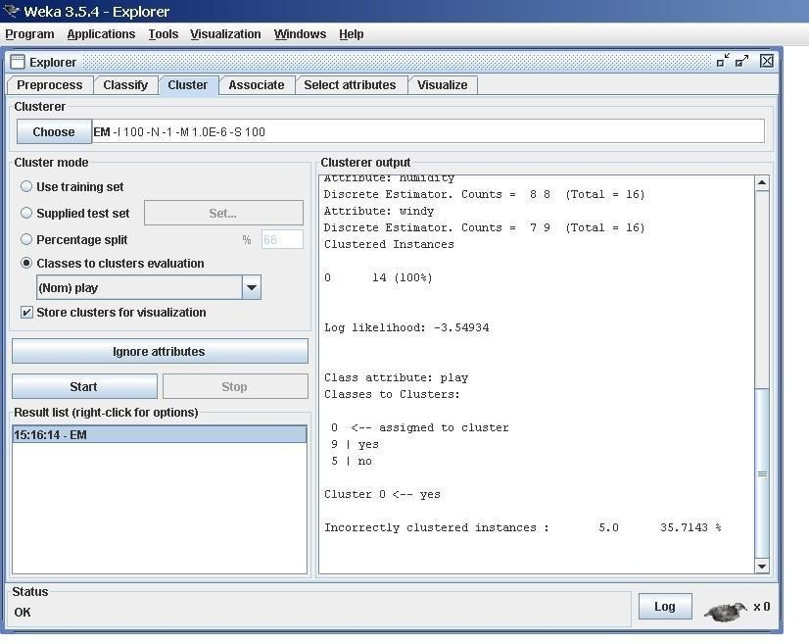

Cluster Modes:
The Cluster mode box is used to choose what to cluster and how to evaluatethe results. The first three options are the same as for classification: Use training set, Supplied test set and Percentage split.

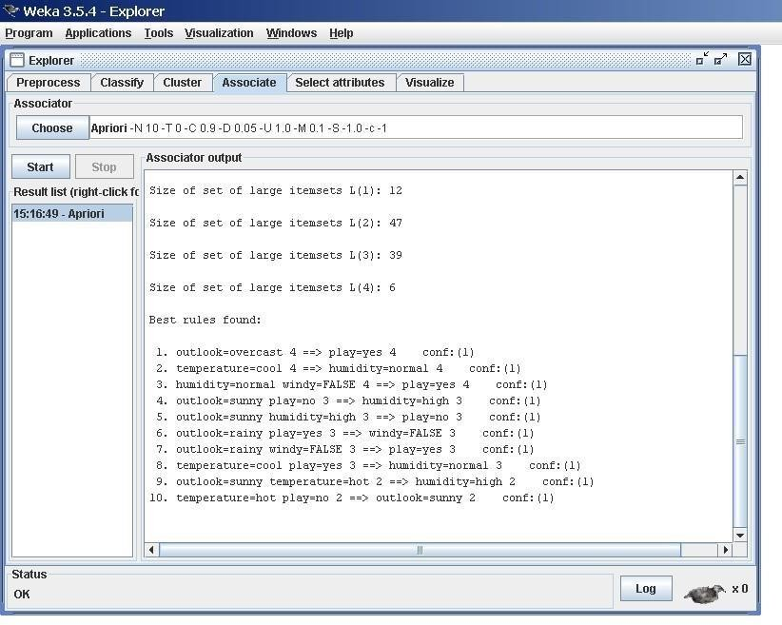
Associating:
Setting Up
This panel contains schemes for learning association rules, and the learners are chosen and configured in the same way as the clusterers, filters, and classifiers in the other panels.

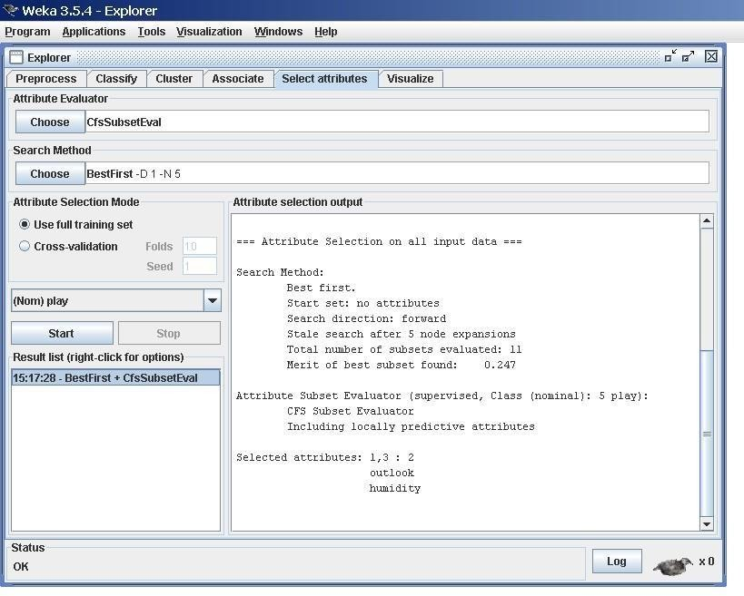
Selecting Attributes:

Searching and Evaluating
Attribute selection involves searching through all possible combinations of attributes in the data to find which subset of attributes works best for prediction. To do this, two

objects must be set up: an attribute evaluator and a searchmethod. The evaluator determines what method is used to assign a worth toeach subset of attributes. The search method determines what style of searchis performed.

Visualizing:
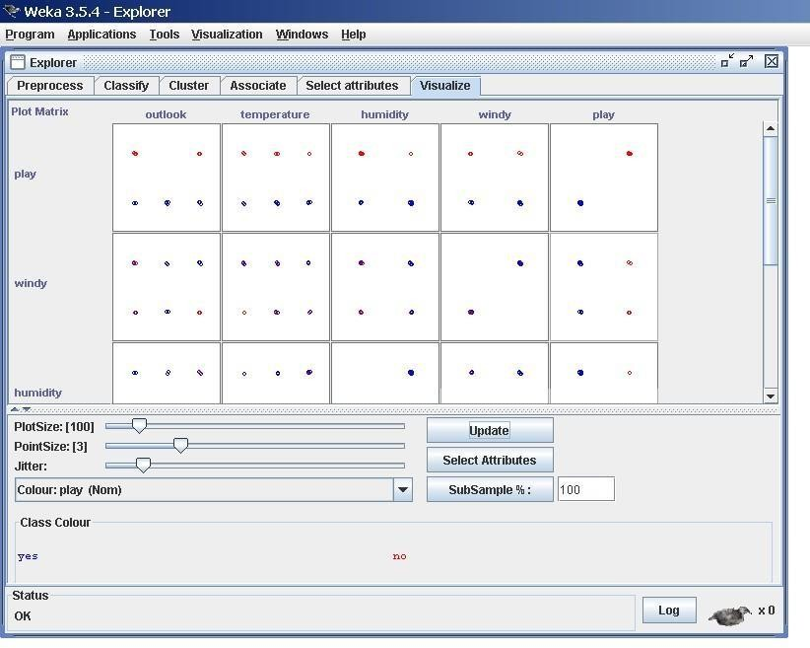
WEKA‘s visualization section allows you to visualize 2D plots of the current relation.

Study the arff file format

An ARFF (Attribute-Relation File Format) file is an ASCII text file that describes a list of instances sharing a set of attributes. ARFF files were developed by the Machine Learning Project at the Department of Computer Science of The University of Waikato for use with the Weka machine learning software.

Overview
ARFF files have two distinct sections. The first section is the Header information, which is followed the Data information.
The Header of the ARFF file contains the name of the relation, a list of the attributes (the columns in the data), and their types. An example header on the standard IRIS dataset looks like this:
% 1. Title: Iris Plants Database

%
% 2. Sources:
% (a) Creator: R.A. Fisher
% (b) Donor: Michael Marshall (MARSHALL%PLU@io.arc.nasa.gov) % (c) Date: July, 1988
%
@RELATION iris
@ATTRIBUTE sepallength NUMERIC @ATTRIBUTE sepalwidth NUMERIC
@ATTRIBUTE petallength NUMERIC @ATTRIBUTE petalwidth NUMERIC
@ATTRIBUTE class {Iris-setosa,Iris-versicolor,Iris-virginica} The Data of the ARFF file looks like the following:
@DATA
5.1,3.5,1.4,0.2,Iris-setosa
4.9,3.0,1.4,0.2,Iris-setosa
4.7,3.2,1.3,0.2,Iris-setosa
4.6,3.1,1.5,0.2,Iris-setosa
5.0,3.6,1.4,0.2,Iris-setosa
5.4,3.9,1.7,0.4,Iris-setosa
4.6,3.4,1.4,0.3,Iris-setosa
5.0,3.4,1.5,0.2,Iris-setosa
4.4,2.9,1.4,0.2,Iris-setosa
4.9,3.1,1.5,0.1,Iris-setosa
Lines that begin with a % are comments.
The @RELATION, @ATTRIBUTE and @DATA declarations are case insensitive.

Explore the available data sets in WEKA

There are 23 different datasets are available in weka (C:\Program Files\Weka-3-6\) by default for testing purpose. All the datasets are available in. arff format. Those datasets are listed below.

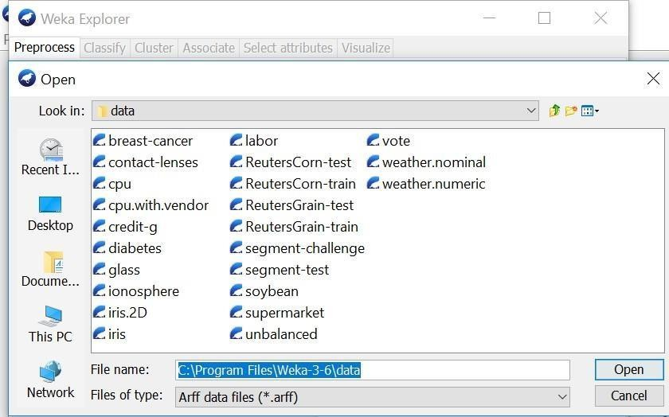

Load a data set (ex. Weather dataset, Iris dataset, etc.) Procedure:
    - Open the weka tool and select the explorer option.
    - New window will be opened which consists of different options (Preprocess, Association etc.) 3. In the preprocess, click the ―open file‖ option.
- Go to C:\Program Files\Weka-3-6\data for finding different existing. arff datasets.
- Click on any dataset for loading the data then the data will be displayed as shown below.
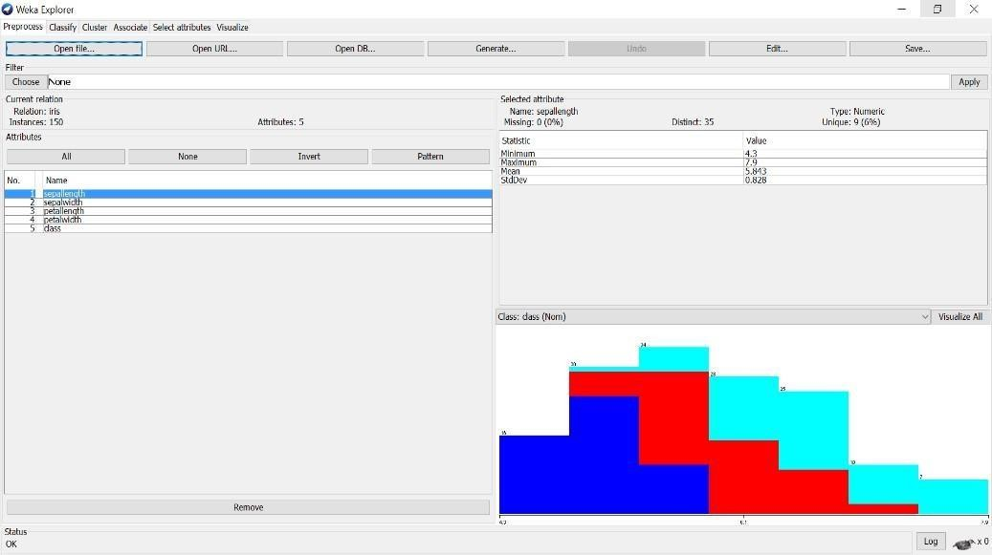

Load each dataset and observe the following:
Here we have taken IRIS.arff dataset as sample for observing all the below things.

List the attribute names and they types
There are 5 attributes& its datatype present in the above loaded dataset (IRIS.arff) sepallength – Numeric sepalwidth – Numeric petallength –
Numeric petallength – Numeric Class – Nominal
- Number of records in each dataset
There are total 150 records (Instances) in dataset (IRIS.arff).

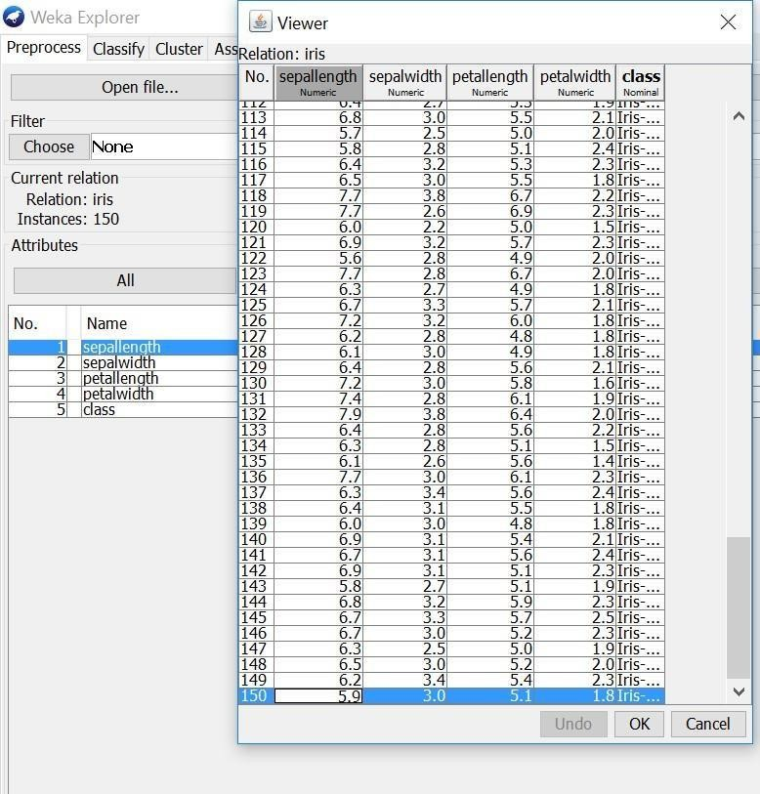

- Identify the class attribute (if any)
There is one class attribute which consists of 3 labels. They
are:
  - Iris-setosa
  - Iris-versicolor
  - Iris-virginica

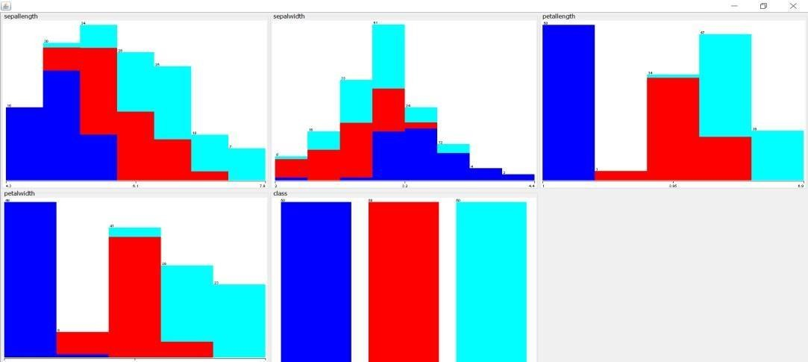
Plot Histogram

- Determine the number of records for each class.

There is one class attribute (150 records) which consists of 3 labels. They are shown below 1. Iris-setosa - 50 records
- Iris-versicolor – 50 records
- Iris-virginica – 50 records

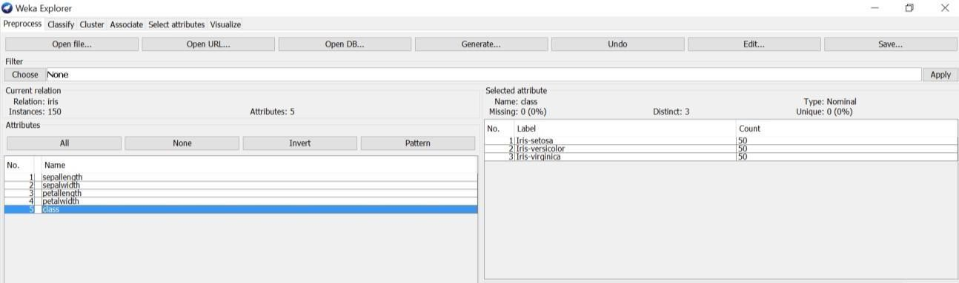

- Visualize the data in various dimensions
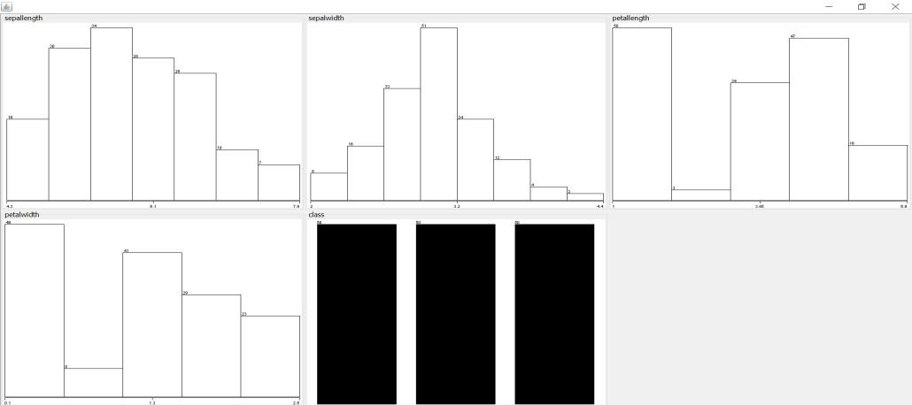
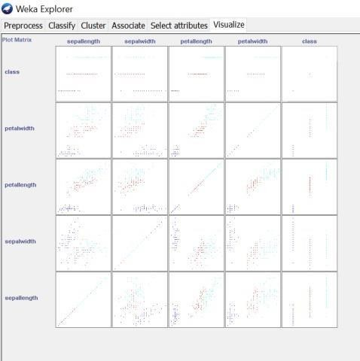

Result :

This program has been successfully executed.

EX.NO: 02 Create an Employee Table with the help of Data Mining Tool WEKA

Aim:
To create an Employee table with the help of Data Mining Tool WEKA

Algorithm:

Step 1: Open WEKA
- Launch WEKA GUI Chooser.
- Click Explorer to open the main data preprocessing and mining interface.

Step 2: Prepare the Employee Data (ARFF or CSV format)

Step 3: Load Data into WEKA
- Open WEKA Explorer.
- Click Open file...
- Select employee.arff or employee.csv file.
- The data will now be displayed under the Preprocess tab.

Step 4: View & Analyze the Table
Once loaded:
- You’ll see a table of attributes on the left.
- Click any attribute to see its statistics (mean, min, max, etc.).
- Use the Visualize All button to view data distribution.

Step 5: (Optional) Apply Data Mining or Clustering
You can now:
- Use the Classify tab to apply classification models (e.g., decision trees).
- Use Cluster tab to perform clustering (e.g., k-means on age/salary).
- Use Associate for association rule mining.
- Use Select attributes to choose important features.

Dataset :
Create a file named employee.arff with the following content:
arff
CopyEdit
@relation employee

@attribute EmployeeID numeric
@attribute Name string
@attribute Age numeric
@attribute Department {HR, Sales, IT, Finance}
@attribute Salary numeric
@attribute ExperienceYears numeric
@attribute Permanent {yes, no}

@data
101, 'Alice', 29, HR, 40000, 5, yes
102, 'Bob', 35, Sales, 55000, 10, yes
103, 'Charlie', 26, IT, 45000, 3, no
104, 'David', 40, Finance, 70000, 15, yes
105, 'Eve', 31, IT, 48000, 6, no

Output:

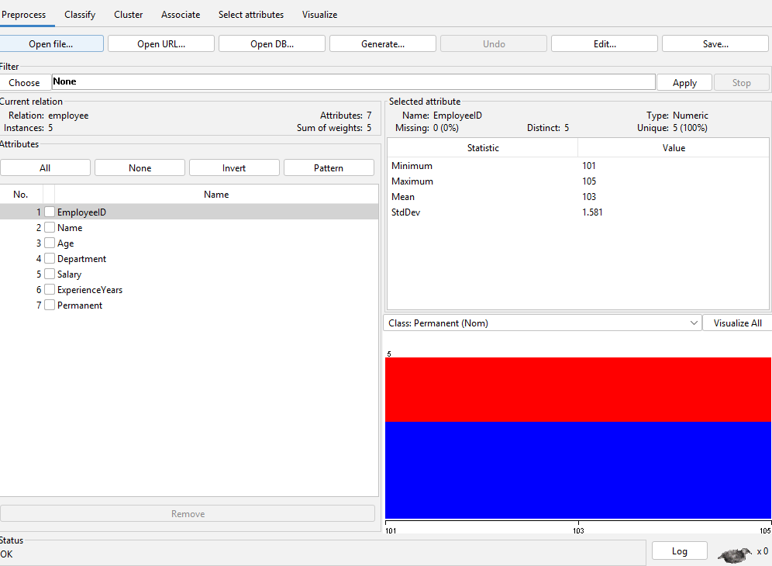

Result:
Thus the employee table with the help of Data Mining Tool WEKA has been implemented successfully.

EX.NO: 03 Create a Weather Table with the help of Data Mining Tool WEKA.

Aim:
To create a Weather Table with the help of Data Mining Tool WEKA.

Algorithm:
Step 1: Prepare the Weather Dataset

Step 2: Open WEKA and Load the Dataset
- Launch WEKA GUI Chooser.
- Click Explorer.
- Click Open File, then select weather.arff or weather.csv.

Step 3: Explore the Weather Table in WEKA
- Under the Preprocess tab, all attributes (columns) will be listed.
- Click on each attribute to see its statistics and distribution.
- Use "Visualize All" to see charts for all attributes.

Step 4: (Optional) Analyze the Weather Data
- You can apply algorithms such as:
- Decision Trees (J48): Go to Classify > Choose > trees > J48
- Clustering: Use Cluster tab with SimpleKMeans
- Association Rules: Use Associate > Apriori
- Feature Selection: Use Select Attributes tab

Step 5: Build a Decision Tree to Predict play
- Click on the Classify tab.
- Choose trees > J48.
- Click Start.
- WEKA will output a decision tree that predicts whether to play based on weather conditions.

Program:
@relation weather

@attribute outlook {sunny, overcast, rainy}
@attribute temperature {hot, mild, cool}
@attribute humidity {high, normal}
@attribute windy {TRUE, FALSE}
@attribute play {yes, no}

@data
sunny, hot, high, FALSE, no
sunny, hot, high, TRUE, no
overcast, hot, high, FALSE, yes
rainy, mild, high, FALSE, yes
rainy, cool, normal, FALSE, yes
rainy, cool, normal, TRUE, no
overcast, cool, normal, TRUE, yes
sunny, mild, high, FALSE, no
sunny, cool, normal, FALSE, yes
rainy, mild, normal, FALSE, yes
sunny, mild, normal, TRUE, yes
overcast, mild, high, TRUE, yes
overcast, hot, normal, FALSE, yes
rainy, mild, high, TRUE, no

Output:

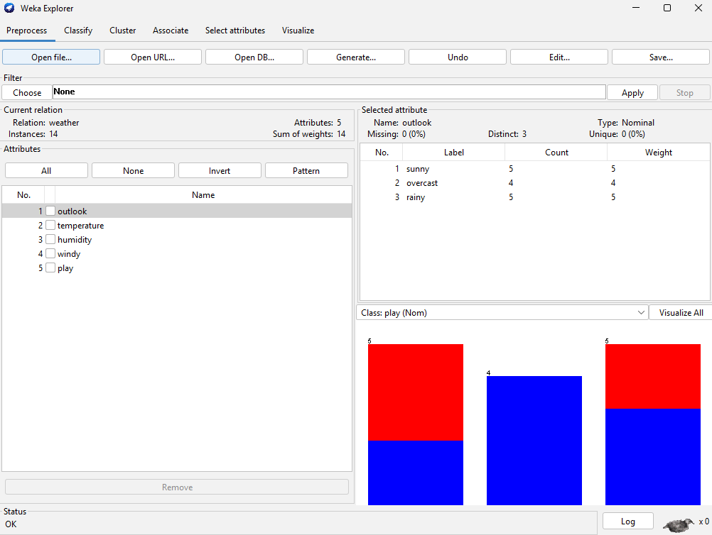

Result:
Thus a Weather Table with the help of Data Mining Tool WEKA has been implemented successfully.

EX.NO: 04 Apply Pre-Processing techniques to the training data set of Weather Table

Aim:
To Apply Pre-Processing techniques to the training data set of Weather Table.

Algorithm:

Step 1: Open the Dataset
- Open WEKA GUI Chooser → Click Explorer.
- Go to the Preprocess tab.
- Click Open File → Load your weather.arff or weather.csv file.

Step 2: View the Raw Dataset
Once loaded, you'll see:
- Attributes list on the left.
- Summary statistics for each attribute.
- Basic charts by clicking on each attribute.

Step 3: Preprocessing Techniques to Apply
Below are common preprocessing techniques you can use in WEKA for the Weather Table:

1. Handling Missing Values
If any values are missing:
Steps:
- Click Choose under Filter > unsupervised > attribute > ReplaceMissingValues.
- Click Apply.
🔸 This will fill missing values based on mean (numeric) or mode (nominal).

2. Discretization (for numeric data)
Convert numeric data into categories (bins):
Steps:
- Click Choose > Filter > unsupervised > attribute > Discretize.
- Click on the filter name to configure (e.g., number of bins = 3).
- Click Apply.
🔸 Useful for converting continuous attributes like temperature or humidity into intervals.

3. Normalize or Standardize (if numeric data exists)
To bring numeric values to a common scale:

Normalize:
- Choose Filter > unsupervised > attribute > Normalize.
Standardize:
- Choose Filter > unsupervised > attribute > Standardize.
🔸 Only applies if your dataset has numeric attributes like temperature in continuous format.

4. Remove Useless Attributes
Remove attributes with little or no variance:
Steps:
- Choose Filter > unsupervised > attribute > RemoveUseless.
- Click Apply.
🔸 This removes constant or near-constant attributes.

5. Reordering or Removing Specific Attributes
To remove specific attributes like Name or ID if present:
Steps:
- Choose Filter > unsupervised > attribute > Remove.
- Click on the filter to select the attribute index to remove (e.g., 1 for the first column).
- Click Apply.

6. Convert Nominal to Binary (One-Hot Encoding)
Convert categories into binary attributes:
Steps:
- Choose Filter > unsupervised > attribute > NominalToBinary.
- Click Apply.
🔸 Turns categorical attributes like outlook into multiple binary attributes.

Example Workflow for the Weather Dataset
- Load weather.arff
- Apply:
  - ReplaceMissingValues
  - NominalToBinary
  - Discretize if temperature/humidity were numeric
- Explore dataset again to confirm changes.

Output:
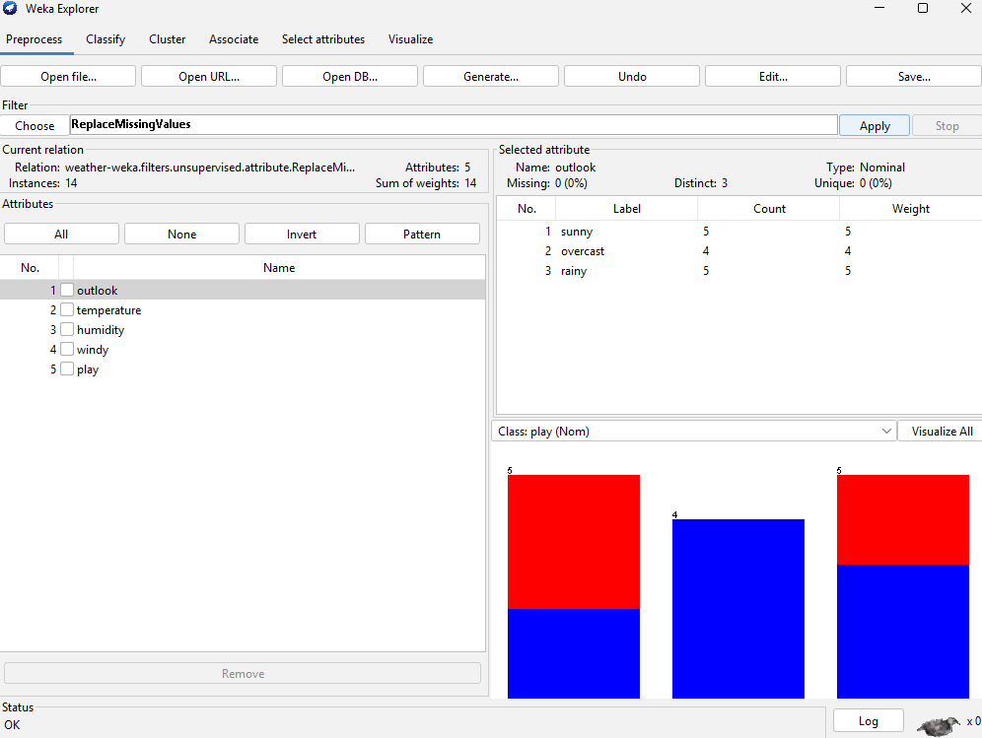

Result:
Thus the Pre-Processing techniques to the training data set of Weather Table has been implemented successfully.

EX.NO: 05 Apply Pre-Processing techniques to the training data set of Employee Table

Aim:
To Apply Pre-Processing techniques to the training data set of Employee Table.

Algorithm:

Step 1: Open the Employee Dataset
- Open WEKA GUI Chooser → Click on Explorer.
- In the Preprocess tab, click Open File.
- Load your employee.arff or employee.csv dataset.

Step 2: Remove Irrelevant or Unique Identifiers
The EmployeeID and Name fields are unique and non-informative for machine learning.
- Click Choose → Filter > unsupervised > attribute > Remove.
- Click the filter name and set attribute indices to 1,2 (for EmployeeID and Name).
- Click Apply.

Step 3: Handle Missing Values (if any)
To automatically fill missing values:
- Choose Filter > unsupervised > attribute > ReplaceMissingValues.
- Click Apply.
🔹 Numeric values are filled with mean, nominal with mode.

Step 4: Discretize Numeric Attributes
Convert continuous variables (like Salary or Age) into categorical bins:
- Choose Filter > unsupervised > attribute > Discretize.
- Set attributes to first-last or specific indices (e.g., 1,2 for Age and Salary).
- Choose number of bins (default is 10; set to 3–5 for small data).
- Click Apply.

Step 5: Normalize or Standardize Numeric Attributes
- Normalize scales values between 0 and 1.
- Standardize centers data with a mean of 0 and standard deviation of 1.
- Choose Filter > unsupervised > attribute > Normalize.
- Click Apply.
- Choose Filter > unsupervised > attribute > Standardize.
- Click Apply.
Use either based on the algorithm to be used:
- Normalize for distance-based models (K-Means, KNN).
- Standardize for models assuming Gaussian distribution (e.g., Logistic Regression).

Step 6: Convert Categorical to Binary (One-Hot Encoding)
Transform attributes like Department and Permanent into binary format:
- Choose Filter > unsupervised > attribute > NominalToBinary.
- Click Apply.
🔹 This helps in algorithms that cannot handle nominal values directly.

Step 7: Remove Useless Attributes
Remove attributes with no variance:
- Choose Filter > unsupervised > attribute > RemoveUseless.
- Click Apply.

Output:
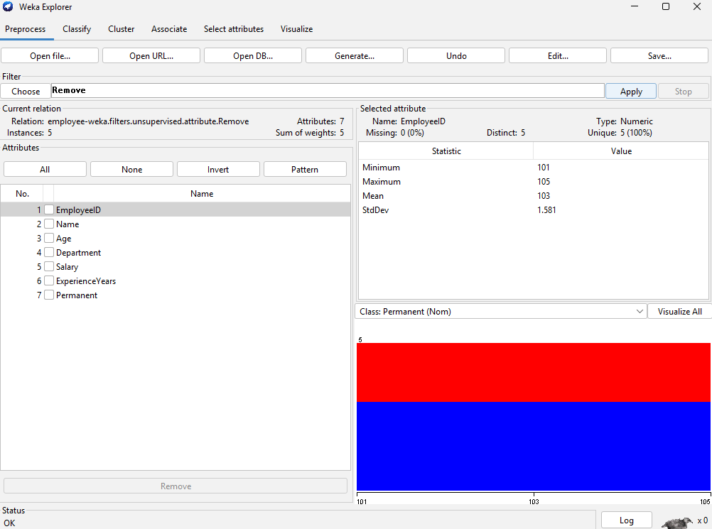

Result:
Thus the Pre-Processing techniques to the training data set of Employee Table has been implemented successfully.

EX.NO: 06 Normalize Weather Table data using Knowledge Flow

Aim:
To Normalize Weather Table data using Knowledge Flow.

Algorithm:

Step 1: Launch Knowledge Flow
- Open WEKA GUI Chooser.
- Click on KnowledgeFlow to open the visual workflow interface.

Step 2: Add Components to the Workspace
From the left-hand panel (under different categories), drag and drop the following components into the canvas:
- ArffLoader
- Location: Data Sources > ArffLoader
- Purpose: Load your weather.arff file.
- Attribute Selection
Location: Filters > Supervised > Attribute Selection
- Normalize
- Location: Filters > UnSupervised > Attribute >Normalize
- Purpose: Apply normalization to numeric attributes.
- Arff Saver
- Location: Data Sinks > ArffSaver
- Purpose: Display the result after normalization.

Step 3: Connect Components
Right-click on each component to create connections:
- Right-click on ArffLoader → Choose "connect" → Normalize
- Right-click on Normalize → Choose "connect" → DataViewer
This defines the data flow:
ArffLoader → Normalize → DataViewer

Step 4: Configure ArffLoader
- Double-click the ArffLoader block.
- Click Browse and select your weather.arff file.
- Click OK.

Step 5: Run the Workflow
- Click the green Start button (▶️) at the top toolbar.
- Once the process completes, double-click the DataViewer block to view the normalized dataset.

Output:
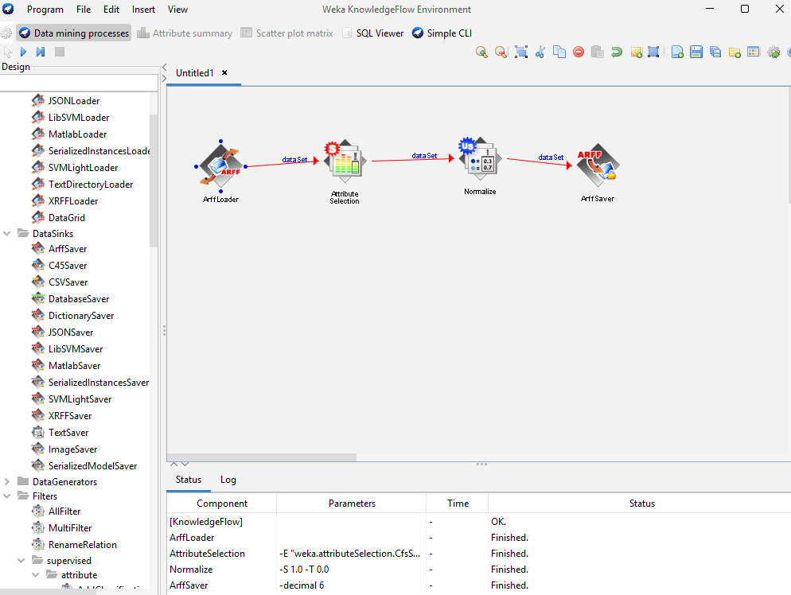

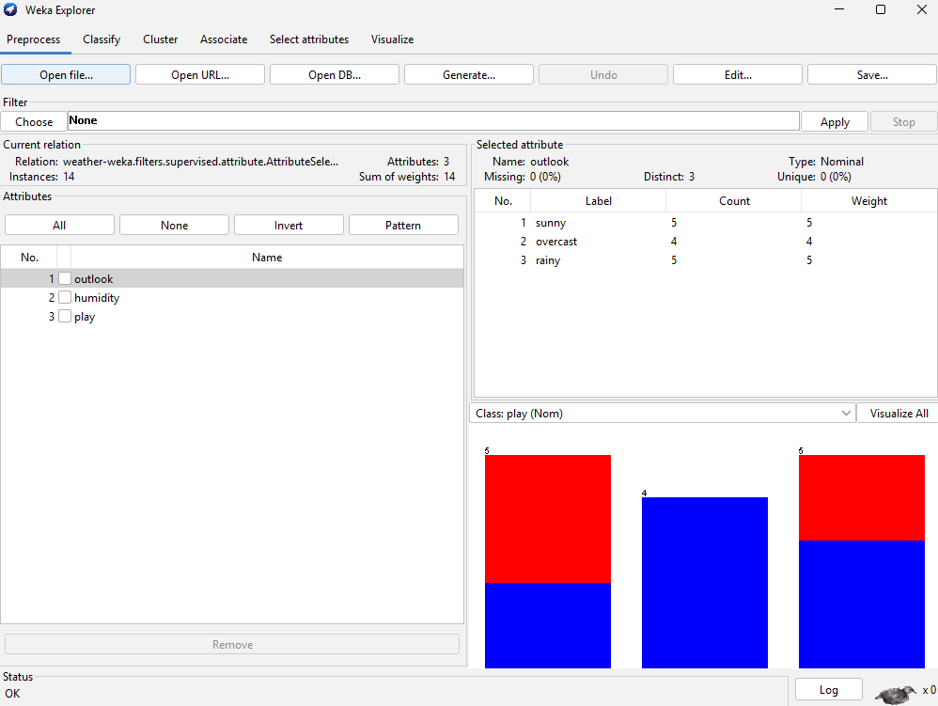

Result:
Thus the Normalization of Weather Table data using Knowledge Flow has been implemented successfully.

EX.NO: 07 Normalize Employee Table data using Knowledge Flow.

Aim:
To normalize employee table data using Knowledge Flow.

Algorithm:

Step 1: Launch Knowledge Flow
- Open WEKA GUI Chooser.
- Click on KnowledgeFlow to open the visual workflow interface.

Step 2: Add Components to the Workspace
From the left-hand panel (under different categories), drag and drop the following components into the canvas:
- ArffLoader
- Location: Data Sources > ArffLoader
- Purpose: Load your weather.arff file.
- Normalize
- Location: Filters > Normalize
- Purpose: Apply normalization to numeric attributes.
- DataViewer
- Location: Data Sinks > DataViewer
- Purpose: Display the result after normalization.

Step 3: Connect Components
Right-click on each component to create connections:
- Right-click on ArffLoader → Choose "connect" → Normalize
- Right-click on Normalize → Choose "connect" → DataViewer
This defines the data flow:
ArffLoader → Normalize → DataViewer

Step 4: Configure ArffLoader
- Double-click the ArffLoader block.
- Click Browse and select your employee.arff file.
- Click OK.

Step 5: Run the Workflow
- Click the green Start button (▶️) at the top toolbar.
- Once the process completes, double-click the DataViewer block to view the normalized dataset.

Output:

Result:
Thus the Normalization of Employee Table data using Knowledge Flow has been implemented successfully.

EX.NO: 08 (a) Finding Association Rules for Buying data.
Aim
To finding association rules for buying data.

Algorithm
Step 1: Prepare the Buying Data

Sample Buying Dataset (buying.arff)
arff
CopyEdit
@relation buying

@attribute bread {t, f}
@attribute butter {t, f}
@attribute milk {t, f}
@attribute cheese {t, f}
@attribute eggs {t, f}

@data
t, t, t, f, t
t, f, t, f, f
t, t, t, t, t
f, t, f, t, t
t, f, f, f, t
f, f, t, f, f

Step 2: Load Dataset into WEKA
- Open WEKA GUI Chooser → Click on Explorer.
- Click Open file... and select buying.arff.
- Dataset will appear in the Preprocess tab.

Step 3: Find Association Rules Using Apriori
- Click the Associate tab at the top.
- In the "Choose" section, select:
  - nginx
  - CopyEdit
  - Associate > Apriori
- Click on Apriori to configure parameters:
  - LowerBoundMinSupport: e.g., 0.3 (30%)
  - MinMetric (confidence): e.g., 0.7 (70%)
  - NumRules: e.g., 10 (how many rules to generate)
- Click Start.

Output:

Result:
Thus the association rules for buying data has been implemented successfully.

EX.NO: 08 (b) Finding Association Rules for Banking data

Aim
To finding association rules for banking data.

Algorithm
Step 1: Prepare the Buying Data

banking.arff

arff

Copy

Edit

@relation banking

@attribute has_account {yes, no}

@attribute has_credit_card {yes, no}

@attribute uses_online_banking {yes, no}

@attribute takes_loan {yes, no}

@attribute has_mobile_app {yes, no}

@data

yes, yes, yes, no, yes

yes, no, yes, no, yes

yes, yes, no, yes, no

no, no, no, no, no

yes, yes, yes, yes, yes

yes, no, no, yes, no

no, yes, no, no, yes

yes, yes, yes, yes, yes

Step 2: Load Dataset into WEKA
- Open WEKA GUI Chooser → Click on Explorer.
- Click Open file... and select buying.arff.
- Dataset will appear in the Preprocess tab.

Step 3: Find Association Rules Using Apriori
- Click the Associate tab at the top.
- In the "Choose" section, select:
  - nginx
  - CopyEdit
  - Associate > Apriori
- Click on Apriori to configure parameters:
  - LowerBoundMinSupport: e.g., 0.3 (30%)
  - MinMetric (confidence): e.g., 0.7 (70%)
  - NumRules: e.g., 10 (how many rules to generate)
- Click Start.

Output:

Result:
Thus the association rules for banking data has been implemented successfully.

EX.NO: 09 Perform data preprocessing tasks and Demonstrate performing association rule mining on data set

Aim
To perform data preprocessing tasks and Demonstrate performing association rule mining on data set.

Algorithm
Step 1: Sample Dataset (shopping.arff)
@relation shopping

@attribute bread {yes, no}
@attribute butter {yes, no}
@attribute milk {yes, no}
@attribute cheese {yes, no}
@attribute eggs {yes, no}

@data
yes, yes, yes, no, yes
yes, no, yes, no, no
yes, yes, yes, yes, yes
no, yes, no, yes, yes
yes, no, no, no, yes
no, no, yes, no, no
yes, yes, no, yes, yes
Step 2: Load Dataset into WEKA
- Launch WEKA GUI Chooser → Click Explorer.
- Click the Preprocess tab.
- Click Open File → Select shopping.arff.
You will now see attributes like bread, butter, milk, etc., with values yes/no.

Step 3: Preprocess the Data

Preprocessing Tasks:

1. Check and Handle Missing Values
- If your dataset had any missing values (?), you’d apply:
  - Filter → unsupervised → attribute → ReplaceMissingValues
But this dataset has no missing values, so this step is skipped here.

2. Convert Nominal to Binary (optional)
- You can use Filter → unsupervised → attribute → NominalToBinary
- But Apriori works well with nominal data (like yes/no), so this is not required here.

3. Remove Useless Attributes
- Apply: Filter → unsupervised → attribute → RemoveUseless
- This removes attributes with no variance (e.g., all values the same).
- In this dataset, all attributes have variance, so again this may not change anything.

4. Ensure Attributes Are Nominal
- Association rule mining requires categorical data.
- You can use Filter → supervised → attribute → Discretize if you had numeric values.

Step 4: Apply Association Rule Mining

Using Apriori in WEKA:
- Go to the Associate tab.
- Click Choose → weka.associations.Apriori
- Click on Apriori to configure:
  - LowerBoundMinSupport: 0.3 (30% minimum support)
  - minMetric: 0.7 (minimum confidence 70%)
  - numRules: 10 (number of rules to generate)
- Click Start

Step 5: Output – Sample Rules
Example result from WEKA (depending on data):
bash
CopyEdit
=== Associator model (full training set) ===

Apriori

Minimum support: 0.3 (2 instances)
Minimum confidence: 0.7

Best rules found:

1. bread=yes butter=yes => milk=yes conf:(0.80) support:(3)
2. milk=yes => bread=yes conf:(0.75) support:(3)
3. cheese=yes => eggs=yes conf:(0.90) support:(3)
4. eggs=yes => bread=yes conf:(0.66) support:(4)

Step 6: Interpret Rules
- Rule 1: If a person buys bread and butter, they are likely to also buy milk (80% confidence).
- Rule 2: Buying milk is often associated with buying bread (75% confidence).
- Rule 3: Buying cheese is associated with also buying eggs (90% confidence).
These rules help businesses make marketing or product placement decisions.

Output:

Result:
Thus data preprocessing tasks and association rule mining on data set has been implemented successfully.

EX.NO: 10 Demonstrate performing classification on data sets

Aim
To Demonstrate performing classification on data sets

Algorithm

Step 1: Choose or Prepare a Dataset
Let’s use the classic Weather dataset which includes conditions and whether to "play" or not (yes/no).
@relation weather

@attribute outlook {sunny, overcast, rainy}
@attribute temperature {hot, mild, cool}
@attribute humidity {high, normal}
@attribute windy {TRUE, FALSE}
@attribute play {yes, no}

@data
sunny, hot, high, FALSE, no
sunny, hot, high, TRUE, no
overcast, hot, high, FALSE, yes
rainy, mild, high, FALSE, yes
rainy, cool, normal, FALSE, yes
rainy, cool, normal, TRUE, no
overcast, cool, normal, TRUE, yes
sunny, mild, high, FALSE, no
sunny, cool, normal, FALSE, yes
rainy, mild, normal, FALSE, yes
sunny, mild, normal, TRUE, yes
overcast, mild, high, TRUE, yes
overcast, hot, normal, FALSE, yes
rainy, mild, high, TRUE, no

Step 2: Load the Dataset in WEKA
- Open WEKA GUI Chooser.
- Click on Explorer.
- Go to the Preprocess tab.
- Click Open File... → Select weather.arff.
You will now see all attributes and their values.

Step 3: Perform Classification
- Click on the Classify tab.
- Set the class attribute (target variable) to play (WEKA does this automatically if it's the last attribute).
- Choose a classification algorithm. Some options:
  - trees > J48 (decision tree)
  - bayes > NaiveBayes
  - functions > Logistic
  - trees > RandomForest

Using J48 Decision Tree
- Click Choose → trees > J48.
- Click Start to run the classification.
WEKA will:
- Perform 10-fold cross-validation by default.
- Output a confusion matrix, accuracy, and decision tree.

Example Output
yaml
CopyEdit
=== Classifier model (full training set) ===
J48 pruned tree
------------------
outlook = sunny
| humidity = high: no
| humidity = normal: yes
outlook = overcast: yes
outlook = rainy
| windy = TRUE: no
| windy = FALSE: yes
=== Evaluation ===
Correctly Classified Instances: 12 (85.7%)
Incorrectly Classified Instances: 2 (14.3%)
Kappa statistic: 0.714
Confusion Matrix:
a b <-- classified as
3 1 | a = no
1 9 | b = yes

Step 4: Interpret the Results
- Accuracy: 85.7%
- Confusion Matrix shows how well the model predicted yes vs. no.
- The tree structure helps explain decision logic (e.g., "if outlook is overcast → play=yes").

Step 5: Try Other Classifiers
Try:
- bayes > NaiveBayes: Good for probabilistic modeling.
- trees > RandomForest: Better for large or noisy datasets.
- Compare accuracies to find the best-performing model.
Output:

Result:
Thus performing classification on data sets has been implemented successfully.

EX.NO: 11 Demonstrate performing clustering on data sets

Aim
To Demonstrate performing clustering on data sets

Algorithm

Step 1: Choose a Suitable Dataset
Clustering requires numeric or converted nominal data. Let's use a simplified Employee dataset with numeric values.
@relation employee

@attribute Age numeric
@attribute Salary numeric
@attribute Experience numeric

@data
29, 40000, 5
35, 55000, 10
26, 45000, 3
40, 70000, 15
31, 48000, 6
25, 38000, 2
36, 62000, 11
30, 46000, 4

Step 2: Load Dataset into WEKA
- Open WEKA GUI Chooser → Click on Explorer.
- Go to the Preprocess tab.
- Click Open File... and select employee_numeric.arff.

Step 3: Normalize the Data (Recommended)
Clustering works better when data is on the same scale.
- Click Choose under the Filter panel.
- Select: Filter → unsupervised → attribute → Normalize
- Click Apply

Step 4: Apply Clustering Algorithm
Go to the Cluster tab in WEKA.

Option 1: K-Means Clustering
- Click Choose → weka.clusterers.SimpleKMeans
- Click on SimpleKMeans to configure:
  - Set number of clusters (k): e.g., 2 or 3
  - Set distance function: default is Euclidean
- Click OK
- Click Start

Step 5: Visualize the Clusters
- In the result panel, click Visualize cluster assignments.
- Select which two attributes to plot (e.g., Age vs. Salary).
- Points will be color-coded by cluster.

Step 6: Interpret the Clusters
- Look at cluster centroids to understand group behavior.
- For example:
  - Cluster 0: Younger employees, lower salary, less experience
  - Cluster 1: Older employees, higher salary, more experience

Output

Result
Thus performing clustering on data sets has been implemented successfully.

EX.NO: 12 Demonstrate performing Regression on data sets

Aim
To Demonstrate performing Regression on data sets

Algorithm

Step 1. Load the Dataset
- Open WEKA → Select Explorer
- Click "Open file" → Select your .arff or .csv dataset
Example: salary_data.csv containing YearsExperience and Salary

Step 2. Select the Regression Algorithm
- Click the “Classify” tab
- In “Choose” → Select a regression algorithm such as:
  - functions → LinearRegression
  - functions → SMOreg (for support vector regression)
  - trees → M5P (model tree regression)

Step 3. Choose the Target Attribute
- At the top right, choose the dependent variable (e.g., Salary) as the class attribute.

Step 4. Set Evaluation Method
Select an evaluation method (bottom left):
- Use training set
- 10-fold cross-validation (Recommended)
- Percentage split (e.g., 70% training, 30% testing)

Step 5. Run the Model
- Click “Start”
- WEKA will train the model and show output like:
  - Correlation coefficient (R)
  - Mean absolute error (MAE)
  - Root mean squared error (RMSE)
  - Regression equation (for linear models)

Step 6. Interpret the Output
Sample output for LinearRegression:
yaml
CopyEdit
Linear Regression Model:
Salary = 9345.94 * YearsExperience + 25792.2

Correlation coefficient = 0.978
Mean absolute error = 2500.34
Root mean squared error = 3021.79
This tells you that Salary increases by 9345.94 per year of experience, approximately.

Sample Dataset – salary_data.arff
arff
CopyEdit
@relation salary_prediction

@attribute YearsExperience numeric
@attribute Salary numeric

@data
1.1,39343
1.3,46205
1.5,37731
2.0,43525
2.2,39891
2.9,56642
3.0,60150
3.2,54445
3.2,64445
3.7,57189
3.9,63218
4.0,55794
4.5,57081
4.9,63218
5.1,66029
5.3,83088
5.9,81363
6.0,93940
6.8,91738
7.1,98273
7.9,101302
8.2,113812
8.7,109431
9.0,105582
9.5,116969
9.6,112635
10.3,122391
10.5,121872

Output

Result
Thus regression on data sets has been implemented successfully.

EX.NO: 13 Credit Risk Assessment. Sample Programs using German Credit Data

Aim
To perform Credit Risk Assessment and to implement Sample Programs using German Credit Data.

Algorithm

Step 1: Convert german.data to ARFF format manually or use WEKA’s CSV loader.
Step 2: Open WEKA → Explorer
Step 3: Load your .arff file
Step 4: Click “Classify” tab
Step 5: Choose algorithms like:
trees → J48 (decision tree)
functions → Logistic (logistic regression)
bayes → NaiveBayes
Step 6: Select class as the target
Step 7: Evaluate using:
10-fold Cross Validation
% split (e.g., 70% training / 30% testing)
Output
Correctly Classified Instances 720 72%
Incorrectly Classified Instances 280 28%
Confusion Matrix:
a b <-- classified as
615 85 | a = good
195 105 | b = bad

Result
Thus credit risk assessment has been successfully completed for Germen credit data.

EX.NO: 14 Sample Programs using Hospital Management System

Aim
To implement sample programs using Hospital Management System.

Algorithm

Step 1. Classification (Predict Outcome)
- Go to Classify tab
- Choose algorithm like trees → J48 or functions → Logistic
- Set Outcome as the class attribute
- Evaluate using 10-fold cross-validation

Step 2. Clustering (Group Patients by Similarity)
- Go to Cluster tab
- Choose algorithm like SimpleKMeans or EM
- Set number of clusters = 2 or 3
- Remove PatientID and Outcome from attributes

Step 3. Association Rule Mining
- Go to Associate tab
- Choose Apriori
- You can mine rules like:
If Symptoms = Fever and Treatment = Paracetamol → Outcome = Recovered
Data Set:
hospital_data.arff
@relation hospital_data

@attribute PatientID string
@attribute Age numeric
@attribute Gender {Male, Female}
@attribute Symptoms {Fever, ChestPain, Cough, Headache}
@attribute Diagnosis {Viral, HeartAttack, Asthma, Migraine}
@attribute Admitted {Yes, No}
@attribute Treatment {Paracetamol, Angioplasty, Inhaler, Painkiller}
@attribute Outcome {Recovered, Stable, Critical}

@data
P001,25,Male,Fever,Viral,Yes,Paracetamol,Recovered
P002,65,Female,ChestPain,HeartAttack,Yes,Angioplasty,Recovered
P003,40,Male,Cough,Asthma,No,Inhaler,Stable
P004,32,Female,Headache,Migraine,No,Painkiller,Recovered
P005,70,Male,ChestPain,HeartAttack,Yes,Angioplasty,Critical
P006,29,Female,Fever,Viral,No,Paracetamol,Stable

Output

Result
Thus credit risk assessment has been successfully completed for Germen credit data.

EX.NO: 15 Simple Project on Data Preprocessing

Objective
To clean and preprocess student performance data for further analysis and machine learning applications such as predicting student success or failure.

Sample Project
Tasks in Data Preprocessing

1. Handling Missing Values
- Fill missing scores with mean or median
- Drop rows with excessive missing data

2. Encoding Categorical Variables
- Convert Gender and Passed from text to numeric (e.g., Male=0, Female=1)

3. Feature Scaling
- Normalize or standardize scores and attendance

4. Removing Unnecessary Columns
- Drop Name or StudentID if not needed for ML

Step-by-Step:
- Save the data as student_data.csv
- Open WEKA → Explorer → Open File → Select your CSV
- Go to Preprocess tab:
  - Handle missing values: Use filters → unsupervised → attribute → ReplaceMissingValues
  - Convert text to numeric: filters → unsupervised → attribute → NominalToBinary or StringToNominal
  - Normalize: filters → unsupervised → attribute → Normalize or Standardize
  - Remove unwanted columns: Use the Remove filter
- Save preprocessed data as .arff for model training.
Dataset
StudentID,Name,Age,Gender,MathScore,EnglishScore,Attendance,Passed
S01,Alice,17,Female,85,78,95,Yes
S02,Bob,18,Male,,69,88,Yes
S03,Charlie,17,Male,72,75,60,No
S04,David,19,Male,66,58,,No
S05,Eva,18,Female,90,92,98,Yes

Conclusion
In this project, we successfully demonstrated essential data preprocessing techniques on a student performance dataset. The original dataset contained missing values, categorical variables, and inconsistencies that could negatively affect any downstream machine learning tasks. Through a series of systematic steps—including handling missing data, encoding categorical features, feature scaling, and removing irrelevant attributes—we transformed the raw data into a clean and structured format suitable for analysis and predictive modeling.
These preprocessing steps are crucial, as they directly impact the accuracy and efficiency of machine learning models. By applying them, we ensured that the dataset is more consistent, reliable, and ready for further tasks such as classification, clustering, or regression. This project highlights the importance of data preprocessing as a foundational step in any data science or machine learning workflow.

ADDITIONAL PROGRAMS

PROGRAM 1 Demonstration of preprocessing on dataset labor.arff

Dataset labor.arff
@relation 'labor-neg-data' @attribute 'duration' real
@attribute 'wage-increase-first-year' real @attribute 'wage-increase-second-year' real @attribute 'wage-increase-third-year' real
@attribute 'cost-of-living-adjustment' {'none','tcf','tc'} @attribute 'working-hours' real
@attribute 'pension' {'none','ret_allw','empl_contr'} @attribute 'standby-pay' real
@attribute 'shift-differential' real @attribute 'education-allowance' {'yes','no'} @attribute 'statutory-holidays' real
@attribute 'vacation' {'below_average','average','generous'} @attribute 'longterm-disability-assistance' {'yes','no'} @attribute 'contribution-to-dental-plan' {'none','half','full'} @attribute 'bereavement-assistance' {'yes','no'}
@attribute 'contribution-to-health-plan' {'none','half','full'} @attribute 'class' {'bad','good'}
@data

1,5,?,?,?,40,?,?,2,?,11,'average',?,?,'yes',?,'good'
2,4.5,5.8,?,?,35,'ret_allw',?,?,'yes',11,'below_average',?,'full',?,'full','good'
?,?,?,?,?,38,'empl_contr',?,5,?,11,'generous','yes','half','yes','half','good'
3,3.7,4,5,'tc',?,?,?,?,'yes',?,?,?,?,'yes',?,'good'
3,4.5,4.5,5,?,40,?,?,?,?,12,'average',?,'half','yes','half','good'
2,2,2.5,?,?,35,?,?,6,'yes',12,'average',?,?,?,?,'good'
3,4,5,5,'tc',?,'empl_contr',?,?,?,12,'generous','yes','none','yes','half','good'
3,6.9,4.8,2.3,?,40,?,?,3,?,12,'below_average',?,?,?,?,'good'
2,3,7,?,?,38,?,12,25,'yes',11,'below_average','yes','half','yes',?,'good'
1,5.7,?,?,'none',40,'empl_contr',?,4,?,11,'generous','yes','full',?,?,'good'
3,3.5,4,4.6,'none',36,?,?,3,?,13,'generous',?,?,'yes','full','good'
2,6.4,6.4,?,?,38,?,?,4,?,15,?,?,'full',?,?,'good'
2,3.5,4,?,'none',40,?,?,2,'no',10,'below_average','no','half',?,'half','bad'
3,3.5,4,5.1,'tcf',37,?,?,4,?,13,'generous',?,'full','yes','full','good'
1,3,?,?,'none',36,?,?,10,'no',11,'generous',?,?,?,?,'good'
2,4.5,4,?,'none',37,'empl_contr',?,?,?,11,'average',?,'full','yes',?,'good'
1,2.8,?,?,?,35,?,?,2,?,12,'below_average',?,?,?,?,'good'
1,2.1,?,?,'tc',40,'ret_allw',2,3,'no',9,'below_average','yes','half',?,'none','bad'
1,2,?,?,'none',38,'none',?,?,'yes',11,'average','no','none','no','none','bad'
2,4,5,?,'tcf',35,?,13,5,?,15,'generous',?,?,?,?,'good'

2,4.3,4.4,?,?,38,?,?,4,?,12,'generous',?,'full',?,'full','good'
2,2.5,3,?,?,40,'none',?,?,?,11,'below_average',?,?,?,?,'bad'
3,3.5,4,4.6,'tcf',27,?,?,?,?,?,?,?,?,?,?,'good'
2,4.5,4,?,?,40,?,?,4,?,10,'generous',?,'half',?,'full','good'
1,6,?,?,?,38,?,8,3,?,9,'generous',?,?,?,?,'good'
3,2,2,2,'none',40,'none',?,?,?,10,'below_average',?,'half','yes','full','bad'
2,4.5,4.5,?,'tcf',?,?,?,?,'yes',10,'below_average','yes','none',?,'half','good'
2,3,3,?,'none',33,?,?,?,'yes',12,'generous',?,?,'yes','full','good'
2,5,4,?,'none',37,?,?,5,'no',11,'below_average','yes','full','yes','full','good'
3,2,2.5,?,?,35,'none',?,?,?,10,'average',?,?,'yes','full','bad'
3,4.5,4.5,5,'none',40,?,?,?,'no',11,'average',?,'half',?,?,'good'
3,3,2,2.5,'tc',40,'none',?,5,'no',10,'below_average','yes','half','yes','full','bad'
2,2.5,2.5,?,?,38,'empl_contr',?,?,?,10,'average',?,?,?,?,'bad'
2,4,5,?,'none',40,'none',?,3,'no',10,'below_average','no','none',?,'none','bad'
3,2,2.5,2.1,'tc',40,'none',2,1,'no',10,'below_average','no','half','yes','full','bad'
2,2,2,?,'none',40,'none',?,?,'no',11,'average','yes','none','yes','full','bad'
1,2,?,?,'tc',40,'ret_allw',4,0,'no',11,'generous','no','none','no','none','bad'
1,2.8,?,?,'none',38,'empl_contr',2,3,'no',9,'below_average','yes','half',?,'none','bad'
3,2,2.5,2,?,37,'empl_contr',?,?,?,10,'average',?,?,'yes','none','bad'
2,4.5,4,?,'none',40,?,?,4,?,12,'average','yes','full','yes','half','good'
1,4,?,?,'none',?,'none',?,?,'yes',11,'average','no','none','no','none','bad'
2,2,3,?,'none',38,'empl_contr',?,?,'yes',12,'generous','yes','none','yes','full','bad'
2,2.5,2.5,?,'tc',39,'empl_contr',?,?,?,12,'average',?,?,'yes',?,'bad'
2,2.5,3,?,'tcf',40,'none',?,?,?,11,'below_average',?,?,'yes',?,'bad'
2,4,4,?,'none',40,'none',?,3,?,10,'below_average','no','none',?,'none','bad'

2,4.5,4,?,?,40,?,?,2,'no',10,'below_average','no','half',?,'half','bad'
%
%

The following screenshot shows the effect of discretization

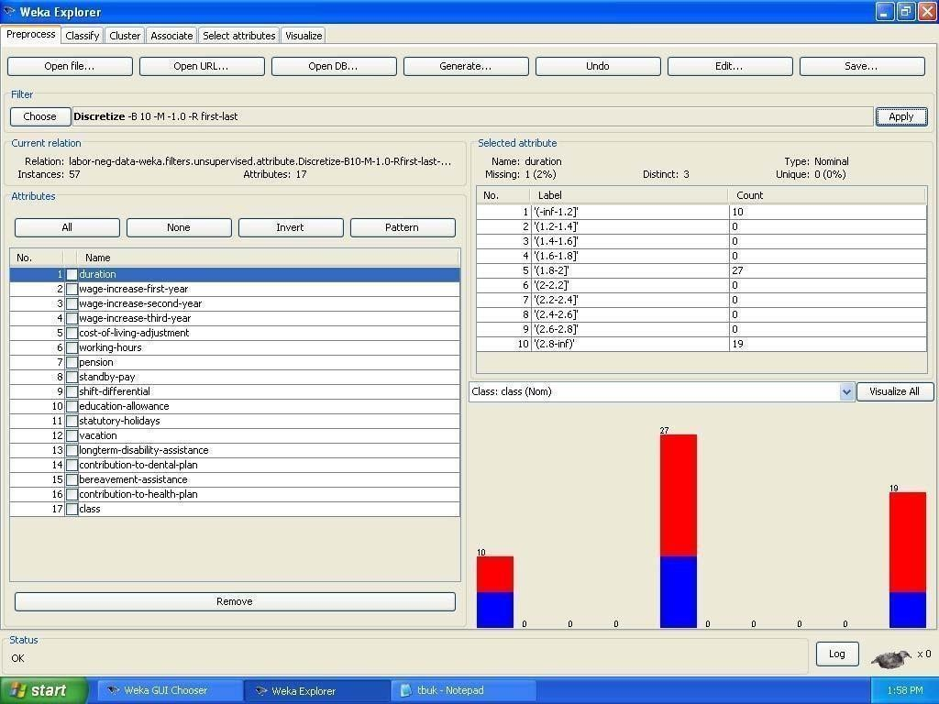

PROGRAM 2 Demonstration of Association rule process on dataset contactlenses.arff using apriori algorithm

Dataset contactlenses.arff
@relation contact-lenses
@attribute age {young, pre-presbyopic, presbyopic} @attribute spectacle-prescrip {myope, hypermetrope} @attribute astigmatism{no, yes}
@attribute tear-prod-rate {reduced, normal} @attribute contact-lenses {soft, hard, none} @data
%
% 24 instances % young,myope,no,reduced,none young,myope,no,normal,soft young,myope,yes,reduced,none young,myope,yes,normal,hard young,hypermetrope,no,reduced,none young,hypermetrope,no,normal,soft young,hypermetrope,yes,reduced,none young,hypermetrope,yes,normal,hard pre-presbyopic,myope,no,reduced,none pre-presbyopic,myope,no,normal,soft pre-presbyopic,myope,yes,reduced,none pre-presbyopic,myope,yes,normal,hard
pre-presbyopic,hypermetrope,no,reduced,none

pre-presbyopic,hypermetrope,no,normal,soft pre-presbyopic,hypermetrope,yes,reduced,none pre-presbyopic,hypermetrope,yes,normal,none presbyopic,myope,no,reduced,none presbyopic,myope,no,normal,none presbyopic,myope,yes,reduced,none presbyopic,myope,yes,normal,hard presbyopic,hypermetrope,no,reduced,none presbyopic,hypermetrope,no,normal,soft presbyopic,hypermetrope,yes,reduced,none presbyopic,hypermetrope,yes,normal,none
%
%
%

The following screenshot shows the association rules that were generated when apriori algorithm is applied on the given dataset.

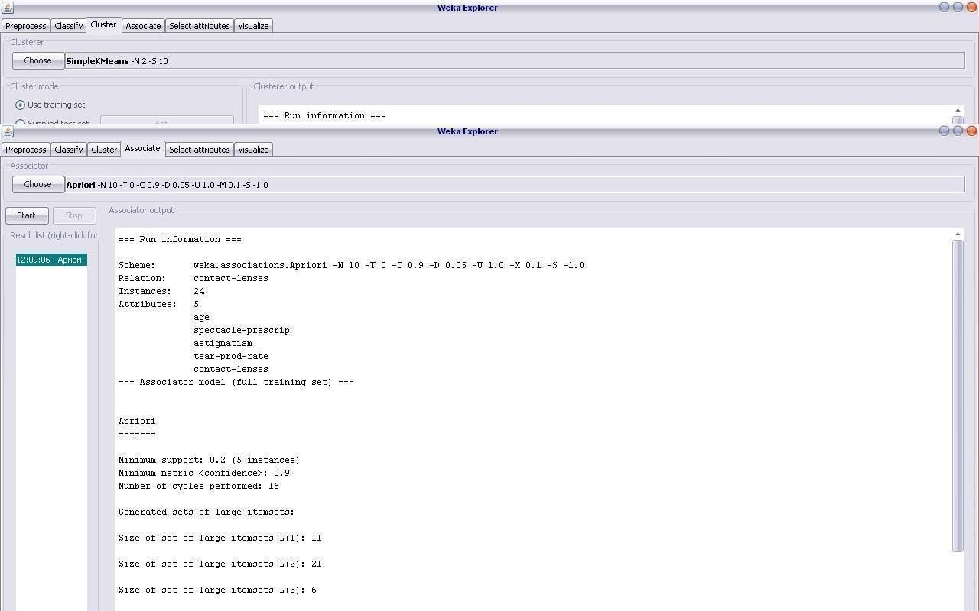

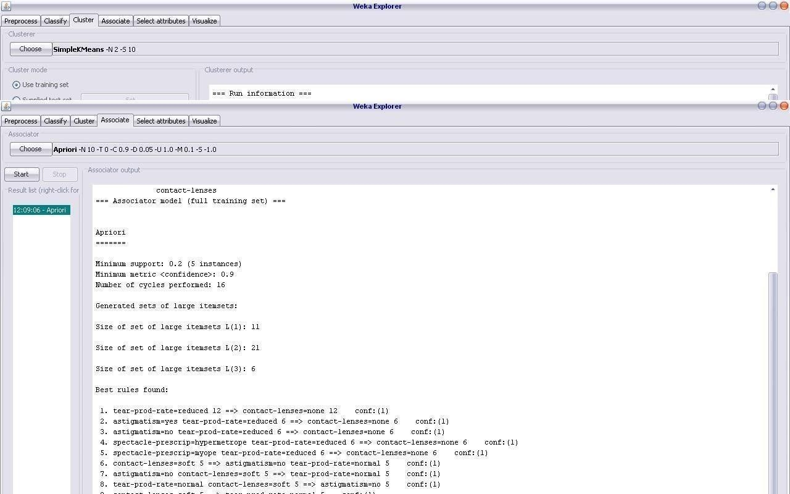

PROGRAM 3 Demonstration of Association rule process on dataset test.arff using apriori algorithm

Dataset test.arff

@relation test
@attribute admissionyear {2005,2006,2007,2008,2009,2010} @attribute course {cse,mech,it,ece}
@data
%
2005, cse
2005, it
2005, cse
2006, mech
2006, it
2006, ece
2007, it
2007, cse
2008, it
2008, cse
2009, it
2009, ece
%
The following screenshot shows the association rules that were generated when apriori algorithm is applied on the given dataset.

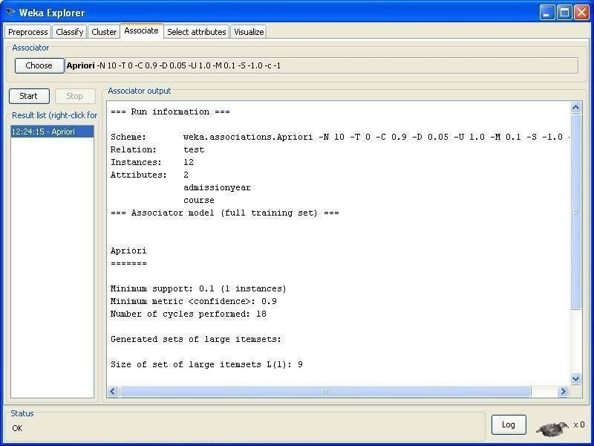
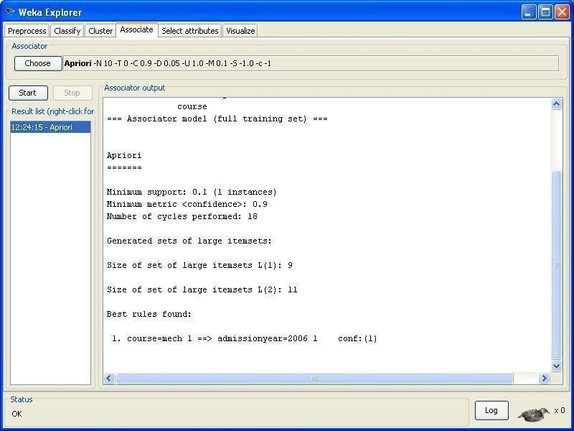

PROGRAM 4 Demonstration of classification rule process on dataset
student.arff using j48 algorithm

Dataset student .arff

@relation student

@attribute age {<30,30-40,>40} @attribute income {low, medium, high} @attribute student {yes, no}
@attribute credit-rating {fair, excellent} @attribute buyspc {yes, no}
@data
%
<30, high, no, fair, no
<30, high, no, excellent, no 30-40, high, no, fair, yes
>40, medium, no, fair, yes
>40, low, yes, fair, yes
>40, low, yes, excellent, no 30-40, low, yes, excellent, yes
<30, medium, no, fair, no
<30, low, yes, fair, no
>40, medium, yes, fair, yes
<30, medium, yes, excellent, yes 30-40, medium, no, excellent, yes 30-40, high, yes, fair, yes
>40, medium, no, excellent, no
%

The following screenshot shows the classification rules that were generated when j48 algorithm is applied on the given dataset.

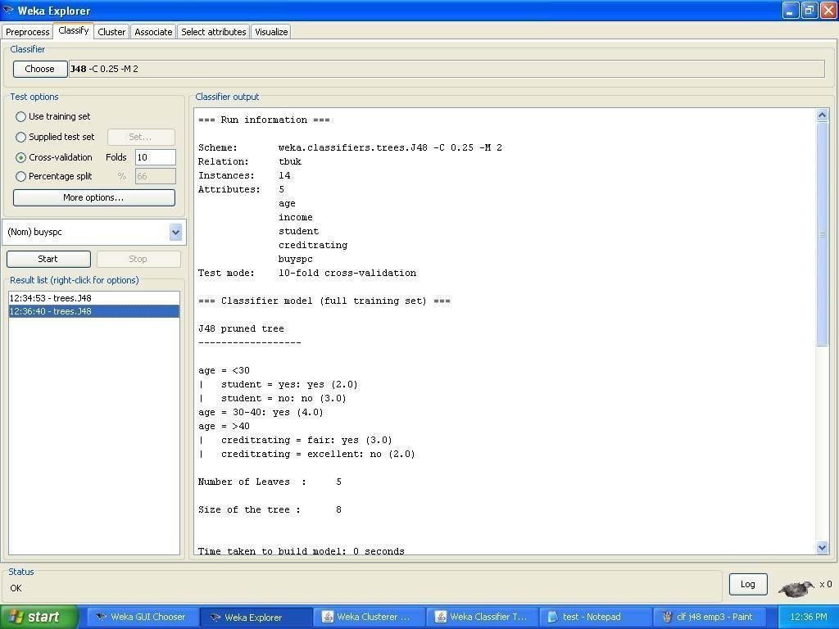

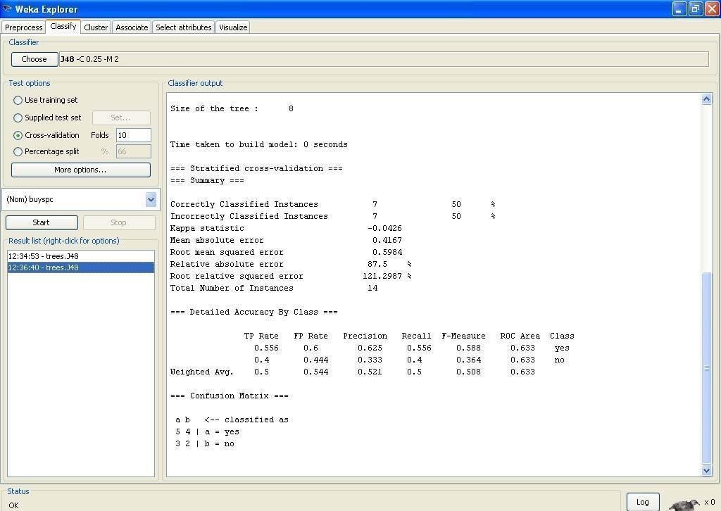
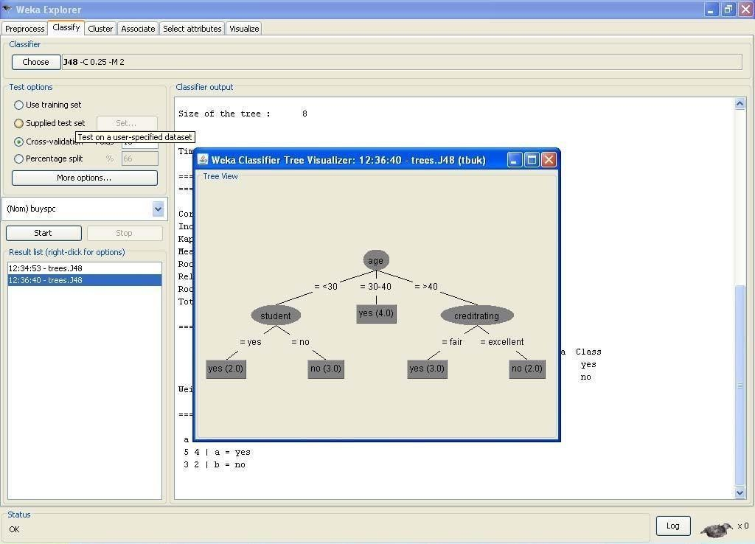

PROGRAM 5 Demonstration of classification rule process on dataset DATE : employee.arff using j48 algorithm

Data set employee.arff:

@relation employee
@attribute age {25, 27, 28, 29, 30, 35, 48} @attribute salary{10k,15k,17k,20k,25k,30k,35k,32k} @attribute performance {good, avg, poor}
@data
%
25, 10k, poor
27, 15k, poor
27, 17k, poor
28, 17k, poor
29, 20k, avg
30, 25k, avg
29, 25k, avg
30, 20k, avg
35, 32k, good
48, 35k, good
48, 32k, good
%
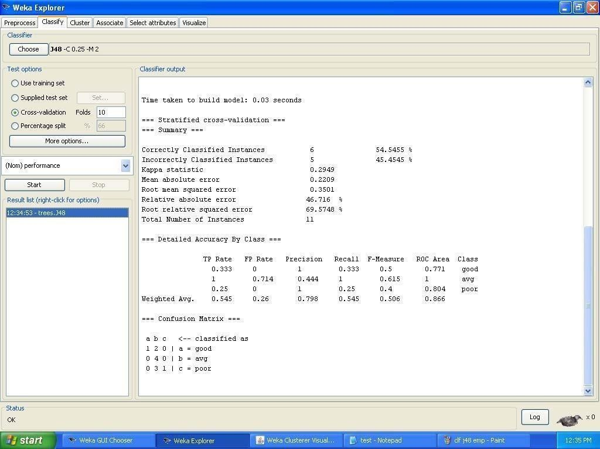

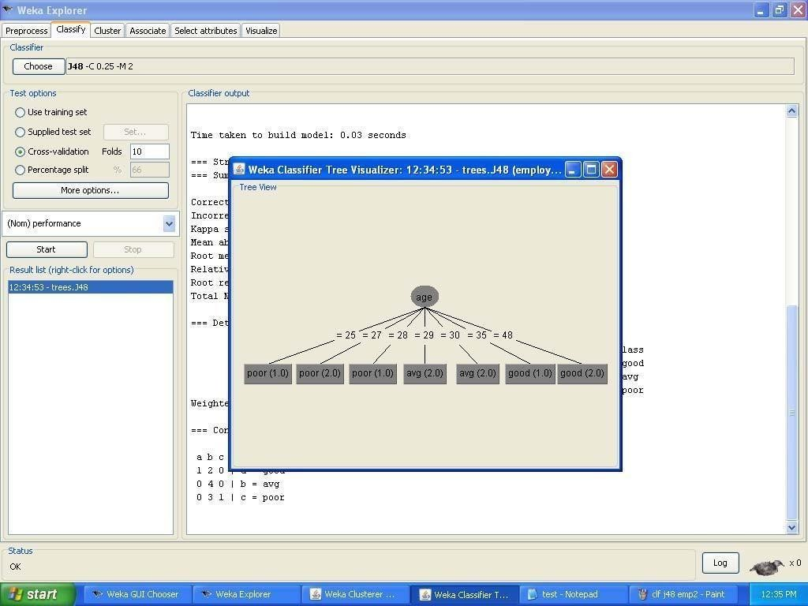

PROGRAM 6 Demonstration of classification rule process on dataset employee.arff using id3 algorithm

Dataset employee.arff:

@relation employee
@attribute age {25, 27, 28, 29, 30, 35, 48}
@attribute salary{10k,15k,17k,20k,25k,30k,35k,32k} @attribute performance {good, avg, poor}
@data
%
25, 10k, poor
27, 15k, poor
27, 17k, poor
28, 17k, poor
29, 20k, avg
30, 25k, avg
29, 25k, avg
30, 20k, avg
35, 32k, good
48, 35k, good
48, 32k, good
%
The following screenshot shows the classification rules that were generated when id3 algorithm is applied on the given dataset.

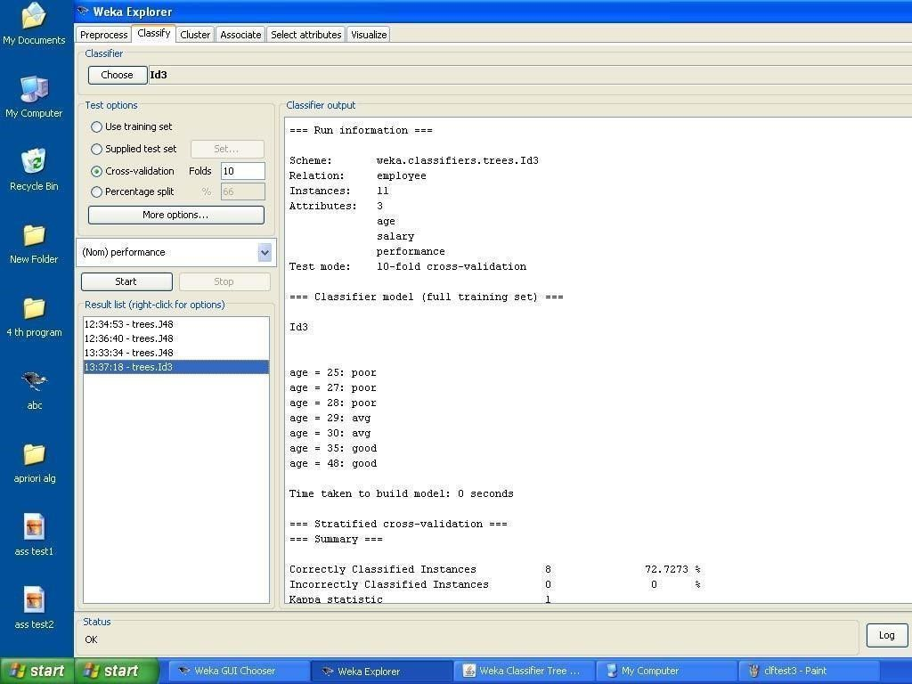

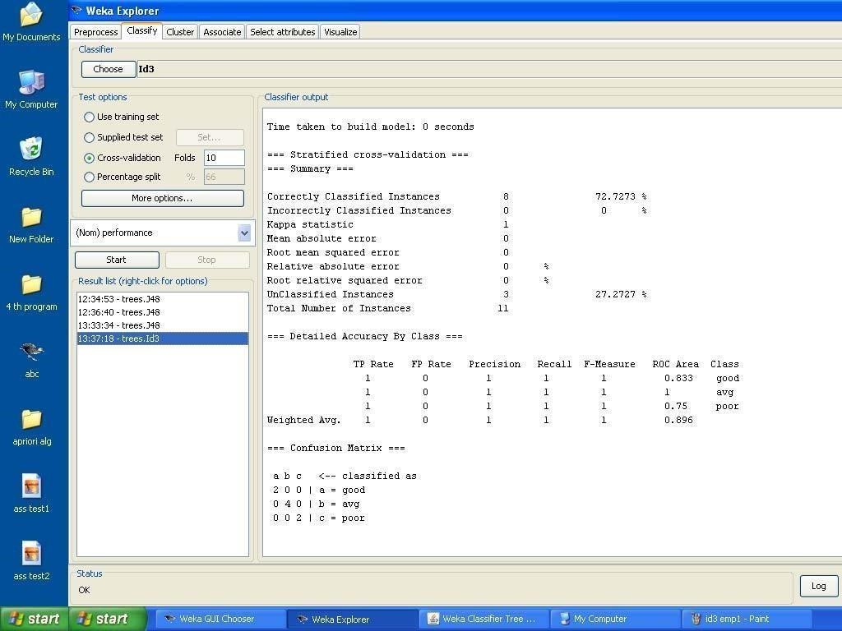

PROGRAM 7 Demonstration of classification rule process on dataset employee.arff using naïve bayes algorithm
Aim:
This experiment illustrates the use of naïve bayes classifier in weka. The sample data set used in this experiment is “employee”data available at arff format. This document assumes that appropriate data pre processing has been performed.

Dataset employee.arff:
@relation employee
@attribute age {25, 27, 28, 29, 30, 35, 48} @attribute salary{10k,15k,17k,20k,25k,30k,35k,32k} @attribute performance {good, avg, poor}
@data
%
25, 10k, poor
27, 15k, poor
27, 17k, poor
28, 17k, poor
29, 20k, avg
30, 25k, avg
29, 25k, avg
30, 20k, avg
35, 32k, good
48, 35k, good
48, 32k, good
%

The following screenshot shows the classification rules that were generated when naive bayes algorithm is applied on the given dataset.

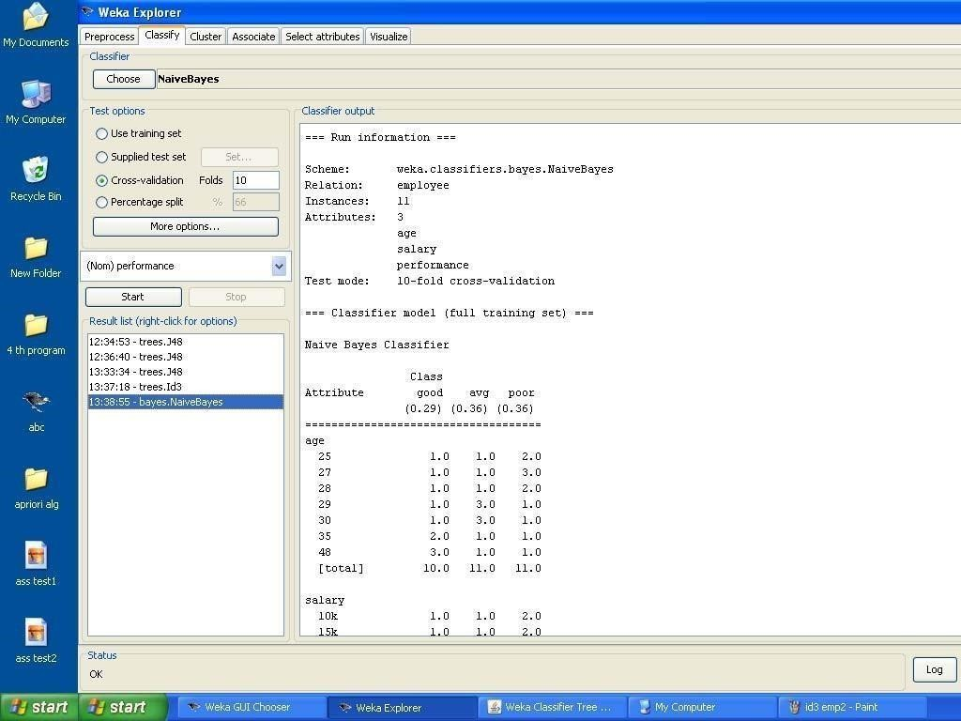

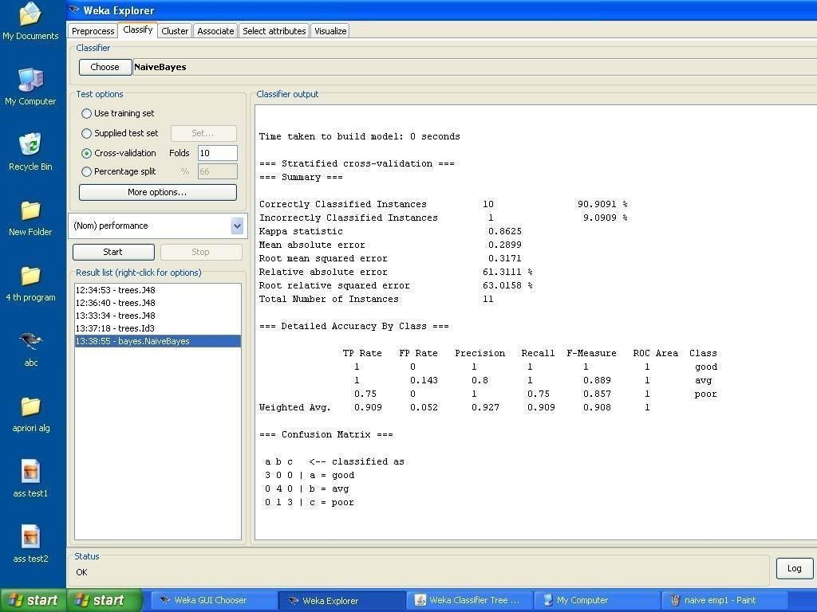

PROGRAM 8 Demonstration of clustering rule process on dataset iris.arff using simple k-means

Dataset iris.arff:

@RELATION iris @ATTRIBUTE sepallength REAL @ATTRIBUTE sepalwidth REAL @ATTRIBUTE petallength REAL @ATTRIBUTE petalwidth REAL
@ATTRIBUTE class {Iris-setosa,Iris-versicolor,Iris-virginica} @DATA
5.1,3.5,1.4,0.2,Iris-setosa
4.9,3.0,1.4,0.2,Iris-setosa
4.7,3.2,1.3,0.2,Iris-setosa
4.6,3.1,1.5,0.2,Iris-setosa
5.0,3.6,1.4,0.2,Iris-setosa
5.4,3.9,1.7,0.4,Iris-setosa
4.6,3.4,1.4,0.3,Iris-setosa
5.0,3.4,1.5,0.2,Iris-setosa
4.4,2.9,1.4,0.2,Iris-setosa
4.9,3.1,1.5,0.1,Iris-setosa
5.4,3.7,1.5,0.2,Iris-setosa
4.8,3.4,1.6,0.2,Iris-setosa
4.8,3.0,1.4,0.1,Iris-setosa
  - ,3.0,1.1,0.1,Iris-setosa
5.8,4.0,1.2,0.2,Iris-setosa
5.7,4.4,1.5,0.4,Iris-setosa
5.4,3.9,1.3,0.4,Iris-setosa
5.1,3.5,1.4,0.3,Iris-setosa
5.7,3.8,1.7,0.3,Iris-setosa
  - ,3.8,1.5,0.3,Iris-setosa
5.4,3.4,1.7,0.2,Iris-setosa
  - ,3.7,1.5,0.4,Iris-setosa
  - ,3.6,1.0,0.2,Iris-setosa
  - ,3.3,1.7,0.5,Iris-setosa
4.8,3.4,1.9,0.2,Iris-setosa
5.0,3.0,1.6,0.2,Iris-setosa
5.0,3.4,1.6,0.4,Iris-setosa
  - ,3.5,1.5,0.2,Iris-setosa

  - ,3.4,1.4,0.2,Iris-setosa
  - ,3.2,1.6,0.2,Iris-setosa
  - ,3.1,1.6,0.2,Iris-setosa
5.4,3.4,1.5,0.4,Iris-setosa
  - ,4.1,1.5,0.1,Iris-setosa

5.5,4.2,1.4,0.2,Iris-setosa
  - ,3.1,1.5,0.1,Iris-setosa
5.0,3.2,1.2,0.2,Iris-setosa
5.5,3.5,1.3,0.2,Iris-setosa
4.9,3.1,1.5,0.1,Iris-setosa
  - ,3.0,1.3,0.2,Iris-setosa
5.1,3.4,1.5,0.2,Iris-setosa
5.0,3.5,1.3,0.3,Iris-setosa
  - ,2.3,1.3,0.3,Iris-setosa
4.4,3.2,1.3,0.2,Iris-setosa
5.0,3.5,1.6,0.6,Iris-setosa
5.1,3.8,1.9,0.4,Iris-setosa
4.8,3.0,1.4,0.3,Iris-setosa
5.1,3.8,1.6,0.2,Iris-setosa
  - ,3.2,1.4,0.2,Iris-setosa
  - ,3.7,1.5,0.2,Iris-setosa
5.0,3.3,1.4,0.2,Iris-setosa 7.0,3.2,4.7,1.4,Iris-versicolor 6.4,3.2,4.5,1.5,Iris-versicolor 6.9,3.1,4.9,1.5,Iris-versicolor 5.5,2.3,4.0,1.3,Iris-versicolor 6.5,2.8,4.6,1.5,Iris-versicolor 5.7,2.8,4.5,1.3,Iris-versicolor 6.3,3.3,4.7,1.6,Iris-versicolor 4.9,2.4,3.3,1.0,Iris-versicolor 6.6,2.9,4.6,1.3,Iris-versicolor 5.2,2.7,3.9,1.4,Iris-versicolor 5.0,2.0,3.5,1.0,Iris-versicolor 5.9,3.0,4.2,1.5,Iris-versicolor 6.0,2.2,4.0,1.0,Iris-versicolor 6.1,2.9,4.7,1.4,Iris-versicolor 5.6,2.9,3.6,1.3,Iris-versicolor 6.7,3.1,4.4,1.4,Iris-versicolor 5.6,3.0,4.5,1.5,Iris-versicolor 5.8,2.7,4.1,1.0,Iris-versicolor 6.2,2.2,4.5,1.5,Iris-versicolor 5.6,2.5,3.9,1.1,Iris-versicolor 5.9,3.2,4.8,1.8,Iris-versicolor

  - ,2.8,4.0,1.3,Iris-versicolor 6.3,2.5,4.9,1.5,Iris-versicolor 6.1,2.8,4.7,1.2,Iris-versicolor 6.4,2.9,4.3,1.3,Iris-versicolor 6.6,3.0,4.4,1.4,Iris-versicolor
6.8,2.8,4.8,1.4,Iris-versicolor 6.7,3.0,5.0,1.7,Iris-versicolor 6.0,2.9,4.5,1.5,Iris-versicolor 5.7,2.6,3.5,1.0,Iris-versicolor 5.5,2.4,3.8,1.1,Iris-versicolor 5.5,2.4,3.7,1.0,Iris-versicolor 5.8,2.7,3.9,1.2,Iris-versicolor 6.0,2.7,5.1,1.6,Iris-versicolor 5.4,3.0,4.5,1.5,Iris-versicolor 6.0,3.4,4.5,1.6,Iris-versicolor 6.7,3.1,4.7,1.5,Iris-versicolor 6.3,2.3,4.4,1.3,Iris-versicolor 5.6,3.0,4.1,1.3,Iris-versicolor 5.5,2.5,4.0,1.3,Iris-versicolor 5.5,2.6,4.4,1.2,Iris-versicolor 6.1,3.0,4.6,1.4,Iris-versicolor 5.8,2.6,4.0,1.2,Iris-versicolor 5.0,2.3,3.3,1.0,Iris-versicolor 5.6,2.7,4.2,1.3,Iris-versicolor 5.7,3.0,4.2,1.2,Iris-versicolor 5.7,2.9,4.2,1.3,Iris-versicolor 6.2,2.9,4.3,1.3,Iris-versicolor 5.1,2.5,3.0,1.1,Iris-versicolor

6.5,3.2,5.1,2.0,Iris-virginica 6.4,2.7,5.3,1.9,Iris-virginica 6.8,3.0,5.5,2.1,Iris-virginica 5.7,2.5,5.0,2.0,Iris-virginica 5.8,2.8,5.1,2.4,Iris-virginica 6.4,3.2,5.3,2.3,Iris-virginica 6.5,3.0,5.5,1.8,Iris-virginica 7.7,3.8,6.7,2.2,Iris-virginica 7.7,2.6,6.9,2.3,Iris-virginica

6.0,2.2,5.0,1.5,Iris-virginica 6.9,3.2,5.7,2.3,Iris-virginica 5.6,2.8,4.9,2.0,Iris-virginica 7.7,2.8,6.7,2.0,Iris-virginica 6.3,2.7,4.9,1.8,Iris-virginica 6.7,3.3,5.7,2.1,Iris-virginica 7.2,3.2,6.0,1.8,Iris-virginica 6.2,2.8,4.8,1.8,Iris-virginica 6.1,3.0,4.9,1.8,Iris-virginica 6.4,2.8,5.6,2.1,Iris-virginica 7.2,3.0,5.8,1.6,Iris-virginica 7.4,2.8,6.1,1.9,Iris-virginica 7.9,3.8,6.4,2.0,Iris-virginica 6.4,2.8,5.6,2.2,Iris-virginica 6.3,2.8,5.1,1.5,Iris-virginica 6.1,2.6,5.6,1.4,Iris-virginica 7.7,3.0,6.1,2.3,Iris-virginica 6.3,3.4,5.6,2.4,Iris-virginica 6.4,3.1,5.5,1.8,Iris-virginica 6.0,3.0,4.8,1.8,Iris-virginica 6.9,3.1,5.4,2.1,Iris-virginica 6.7,3.1,5.6,2.4,Iris-virginica 6.9,3.1,5.1,2.3,Iris-virginica 5.8,2.7,5.1,1.9,Iris-virginica 6.8,3.2,5.9,2.3,Iris-virginica 6.7,3.3,5.7,2.5,Iris-virginica 6.7,3.0,5.2,2.3,Iris-virginica 6.3,2.5,5.0,1.9,Iris-virginica 6.5,3.0,5.2,2.0,Iris-virginica 6.2,3.4,5.4,2.3,Iris-virginica 5.9,3.0,5.1,1.8,Iris-virginica
%
%
%

The following screenshot shows the clustering rules that were generated when simple k means algorithm is applied on the given dataset.

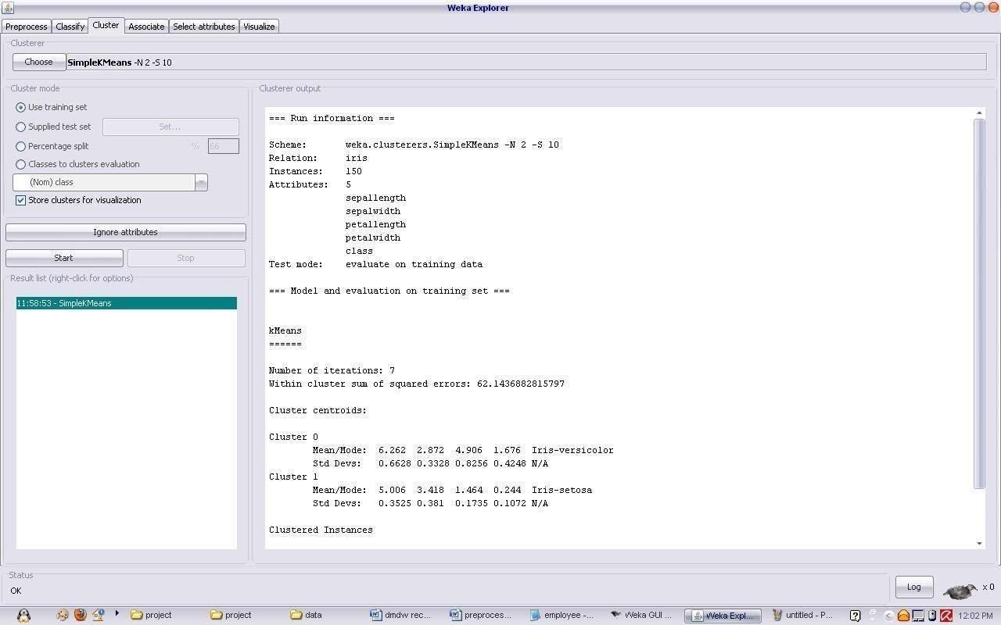

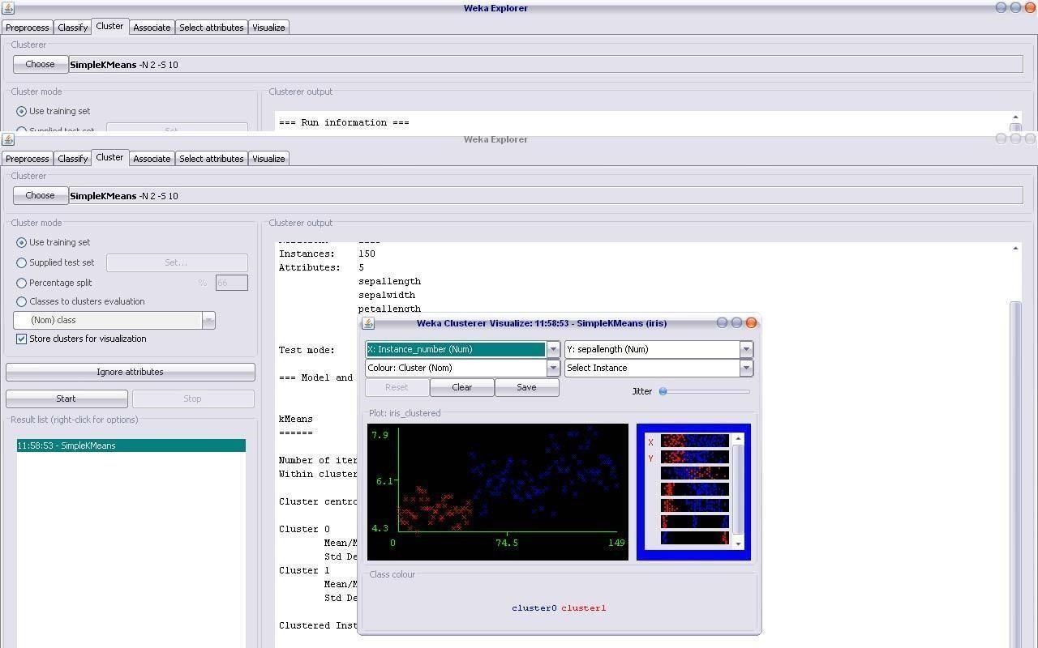

PROGRAM 9 Demonstration of clustering rule process on dataset
student.arff using simple k- means

Dataset student .arff

@relation student
@attribute age {<30,30-40,>40} @attribute income {low,medium,high} @attribute student {yes,no}
@attribute credit-rating {fair,excellent} @attribute buyspc {yes,no}
@data
%
<30, high, no, fair, no
<30, high, no, excellent, no 30-40, high, no, fair, yes
>40, medium, no, fair, yes
>40, low, yes, fair, yes
>40, low, yes, excellent, no 30-40, low, yes, excellent, yes
<30, medium, no, fair, no
<30, low, yes, fair, no
>40, medium, yes, fair, yes
<30, medium, yes, excellent, yes 30-40, medium, no, excellent, yes 30-40, high, yes, fair, yes
>40, medium, no, excellent, no
%

The following screenshot shows the clustering rules that were generated when simple k- means algorithm is applied on the given dataset.

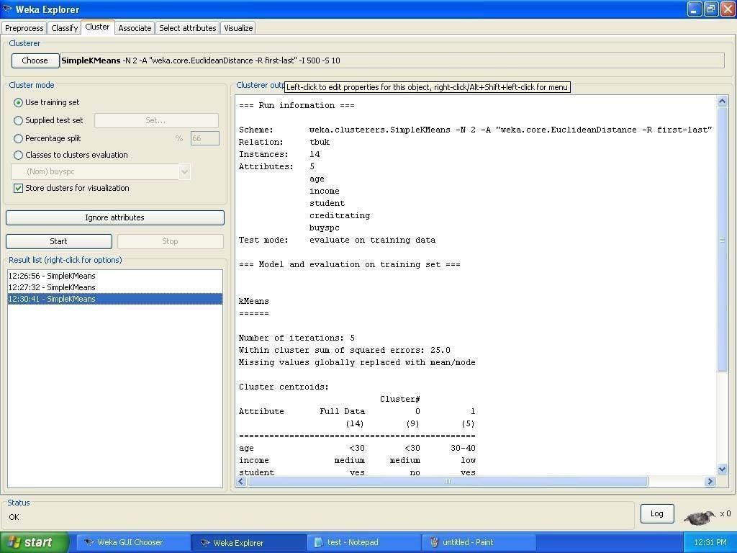

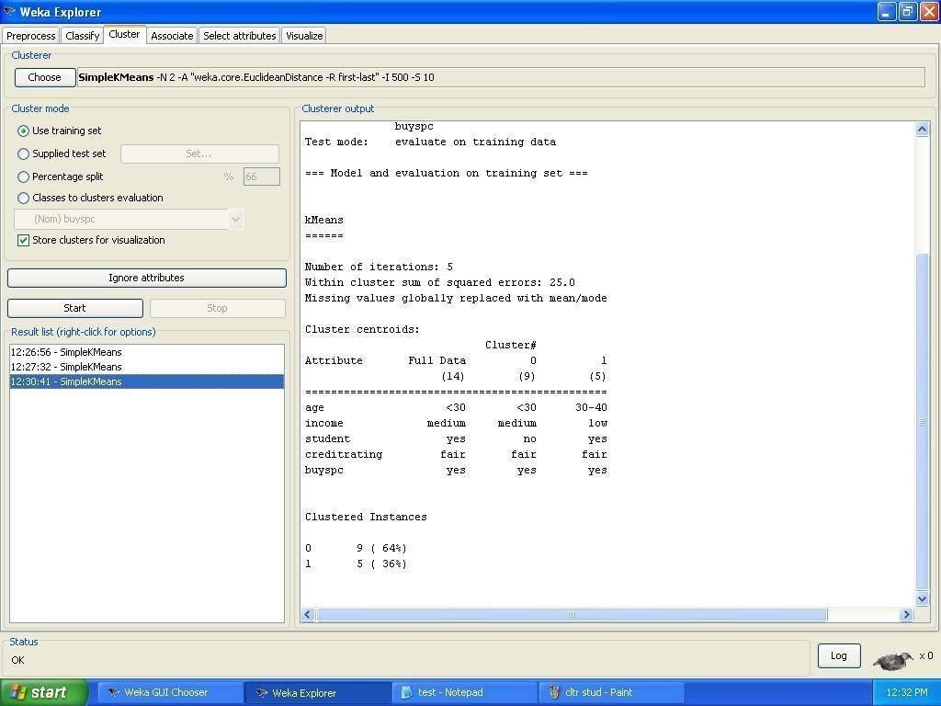

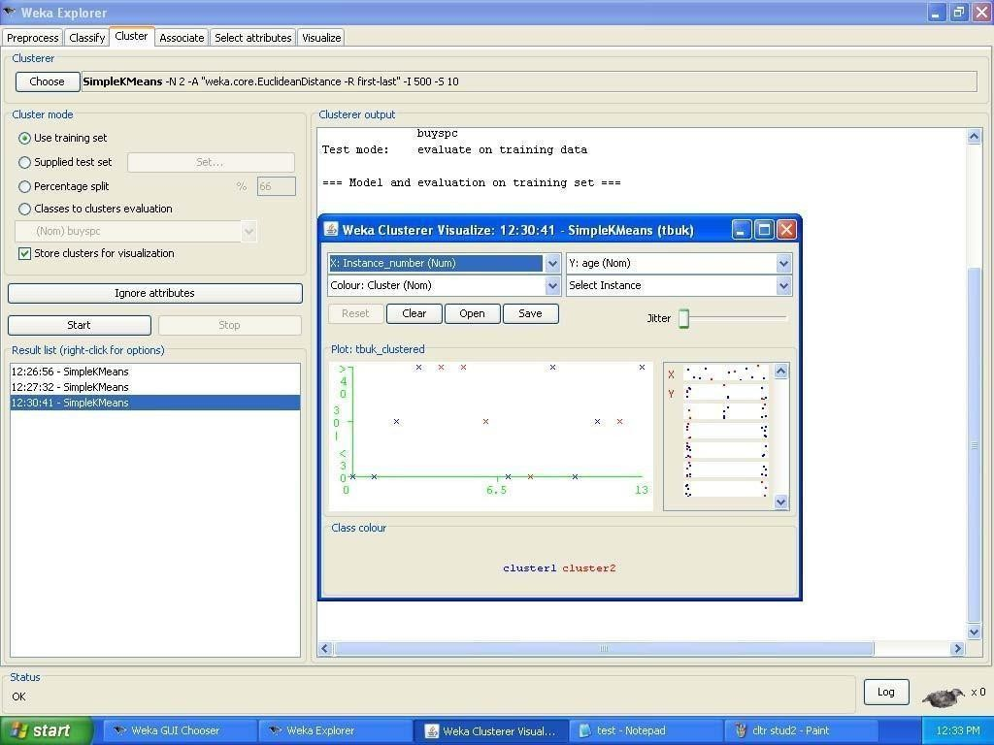

PROGRAM 10 Demonstrate performing Linear Regression on data sets

Dataset cpu .arff :
@relation 'cpu'
@attribute vendor { adviser, amdahl, apollo, basf, bti, burroughs, c.r.d, cdc, cambex, dec, dg, formation, four-phase, gould, hp, harris, honeywell, ibm, ipl, magnuson, microdata, nas, ncr, nixdorf, perkin-elmer, prime, siemens, sperry, sratus, wang}
@attribute MYCT real @attribute MMIN real @attribute MMAX real @attribute CACH real @attribute CHMIN real @attribute CHMAX real @attribute ERP real @data
adviser,125,256,6000,256,16,128,199 amdahl,29,8000,32000,32,8,32,253 amdahl,29,8000,32000,32,8,32,253 amdahl,29,8000,32000,32,8,32,253 amdahl,29,8000,16000,32,8,16,132 amdahl,26,8000,32000,64,8,32,290 amdahl,23,16000,32000,64,16,32,381 amdahl,23,16000,32000,64,16,32,381 amdahl,23,16000,64000,64,16,32,749 amdahl,23,32000,64000,128,32,64,1238 apollo,400,1000,3000,0,1,2,23 apollo,400,512,3500,4,1,6,24 basf,60,2000,8000,65,1,8,70 basf,50,4000,16000,65,1,8,117 bti,350,64,64,0,1,4,15 bti,200,512,16000,0,4,32,64 burroughs,167,524,2000,8,4,15,23 burroughs,143,512,5000,0,7,32,29 burroughs,143,1000,2000,0,5,16,22 burroughs,110,5000,5000,142,8,64,124 burroughs,143,1500,6300,0,5,32,35 burroughs,143,3100,6200,0,5,20,39 burroughs,143,2300,6200,0,6,64,40 burroughs,110,3100,6200,0,6,64,45 c.r.d,320,128,6000,0,1,12,28
c.r.d,320,512,2000,4,1,3,21
c.r.d,320,256,6000,0,1,6,28

c.r.d,320,256,5000,4,1,6,27 cdc,25,1310,2620,131,12,24,102 cdc,25,1310,2620,131,12,24,102 cdc,50,2620,10480,30,12,24,74 cdc,50,2620,10480,30,12,24,74 cdc,56,5240,20970,30,12,24,138 cdc,64,5240,20970,30,12,24,136 cdc,50,500,2000,8,1,4,23 cdc,50,1000,4000,8,1,5,29 cdc,50,2000,8000,8,1,5,44 cambex,50,1000,4000,8,3,5,30 cambex,50,1000,8000,8,3,5,41 cambex,50,2000,16000,8,3,5,74 cambex,50,2000,16000,8,3,6,74 cambex,50,2000,16000,8,3,6,74 dec,133,1000,12000,9,3,12,54 dec,133,1000,8000,9,3,12,41 dec,810,512,512,8,1,1,18 dec,810,1000,5000,0,1,1,28 dec,320,512,8000,4,1,5,36 dec,200,512,8000,8,1,8,38 dg,700,384,8000,0,1,1,34 dg,700,256,2000,0,1,1,19 dg,140,1000,16000,16,1,3,72 dg,200,1000,8000,0,1,2,36 dg,110,1000,4000,16,1,2,30 dg,110,1000,12000,16,1,2,56 dg,220,1000,8000,16,1,2,42 formation,800,256,8000,0,1,4,34 formation,800,256,8000,0,1,4,34 formation,800,256,8000,0,1,4,34 formation,800,256,8000,0,1,4,34 formation,800,256,8000,0,1,4,34 four-phase,125,512,1000,0,8,20,19 gould,75,2000,8000,64,1,38,75 gould,75,2000,16000,64,1,38,113 gould,75,2000,16000,128,1,38,157 hp,90,256,1000,0,3,10,18 hp,105,256,2000,0,3,10,20 hp,105,1000,4000,0,3,24,28 hp,105,2000,4000,8,3,19,33 hp,75,2000,8000,8,3,24,47

hp,75,3000,8000,8,3,48,54 hp,175,256,2000,0,3,24,20 harris,300,768,3000,0,6,24,23 harris,300,768,3000,6,6,24,25 harris,300,768,12000,6,6,24,52 harris,300,768,4500,0,1,24,27 harris,300,384,12000,6,1,24,50 harris,300,192,768,6,6,24,18 harris,180,768,12000,6,1,31,53 honeywell,330,1000,3000,0,2,4,23 honeywell,300,1000,4000,8,3,64,30 honeywell,300,1000,16000,8,2,112,73 honeywell,330,1000,2000,0,1,2,20 honeywell,330,1000,4000,0,3,6,25 honeywell,140,2000,4000,0,3,6,28 honeywell,140,2000,4000,0,4,8,29 honeywell,140,2000,4000,8,1,20,32 honeywell,140,2000,32000,32,1,20,175 honeywell,140,2000,8000,32,1,54,57 honeywell,140,2000,32000,32,1,54,181 honeywell,140,2000,32000,32,1,54,181 honeywell,140,2000,4000,8,1,20,32 ibm,57,4000,16000,1,6,12,82 ibm,57,4000,24000,64,12,16,171 ibm,26,16000,32000,64,16,24,361 ibm,26,16000,32000,64,8,24,350 ibm,26,8000,32000,0,8,24,220 ibm,26,8000,16000,0,8,16,113 ibm,480,96,512,0,1,1,15 ibm,203,1000,2000,0,1,5,21 ibm,115,512,6000,16,1,6,35 ibm,1100,512,1500,0,1,1,18 ibm,1100,768,2000,0,1,1,20 ibm,600,768,2000,0,1,1,20 ibm,400,2000,4000,0,1,1,28 ibm,400,4000,8000,0,1,1,45 ibm,900,1000,1000,0,1,2,18 ibm,900,512,1000,0,1,2,17 ibm,900,1000,4000,4,1,2,26 ibm,900,1000,4000,8,1,2,28 ibm,900,2000,4000,0,3,6,28 ibm,225,2000,4000,8,3,6,31

ibm,225,2000,4000,8,3,6,31 ibm,180,2000,8000,8,1,6,42 ibm,185,2000,16000,16,1,6,76 ibm,180,2000,16000,16,1,6,76 ibm,225,1000,4000,2,3,6,26 ibm,25,2000,12000,8,1,4,59 ibm,25,2000,12000,16,3,5,65 ibm,17,4000,16000,8,6,12,101 ibm,17,4000,16000,32,6,12,116 ibm,1500,768,1000,0,0,0,18 ibm,1500,768,2000,0,0,0,20 ibm,800,768,2000,0,0,0,20 ipl,50,2000,4000,0,3,6,30 ipl,50,2000,8000,8,3,6,44 ipl,50,2000,8000,8,1,6,44 ipl,50,2000,16000,24,1,6,82 ipl,50,2000,16000,24,1,6,82 ipl,50,8000,16000,48,1,10,128 magnuson,100,1000,8000,0,2,6,37 magnuson,100,1000,8000,24,2,6,46 magnuson,100,1000,8000,24,3,6,46 magnuson,50,2000,16000,12,3,16,80 magnuson,50,2000,16000,24,6,16,88 magnuson,50,2000,16000,24,6,16,88 microdata,150,512,4000,0,8,128,33 nas,115,2000,8000,16,1,3,46 nas,115,2000,4000,2,1,5,29 nas,92,2000,8000,32,1,6,53 nas,92,2000,8000,32,1,6,53 nas,92,2000,8000,4,1,6,41 nas,75,4000,16000,16,1,6,86 nas,60,4000,16000,32,1,6,95 nas,60,2000,16000,64,5,8,107 nas,60,4000,16000,64,5,8,117 nas,50,4000,16000,64,5,10,119 nas,72,4000,16000,64,8,16,120 nas,72,2000,8000,16,6,8,48 nas,40,8000,16000,32,8,16,126 nas,40,8000,32000,64,8,24,266 nas,35,8000,32000,64,8,24,270 nas,38,16000,32000,128,16,32,426 nas,48,4000,24000,32,8,24,151

nas,38,8000,32000,64,8,24,267 nas,30,16000,32000,256,16,24,603 ncr,112,1000,1000,0,1,4,19 ncr,84,1000,2000,0,1,6,21 ncr,56,1000,4000,0,1,6,26 ncr,56,2000,6000,0,1,8,35 ncr,56,2000,8000,0,1,8,41 ncr,56,4000,8000,0,1,8,47 ncr,56,4000,12000,0,1,8,62 ncr,56,4000,16000,0,1,8,78 ncr,38,4000,8000,32,16,32,80 ncr,38,4000,8000,32,16,32,80 ncr,38,8000,16000,64,4,8,142 ncr,38,8000,24000,160,4,8,281 ncr,38,4000,16000,128,16,32,190 nixdorf,200,1000,2000,0,1,2,21 nixdorf,200,1000,4000,0,1,4,25 nixdorf,200,2000,8000,64,1,5,67
perkin-elmer,250,512,4000,0,1,7,24 perkin-elmer,250,512,4000,0,4,7,24 perkin-elmer,250,1000,16000,1,1,8,64 prime,160,512,4000,2,1,5,25 prime,160,512,2000,2,3,8,20 prime,160,1000,4000,8,1,14,29 prime,160,1000,8000,16,1,14,43 prime,160,2000,8000,32,1,13,53 siemens,240,512,1000,8,1,3,19 siemens,240,512,2000,8,1,5,22 siemens,105,2000,4000,8,3,8,31 siemens,105,2000,6000,16,6,16,41 siemens,105,2000,8000,16,4,14,47 siemens,52,4000,16000,32,4,12,99 siemens,70,4000,12000,8,6,8,67 siemens,59,4000,12000,32,6,12,81 siemens,59,8000,16000,64,12,24,149 siemens,26,8000,24000,32,8,16,183 siemens,26,8000,32000,64,12,16,275 siemens,26,8000,32000,128,24,32,382 sperry,116,2000,8000,32,5,28,56 sperry,50,2000,32000,24,6,26,182 sperry,50,2000,32000,48,26,52,227 sperry,50,2000,32000,112,52,104,341

sperry,50,4000,32000,112,52,104,360 sperry,30,8000,64000,96,12,176,919 sperry,30,8000,64000,128,12,176,978 sperry,180,262,4000,0,1,3,24 sperry,180,512,4000,0,1,3,24 sperry,180,262,4000,0,1,3,24 sperry,180,512,4000,0,1,3,24 sperry,124,1000,8000,0,1,8,37 sperry,98,1000,8000,32,2,8,50 sratus,125,2000,8000,0,2,14,41 wang,480,512,8000,32,0,0,47 wang,480,1000,4000,0,0,0,25

The following screenshot shows the clustering rules that were generated when Linear Regression algorithm is applied on the given dataset.

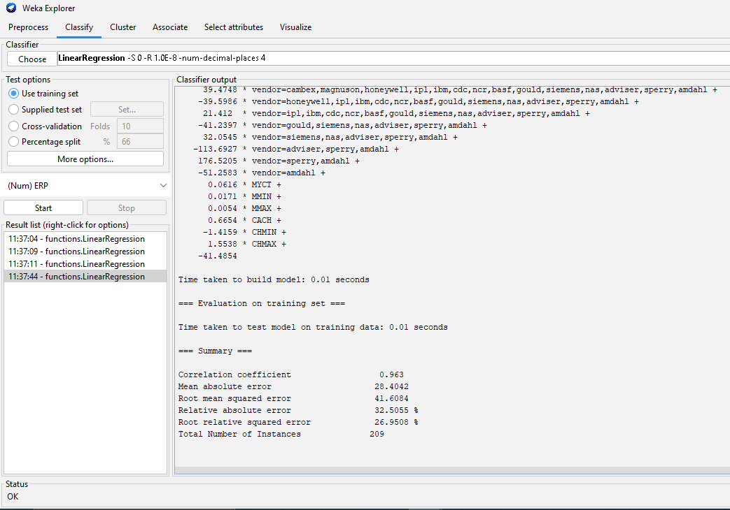

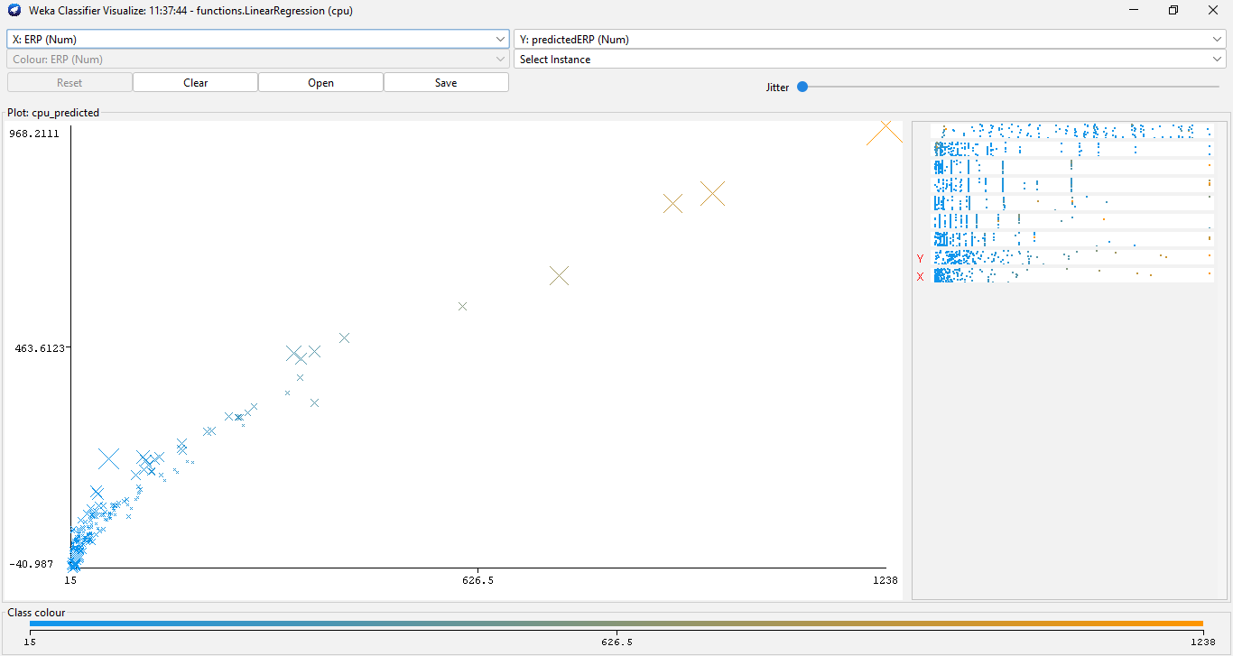

cross-validation:

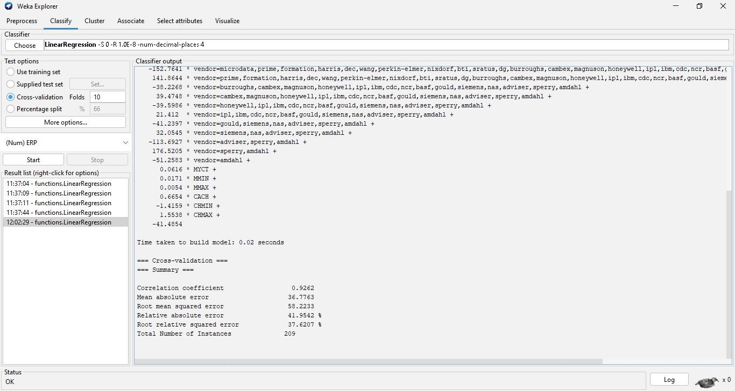

percentage split:

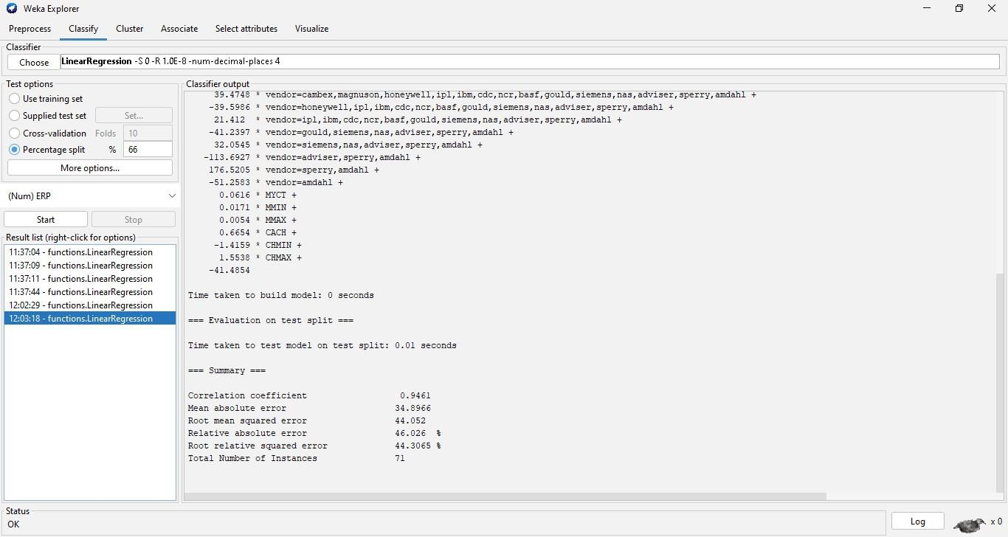

PROGRAM 11 Sample Programs using German Credit Data DATE :

Credit Risk Assessment
Description: The business of banks is making loans. Assessing the credit worthiness of an applicant is of crucial importance. You have to develop a system to help a loan officer decide whether the credit of a customer is good. Or bad. A bank’s business rules regarding loans must consider two opposing factors. On th one han, a bank wants to make as many loans as possible.
Interest on these loans is the banks profit source. On the other hand, a bank can not afford to make too many bad loans. Too many bad loans could lead to the collapse of the bank. The bank’s loan policy must involved a compromise. Not too strict and not too lenient.
To do the assignment, you first and foremost need some knowledge about the world of credit. You can acquire such knowledge in a number of ways.

- Knowledge engineering: Find a loan officer who is willing to talk. Interview her and try to represent her knowledge in a number of ways.

- Books: Find some training manuals for loan officers or perhaps a suitable textbook on finance. Translate this knowledge from text from to production rule form.

- Common sense: Imagine yourself as a loan officer and make up reasonable rules which can be used to judge the credit worthiness of a loan applicant.

- Case histories: Find records of actual cases where competent loan officers correctly judged when and not to. Approve a loan application.

The German Credit Data

Actual historical credit data is not always easy to come by because of confidentiality rules. Here is one such data set. Consisting of 1000 actual cases collected in Germany.
In spite of the fact that the data is German, you should probably make use of it for this assignment(Unless you really can consult a real loan officer!)

There are 20 attributes used in judging a loan applicant( ie., 7 Numerical attributes and 13 Categoricl or Nominal attributes). The goal is the classify the applicant into one of two categories. Good or Bad.
The total number of attributes present in German credit data are.

- Checking_Status
- Duration
- Credit_history
- Purpose
- Credit_amout
- Savings_status
- Employment
- Installment_Commitment
- Personal_status
- Other_parties
- Residence_since
- Property_Magnitude
- Age
- Other_payment_plans
- Housing
- Existing_credits
- Job
- Num_dependents
- Own_telephone
- Foreign_worker
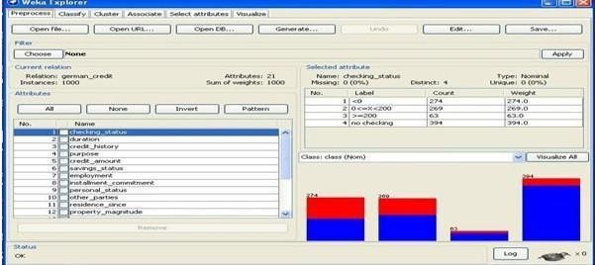
- Class

Tasks:

List all the categorical (or nominal) attributes and the real valued attributes separately.

Ans) Steps for identifying categorical attributes

  - Double click on credit-g.arff file.
  - Select all categorical attributes.
  - Click on invert.
  - Then we get all real valued attributes selected
  - Click on remove
  - Click on visualize all.

Steps for identifying real valued attributes

- Double click on credit-g.arff file.
- Select all real valued attributes.

- Click on invert.
- Then we get all categorial attributes selected
- Click on remove
- Click on visualize all.

The following are the Categorical (or Nominal) attributes)

- Checking_Status
- Credit_history
- Purpose
- Savings_status
- Employment
- Personal_status
- Other_parties
- Property_Magnitude
- Other_payment_plans
- Housing
- Job
- Own_telephone
- Foreign_worker

The following are the Numerical attributes)

- Duration
- Credit_amout
- Installment_Commitment
- Residence_since
- Age
- Existing_credits
- Num_dependents

What attributes do you think might be crucial in making the credit assessment? Come up with some simple rules in plain English using your selected attributes.
Ans) The following are the attributes may be crucial in making the credit assessment.
  - Credit_amount
  - Age
  - Job
  - Savings_status
  - Existing_credits
  - Installment_commitment
  - Property_magnitude

One type of model that you can create is a Decision tree . train a Decision tree using the complete data set as the training data. Report the model obtained after training.

Ans) Steps to model decision tree.

  - Double click on credit-g.arff file.
  - Consider all the 21 attributes for making decision tree.
  - Click on classify tab.
  - Click on choose button.
  - Expand tree folder and select J48 6. Click on use training set in test options.
- Click on start button.
- Right click on result list and choose the visualize tree to get decision tree.

We created a decision tree by using J48 Technique for the complete dataset as the training data.
The following model obtained after training.

Output:

=== Run information ===

Scheme : weka.classifiers.trees.J48 -C 0.25 -M 2 Relation : german_credit
Instances : 1000
Attributes : 21

Checking_status duration credit_history purpose credit_amount savings_status employment installment_commitment personal_status other_parties residence_since property_magnitude age other_payment_plans housing existing_credits job num_dependents own_telephone foreign_worker class
Test mode: evaluate on training data
=== Classifier model (full training set) === J48 pruned tree -
Number of Leaves : 103 Size of the tree 140

Time taken to build model: 0.08 seconds
=== Evaluation on training set ===
=== Summary ===
Correctly Classified Instances | 855 | 85.5 %
Incorrectly Classified Instances | 145 | 14.5 %
Kappa statistic | 0.6251
Mean absolute error | 0.2312
Root mean squared error | 0.34
Relative absolute error | 55.0377%
Root relative squared error | 74.2015%
Coverage of cases(0.95level) | 100 %

Mean rel. region size (0.95 level) 93.3% Total Number of Instances 1000

=== Detailed Accuracy By Class ===
TP Rate FP Rate Precision Recall F-Measure ROC Area Class

0.956 | 0.38 | 0.854 | 0.956 | 0.902 | 0.857 | good
0.62 | 0.044 | 0.857 | 0.62 | 0.72 | 0.857 | bad
WeightedAvg.0.855 | 0.279 | 0.855 | 0.855 | 0.847 | 0.857

=== Confusion Matrix ===

a b <-- classified as 669 31 | a = good

114 186 | b = bad

Suppose you use your above model trained on the complete dataset, and classify credit good/bad for each of the examples in the dataset. What % of examples can you classify correctly?(This is also called testing on the training set) why do you think can not get 100% training accuracy?
Ans) Steps followed are:

  - Double click on credit-g.arff file.
  - Click on classify tab.
  - Click on choose button.
  - Expand tree folder and select J48 5. Click on use training set in test options.
- Click on start button.
- On right side we find confusion matrix
- Note the correctly classified instances.
Output:
If we used our above model trained on the complete dataset and classified credit as good/bad for each of the examples in that dataset. We can not get 100% training accuracy only 85.5% of examples, we can classify correctly.

- Is testing on the training set as you did above a good idea? Why or why not? Ans)It is not good idea by using 100% training data set.

One approach for solving the problem encountered in the previous question is using cross-validation? Describe what is cross validation briefly. Train a decision tree again using cross validation and report your results. Does accuracy increase/decrease? Why?

Ans) steps followed are:
  - Double click on credit-g.arff file.
  - Click on classify tab.
  - Click on choose button.
  - Expand tree folder and select J48
  - Click on cross validations in test options.
  - Select folds as 10
  - Click on start
  - Change the folds to 5
  - Again click on start 10. Change the folds with 2
- Click on start.
- Right click on blue bar under result list and go to visualize tree Output:

Cross-Validation Definition: The classifier is evaluated by cross validation using the number of folds that are entered in the folds text field.
In Classify Tab, Select cross-validation option and folds size is 2 then Press Start Button, next time change as folds size is 5 then press start, and next time change as folds size is 10 then press start.

i) Fold Size-10
Stratified cross-validation ===
=== Summary ===
Correctly Classified Instances | 705 70.5 %
Incorrectly Classified Instances | 295 29.5 %
Kappa statistic | 0.2467
Mean absolute error | 0.3467
Root mean squared error | 0.4796
Relative absolute error | 82.5233 %
Root relative squared error | 104.6565 %
Coverage of cases (0.95 level) | 92.8 %
Mean rel. region size (0.95 level) | 91.7 %
Total Number of Instances | 1000

=== Detailed Accuracy By Class ===
TP Rate FP Rate Precision Recall F-Measure ROC Area Class
0.84 | 0.61 | 0.763 | 0.84 | 0.799 | 0.639 | good
0.39 | 0.16 | 0.511 | 0.39 | 0.442 | 0.639 | bad
Weighted Avg. 0.705 | 0.475 | 0.687 | 0.705 | 0.692 | 0.639

=== Confusion Matrix ===

a b <-- classified as 588 112 | a = good
183 117 | b = bad

ii) Fold Size-5
Stratified cross-validation ===
=== Summary ===
Correctly Classified Instances | 733 | 73.3 %
Incorrectly Classified Instances | 267 | 26.7 %
Kappa statistic | 0.3264
Mean absolute error | 0.3293
Root mean squared error | 0.4579
Relative absolute error | 78.3705 %
Root relative squared error | 99.914 %
Coverage of cases (0.95 level) | 94.7 %
Mean rel. region size (0.95 level) | 93 %
Total Number of Instances | 1000

=== Detailed Accuracy By Class ===
TP Rate FP Rate Precision Recall F-Measure ROC Area Class
0.851 0.543 | 0.785 | 0.851 | 0.817 | 0.685 | good
0.457 0.149 | 0.568 | 0.457 | 0.506 | 0.685 | bad
Weighted Avg. 0.733 0.425  === Confusion Matrix === a b <-- classified as  596 104 | a = good  163 137 | b = bad | 0.72 | 0.733 | 0.724 | 0.685
iii) Fold Size-2
Stratified cross-validation ===
=== Summary ===
Correctly Classified Instances | 721 | 72.1%
Incorrectly Classified Instances | 279 | 27.9%
Kappa statistic | 0.2443
Mean absolute error | 0.3407
Root mean squared error | 0.4669
Relative absolute error | 81.0491 %

Root relative squared error | 101.8806 %
Coverage of cases (0.95 level) | 92.8 %
Mean rel. region size (0.95 level) | 91.3 %
Total Number of Instances | 1000
=== Detailed Accuracy By Class ===
TP Rate FP Rate Precision Recall F-Measure ROC Area Class

0.891 | 0.677 | 0.755 0.891 | 0.817 | 0.662 | good
0.323 | 0.109 | 0.561 0.323 | 0.41 | 0.662 | bad
Weighted Avg. 0.721 0.506 0.696 0.721 0.695 0.662

=== Confusion Matrix === a b <-- classified as
624 76 | a = good
203 97 | b = bad

Note: With this observation, we have seen accuracy is increased when we have folds size is 5 and accuracy is decreased when we have 10 folds.

Check to see if the data shows a bias against “foreign workers” or “personal-status”.

One way to do this is to remove these attributes from the data set and see if the decision tree created in those cases is significantly different from the full dataset case which you have already done. Did removing these attributes have any significantly effect? Discuss.
Ans) steps followed are:
  - Double click on credit-g.arff file.
  - Click on classify tab.
  - Click on choose button.
  - Expand tree folder and select J48
  - Click on cross validations in test options.
  - Select folds as 10
  - Click on start
  - Click on visualization
  - Now click on preprocessor tab
  - Select 9th and 20th attribute
  - Click on remove button
  - Goto classify tab
  - Choose J48 tree

  - Select cross validation with 10 folds
  - Click on start button
  - Right click on blue bar under the result list and go to visualize tree.

Output:

We use the Preprocess Tab in Weka GUI Explorer to remove an attribute “Foreignworkers” & “Perosnal_status” one by one. In Classify Tab, Select Use Training set option then
Press Start Button, If these attributes removed from the dataset, we can see change in the accuracy compare to full data set when we removed.

i) If Foreign_worker is removed

Evaluation on training set ===
=== Summary ===
Correctly Classified Instances | 859 85.9%
Incorrectly Classified Instances | 141 14.1%
Kappa statistic | 0.6377
Mean absolute error | 0.2233
Root mean squared error | 0.3341
Relative absolute error | 53.1347%
Root relative squared error | 72.9074%
Coverage of cases (0.95 level) | 100 %
Mean rel. region size (0.95 level) 91.9%
Total Number of Instances 1000

=== Detailed Accuracy By Class ===

TP Rate |  | FP Rate | Precision | Recall | F-Measure | ROC Area | Class
 | 0.954 | 0.363 | 0.86 | 0.954 | 0.905 | 0.867 | good
 | 0.637 | 0.046 | 0.857 | 0.637 | 0.73 | 0.867 | bad
Weighted Avg | 0.859 | 0.268 | 0.859 | 0.859 | 0.852 | 0.867
=== Confusion Matrix === a b <-- classified as
668 32 | a = good
109 191 | b = bad

i) | If Personal_status is removed
Evaluation on training set ===
=== Summary ===
 | Correctly Classified Instances | 866 | 86.6%
 | Incorrectly Classified Instances | 134 | 13.4%
 | Kappa statistic | 0.6582
 | Mean absolute error | 0.2162
 | Root mean squared error | 0.3288
 | Relative absolute error | 51.4483%
 | Root relative squared error | 71.7411%
 | Coverage of cases (0.95 level) | 100%
 | Mean rel. region size (0.95 level) | 91.7 %
 | Total Number of Instances | 1000
 | === Detailed Accuracy By Class ===
 | TP Rate FP Rate Precision Recall F-Measure ROC Area Class
 | 0.954 0.34 0.868 | 0.954 | 0.909 | 0.868 | good
 | 0.66 0.046 0.861 | 0.66 | 0.747 | 0.868 | bad
 | Weighted Avg. 0.866 0.252 0.866 | 0.866 | 0.86 | 0.868
=== Confusion Matrix === a b <-- classified as
668 32 | a = good
102 198 | b = bad
Note: With this observation we have seen, when “Foreign_worker “attribute is removed from the
Dataset, the accuracy is decreased. So this attribute is important for classification.

Another question might be, do you really need to input so many attributes to get good results? May be only a few would do. For example, you could try just having attributes 2,3,5,7,10,17 and 21. Try out some combinations.(You had removed two attributes in problem 7. Remember to reload the arff data file to get all the attributes initially before you start selecting the ones you want.)
Ans) steps followed are:

  - Double click on credit-g.arff file.
  - Select 2,3,5,7,10,17,21 and tick the check boxes.
  - Click on invert
  - Click on remove
  - Click on classify tab
  - Choose trace and then algorithm as J48 7. Select cross validation folds as 2
8. Click on start.

OUTPUT:
We use the Preprocess Tab in Weka GUI Explorer to remove 2nd attribute (Duration). In Classify Tab, Select Use Training set option then Press Start Button, If these attributes removed from the dataset, we can see change in the accuracy compare to full data set when we removed.
=== Evaluation on training set ===
=== Summary ===

Correctly Classified Instances | 841 | 84.1 | %
Incorrectly Classified Instances  Confusion Matrix === | 159 | 15.9 | %

a b <-- classified as 647 53 | a = good
106 194 | b = bad

Remember to reload the previous removed attribute, press Undo option in Preprocess tab. We use the Preprocess Tab in Weka GUI Explorer to remove 3rd attribute (Credit_history). In Classify Tab, Select Use Training set option then Press Start Button, If these attributes removed from the dataset, we can see change in the accuracy compare to full data set when we removed.
=== Evaluation on training set ===
=== Summary ===
Correctly Classified Instances 839 | 83.9 | %
Incorrectly Classified Instances 161 | 16.1 | %

== Confusion Matrix === a b <-- classified as
645 55 | a = good
106 194 | b = bad

Remember to reload the previous removed attribute, press Undo option in Preprocess tab. We use the Preprocess Tab in Weka GUI Explorer to remove 5th attribute (Credit_amount). In Classify Tab, Select Use Training set option then Press Start Button, If these attributes removed from the dataset, we can see change in the accuracy compare to full data set when we removed. === Evaluation on training set ===
=== Summary ===
Correctly Classified Instances 864 | 86.4 | %
Incorrectly Classified Instances 136 | 13.6 | %

= Confusion Matrix === a b <-- classified as
675 25 | a = good
111 189 | b = bad

Remember to reload the previous removed attribute, press Undo option in Preprocess tab. We use the Preprocess Tab in Weka GUI Explorer to remove 7th attribute (Employment). In Classify Tab, Select Use Training set option then Press Start Button, If these attributes removed from the dataset, we can see change in the accuracy compare to full data set when we removed.
=== Evaluation on training set ===
=== Summary ===
Correctly Classified Instances 858 | 85.8 | %
Incorrectly Classified Instances 142 | 14.2 | %

== Confusion Matrix === a b <-- classified as
670 30 | a = good
112 188 | b = bad

Remember to reload the previous removed attribute, press Undo option in Preprocess tab. We use the Preprocess Tab in Weka GUI Explorer to remove 10th attribute (Other_parties). In Classify Tab, Select Use Training set option then Press Start Button, If these attributes removed from the dataset, we can see change in the accuracy compare to full data set when we removed.
Time taken to build model: 0.05 seconds

=== Evaluation on training set ===

=== Summary ===

Correctly Classified Instances | 845 | 84.5 %
Incorrectly Classified Instances | 155 | 15.5 %
Confusion Matrix === a b <-- classified as 663 37 | a = good
118 182 | b = bad

Remember to reload the previous removed attribute, press Undo option in Preprocess tab. We use the Preprocess Tab in Weka GUI Explorer to remove 17th attribute (Job). In Classify Tab, Select Use Training set option then Press Start Button, If these attributes removed from the dataset, we can see change in the accuracy compare to full data set when we removed.
=== Evaluation on training set ===
=== Summary ===

Correctly Classified Instances | 859 | 85.9 | %
Incorrectly Classified Instances | 141 | 14.1 | %
=== Confusion Matrix === a b <-- classified as
675 25 | a = good
116 184 | b = bad

Remember to reload the previous removed attribute, press Undo option in Preprocess tab. We use the Preprocess Tab in Weka GUI Explorer to remove 21st attribute (Class). In Classify Tab, Select Use Training set option then Press Start Button, If these attributes removed from the dataset, we can see change in the accuracy compare to full data set when we removed.
=== Evaluation on training set ===
=== Summary ===
Correctly Classified Instances 963 | 96.3 %
Incorrectly Classified Instances 37 | 3.7 %
=== Confusion Matrix === a b <-- classified as
963 0 | a = yes
37 0 | b = no

Note: With this observation we have seen, when 3rd attribute is removed from the Dataset, the accuracy (83%) is decreased. So this attribute is important for classification. when 2nd and 10th attributes are removed from the Dataset, the accuracy(84%) is same. So we can remove any one among them. when 7th and 17th attributes are removed from the Dataset, the accuracy(85%) is same. So we can remove any one among them. If we remove 5th and 21st attributes the accuracy is increased, so these attributes may not be needed for the classification.

Sometimes, The cost of rejecting an applicant who actually has good credit might be higher than accepting an applicant who has bad credit. Instead of counting the misclassification equally in both cases, give a higher cost to the first case ( say cost 5) and lower cost to the second case. By using a cost matrix in weak. Train your decision tree and report the Decision Tree and cross validation results. Are they significantly different from results obtained in problem 6.
Ans) steps followed are:
  - Double click on credit-g.arff file.
  - Click on classify tab.
  - Click on choose button.
  - Expand tree folder and select J48
  - Click on start
  - Note down the accuracy values
  - Now click on credit arff file
  - Click on attributes 2,3,5,7,10,17,21
  - Click on invert
  - Click on classify tab
  - Choose J48 algorithm
  - Select Cross validation fold as 2
  - Click on start and note down the accuracy values.
  - Again make cross validation folds as 10 and note down the accuracy values.
  - Again make cross validation folds as 20 and note down the accuracy values.

OUTPUT:

In Weka GUI Explorer, Select Classify Tab, In that Select Use Training set option . In Classify Tab then press Choose button in that select J48 as Decision Tree Technique. In Classify Tab then press More options button then we get classifier evaluation options window in that select cost sensitive evaluation the press set option Button then we get Cost Matrix

Editor. In that change classes as 2 then press Resize button. Then we get 2X2 Cost matrix. In Cost Matrix (0,1) location value change as 5, then we get modified cost matrix is as follows.
0.0 5.0
1.0 0.0
Then close the cost matrix editor, then press ok button. Then press start button.
=== Evaluation on training set ===
=== Summary ===

Correctly Classified Instances 855 | 85.5 | %
Incorrectly Classified Instances 145 | 14.5 | %
=== Confusion Matrix === a b <-- classified as
669 31 | a = good
114 186 | b = bad

Note: With this observation we have seen that ,total 700 customers in that 669 classified as good customers and 31 misclassified as bad customers. In total 300cusotmers, 186 classified as bad customers and 114 misclassified as good customers.

Do you think it is a good idea to prefect simple decision trees instead of having long complex decision tress? How does the complexity of a Decision Tree relate to the bias of the model? Ans)
steps followed are:-
- click on credit arff file
- Select all attributes
- click on classify tab
- click on choose and select J48 algorithm
- select cross validation folds with 2
- click on start
- write down the time complexity value

It is Good idea to prefer simple Decision trees, instead of having complex Decision tree.

You can make your Decision Trees simpler by pruning the nodes. One approach is to use Reduced Error Pruning. Explain this idea briefly. Try reduced error pruning

for training your Decision Trees using cross validation and report the Decision Trees you obtain? Also Report your accuracy using the pruned model Does your Accuracy increase?
Ans)

steps followed are:-
- click on credit arff file
- Select all attributes
- click on classify tab
- click on choose and select REP algorithm
- select cross validation 2
- click on start
- Note down the results

We can make our decision tree simpler by pruning the nodes. For that In Weka GUI Explorer, Select Classify Tab, In that Select Use Training set option . In Classify Tab then press Choose button in that select J48 as Decision Tree Technique. Beside Choose Button Press on J48 –c
0.25 –M2 text we get Generic Object Editor. In that select Reduced Error pruning Property
as True then press ok. Then press start button.

=== Evaluation on training set ===
=== Summary ===
Correctly Classified Instances 786 | 78.6 | %
Incorrectly Classified Instances 214 | 21.4 | %

==Confusion Matrix===
a b <-- classified as 662 38 | a = good
176 124 | b = bad
By using pruned model, the accuracy decreased. Therefore by pruning the nodes we can make our decision tree simpler.

12) How can you convert a Decision Tree into “if-then-else rules”. Make up your own small
Decision Tree consisting 2-3 levels and convert into a set of rules. There also exist different classifiers that output the model in the form of rules. One such classifier in weka is rules. PART, train this model and report the set of rules obtained. Sometimes just one attribute can be good enough in making the decision, yes, just one ! Can you predict what attribute that might be in this data set? OneR classifier uses a single

attribute to make decisions(it chooses the attribute based on minimum error).Report the rule obtained by training a one R classifier. Rank the performance of j48,PART,oneR.

Ans)

Steps For Analyze Decision Tree:
- click on credit arff file
- Select all attributes
- click on classify tab
- click on choose and select J48 algorithm
- select cross validation folds with 2
- click on start
- note down the accuracy value
- again goto choose tab and select PART
- select cross validation folds with 2
- click on start
- note down accuracy value
- again goto choose tab and select One R
- select cross validation folds with 2
- click on start
- note down the accuracy value.

Sample Decision Tree of 2-3 levles.
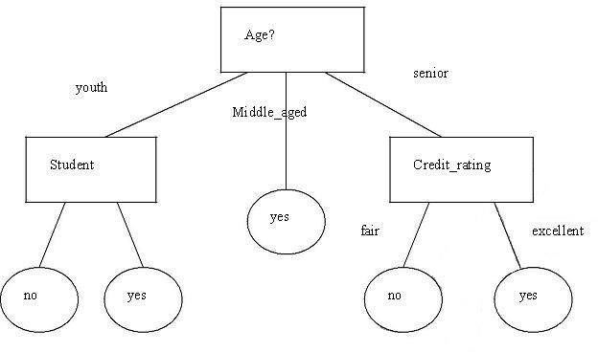

Converting Decision tree into a set of rules is as follows.

Rule1: If age = youth AND student=yes THEN buys_computer=yes Rule2: If age = youth AND student=no THEN buys_computer=no Rule3: If age = middle_aged THEN buys_computer=yes
Rule4: If age = senior AND credit_rating=excellent THEN buys_computer=yes Rule5: If age = senior AND credit_rating=fair THEN buys_computer=no
In Weka GUI Explorer, Select Classify Tab, In that Select Use Training set option .There also exist different classifiers that output the model in the form of Rules. Such classifiers in weka are

“PART” and ”OneR” . Then go to Choose and select Rules in that select PART and press start Button.

== Evaluation on training set ===
=== Summary ===
Correctly Classified Instances 897 89.7 %
Incorrectly Classified Instances 103 10.3 %
== Confusion Matrix === a b <-- classified as
653 47 | a = good
56 244 | b = bad

Then go to Choose and select Rules in that select OneR and press start Button.
== Evaluation on training set ===
=== Summary ===
Correctly Classified Instances | 742 | 74.2 | %
Incorrectly Classified Instances | 258 | 25.8 | %

=== Confusion Matrix ===
a b <-- classified as 642 58 | a = good
200 100 | b = bad

Then go to Choose and select Trees in that select J48 and press start Button.
=== Evaluation on training set ===

=== Summary ===
Correctly Classified Instances 855 | 85.5 | %
Incorrectly Classified Instances 145 | 14.5 | %

=== Confusion Matrix ===

a b <-- classified as 669 31 | a = good
114 186 | b = bad

Note: With this observation we have seen the performance of classifier and Rank is as follows

- PART
- J48 3. OneR

Result :

This program has been successfully executed.

PROGRAM 12 Hospital Management System DATE :

Data warehouse consists dimension table and fact table. REMEMBER the following
Dimension
The dimension object(dimension);
_name
_attributes(levels),with primary key
_hierarchies
One time dimension is must. About levels and hierarchies
Dimensions objects(dimension) consists of set of levels and set of hierarchies defined over
those levels.the levels represent levels of aggregation.hierarchies describe-child relationships among a set of levels.
For example .a typical calander dimension could contain five levels.two hierarchies can be defined on these levels.
H1: YearL>QuarterL>MonthL>DayL H2: YearL>WeekL>DayL
The hierarchies are describes from parent to child,so that year is the parent of Quarter,quarter are parent of month,and so forth.
About Unique key constraints
When you create a definition for a hierarchy,warehouse builder creates an identifier key for each level of the hierarchy and unique key constraint on the lowest level (base level)
Design a hospital management system data warehouse(TARGET) consists of dimensions patient,medicine,supplier,time.where measure are ‘ NO UNITS’ ,UNIT PRICE.
Assume the relational database(SOURCE)table schemas as follows TIME(day,month,year)
PATIENT(patient_name,age,address,etc) MEDICINE(Medicine_brand_name,Drug_name,supplier,no_units,units_price,etc..,)

SUPPLIER:( Supplier_name,medicine_brand_name,address,etc..,)
If each dimension has 6 levels,decide the levels and hierarchies,assumes the level names suitably.
Design the hospital management system data warehousing using all schemas.give the example 4-D cube with assumption names.

Result :

This program has been successfully executed.

PROGRAM 13 Simple Project on Data Preprocessing

Data Preprocessing

Objective:
Understanding the purpose of unsupervised attribute/instance filters for preprocessing the input data.
Follow the steps mentioned below to configure and apply a filter.
The preprocess section allows filters to be defined that transform the data in various ways. The Filter box is used to set up filters that are required. At the left of the Filter box is a Choose button. By clicking this button it is possible to select one of the filters in Weka. Once a filter has been selected, its name and options are shown in the field next to the Choose button. Clicking on this box brings up a GenericObjectEditor dialog box, which lets you configure a filter. Once you are happy with the settings you have chosen, click OK to return to the main Explorer window.
Now you can apply it to the data by pressing the Apply button at the right end of the Filter panel. The Preprocess panel will then show the transformed data. The change can be undone using the Undo button. Use the Edit button to view your transformed data in the dataset editor.
Try each of the following Unsupervised Attribute Filters. (Choose -> weka -> filters -> unsupervised -> attribute)
- Use ReplaceMissingValues to replace missing values in the given dataset.
- Use the filter Add to add the attribute Average.
- Use the filter AddExpression and add an attribute which is the average of attributes M1 and M2. Name this attribute as AVG.
- Understand the purpose of the attribute filter Copy.
- Use the attribute filters Discretize and PKIDiscretize to discretize the M1 and
M2 attributes into five bins. (NOTE: Open the file afresh to apply the second filter since there would be no numeric attribute to dicretize after you have applied the first filter.)
- Perform Normalize and Standardize on the dataset and identify the difference between these operations.
- Use the attribute filter FirstOrder to convert the M1 and M2 attributes into a single attribute representing the first differences between them.

- Add a nominal attribute Grade and use the filter MakeIndicator to convert the attribute into a Boolean attribute.
- Try if you can accomplish the task in the previous step using the filter MergeTwoValues.
- Try the following transformation functions and identify the purpose of each
- NumericTransform
- NominalToBinary
- NumericToBinary
- Remove
- RemoveType
- RemoveUseless
- ReplaceMissingValues
- SwapValues
Try the following Unsupervised Instance Filters.
(Choose -> weka -> filters -> unsupervised -> instance)
- Perform Randomize on the given dataset and try to correlate the resultant sequence with the given one.
- Use RemoveRange filter to remove the last two instances.
- Use RemovePercent to remove 10 percent of the dataset.
- Apply the filter RemoveWithValues to a nominal and a numeric attribute

Result :

This program has been successfully executed.

